**NAME: SHALMON N. ANANDAS**

**CLASS: M.Sc. PART – I**

**COURSE: BIOINFORMATICS**

**ACADEMIC YEAR: 2021-2022**

**ROLL NO: 91**

**PAPER CODE: GNKPSBI202 (PAPER 2)**

**COURSE TITLE: Structural Biology & Bioinformatics**

**GURU NANAK KHALSA COLLEGE**

**MATUNGA, MUMBAI – 400019**

**DEPARTMENT OF BIOINFORMATICS**

**CERTIFICATE**

This is to certify that Mr. **Shalmon N Anandas** of M.Sc. Part I Bioinformatics has satisfactorily completed the practical semester I course prescribed by the university of Mumbai during the academic year 2021-2022

**TEACHER IN CHARGE HEAD OF DEPARTMENT**

**INDEX**

|  |  |  |  |  |  |
| --- | --- | --- | --- | --- | --- |
| **SR. NO** | **SUB** | **WEBLEM** | **PAGE NO** | **DATE** | **SIGNATURE** |
| 1 |  | Secondary Structure Prediction |  | 20-2-22 |  |
|  | 1a | Secondary Structure prediction using various tools |  | 20-2-22 |  |
| 2 |  | Introduction to Protein Classification |  | 27-02-22 |  |
|  | 2a | CATH and SCOP |  | 27-02-22 |  |
| 3 |  | Introduction to Tertiary Structure Prediction |  | 20-03-22 |  |
|  | 3a | MODELLER |  | 20-03-22 |  |
|  | 3b | I-TASSAR |  | 20-03-22 |  |
|  | 3c | Robetta |  | 20-03-22 |  |
| 4 |  | Introduction to Validation server – SAVES server |  | 10-03-22 |  |
|  | 4a | SAVES server |  | 10-03-22 |  |
|  | 4b | SAVES server |  | 10-03-22 |  |
|  | 4c | SAVES server |  | 10-03-22 |  |
| 5 |  | Introduction to Visualization of Tertiary structure using RASMOL and PyMOL |  | 05-03-22 |  |
|  | 5a | RASMOL and PyMOL |  | 05-03-22 |  |
| 6 |  | Introduction to binding pocket prediction of protein with respect to PTM studies |  | 04-03-22 |  |
|  | 6a | CASTp |  | 04-03-22 |  |
|  | 6b | NetNGLYc 4.0 |  | 04-03-22 |  |
|  | 6c | NetPhos 3.1 |  | 04-03-22 |  |
| 7 |  | Introduction to Structural Blast -VAST & DALI |  | 18-03-22 |  |
|  | 7a | VAST |  | 18-03-22 |  |
|  | 7b | DALI |  | 18-03-22 |  |
| 8 |  | Introduction to Gene Prediction and various elements in Prokaryotes and Eukaryotes |  | 19-03-22 |  |
|  | 8a | TSSW |  | 19-03-22 |  |
|  | 8b | BPROM |  | 19-03-22 |  |
|  | 8c | FGENESB |  | 19-03-22 |  |
|  | 8d | FGENES |  | 19-03-22 |  |
|  | 8e | ORF finder – NCBI |  | 19-03-22 |  |
| 9 |  | Introduction to Genomics & its various browsers (UCSC, ENSEMBL, GDV) |  | 30-03-22 |  |
|  | 9a | UCSC Genome Browser |  | 30-03-22 |  |
|  | 9b | ENSEMBL Genome Browser |  | 30-03-22 |  |
|  | 9c | Genome Data Viewer |  | 30-03-22 |  |
| 10 |  | A field guid to whole-genome sequencing, assembly and annotation |  | 31-03-22 |  |

**DATE: 20-02-22**

**WEBLEM 1**

**SECONDARY STRUCTURE PREDICTION**

**Introduction:**

* Secondary structure prediction is relatively accurate, and is in fact much easier to solve than three-dimensional structure prediction. The accuracy of assigning strand, helix or loops to a certain residue can go up to 80% with the most reliable methods. Typically, these methods use periodicity in the sequence combined with phi and psi angle preferences of certain amino acids types to come to accurate predictions. The real challenge lies in assembling the secondary structure element in a correct topology. Nevertheless, secondary structure prediction may be used to assess the quality of model built with a structure prediction method. Many methods also incorporated secondary structure information during homology detection.

**Secondary structure prediction has three generations:**

**1. First Generation: Chou and Fasman**

* CFSSP (Chou & Fasman Secondary Structure Prediction Server) is an online protein secondary structure prediction server. This server predicts regions of secondary structure from the protein sequence such as alpha helix, beta sheet, and turns from the amino acid sequence. The output of predicted secondary structure is also displayed in linear sequential graphical view based on the probability of occurrence of alpha helix, beta sheet, and turns. The method implemented in CFSSP is Chou-Fasman algorithm, which is based on analyses of the relative frequencies of each amino acid in alpha helices, beta sheets, and turns based on known protein structures solved with X-ray crystallography. CFSSP is freely accessible via ExPASy server.

**2. Second Generation: GOR IV**

* The GOR method is based on information theory and was developed by J.Garnier, D.Osguthorpe and B.Robson (J.Mol.Biol.120,97, 1978). The present version, GOR IV, uses all possible pair frequencies within a window of 17 amino acid residues and is reported by J. Garnier. J.F. Gibrat and B.Robson in Methods in Enzymology, vol 266, p 540-553 (1996). After cross validation on a data base of 267 proteins, the version IV of GOR has a mean accuracy of 64.4% for a three-state prediction (Q3). The program gives two outputs, one eye-friendly giving the sequence and the predicted secondary structure in rows, H=helix, E=extended or beta strand and C=coil; the second gives the probability values for each secondary structure at each amino acid position. The predicted secondary structure is the one of highest probability compatible with a predicted helix segment of at least four residues and a predicted extended segment of at least two residues.

**3. Third Generation: PSIPRED**

* The PSIPRED Workbench provides a range of protein structure prediction methods. The site can be used interactively via a web browser or programmatically via our REST API. For high- throughput analyses, downloads of all the algorithms are available. Amino acid sequences enable: secondary structure prediction, including regions of disorder and transmembrane helix packing; contact analysis; fold recognition; structure modelling; and prediction of domains and function. In addition, PDB Structure files allow prediction of protein-metal ion contacts, protein-protein hotspot residues, and membrane protein orientation.

**References:**

* Protein Secondary Structure - an overview | ScienceDirect Topics. (2016). Science Direct. <https://www.sciencedirect.com/topics/biochemistry-genetics-and-molecular-biology/protein-secondary-structure>
* Edwards, Y. J., and Cottage, A. 2003. Bioinformatics methods to predict protein structure and function. A practical approach. Mol. Biotechnol. 23:139-66.
* Ashok Kumar, T. (2013). CFSSP: Chou and Fasman Secondary Structure Prediction server. WIDE SPECTRUM: Research Journal. 1(9):15-19.
* Heringa J. 2002. Computational methods for protein secondary structure prediction using multiple sequence alignments. Curr. Protein Pept. Sci. 1:273-301.
* Lehnert, U., Xia, Y., Royce, T. E., Goh, C. S., Liu, Y., Senes, A., Yu. H., Zhang, Z. L., Engelman, D. M, and Gerstein M. 2004. Computational analysis of membrane proteins: Genomic occurrence,structure prediction and helix interactions. Q. Rev. Biophys. 37:121-46.
* Moller, S., Croning, M. D. R., and Apweiler, R. 2001. Evaluation of methods for the prediction of ̈ membrane spanning regions. Bioinformatics 17:646-53.

**DATE: 20-02-22**

**WEBLEM 1A**

**SECONDARY STRUCTURE PREDICTION**

**Aim:**

* Secondary Structure prediction for CAD13_HUMAN (Cadherin) using various tools (CF, GOR IV, PSIPRED)

**Introduction:**

* Secondary Structure prediction has three generations:

**1. First Generation: Chou and Fasman**

* CFSSP (Chou & Fasman Secondary Structure Prediction Server) is an online protein secondary structure prediction server. This server predicts regions of secondary structure from the protein sequence such as alpha helix, beta sheet, and turns from the amino acid sequence. The output of predicted secondary structure is also displayed in linear sequential graphical view based on the probability of occurrence of alpha helix, beta sheet, and turns.

**2. Second Generation: GOR IV**

* The GOR method is based on information theory and was developed by J.Garnier, D.Osguthorpe and B.Robson. After cross validation on a data base of 267 proteins, the version IV of GOR has a mean accuracy of 64.4% for a three-state prediction. The program gives two outputs, one eye-friendly giving the sequence and the predicted secondary structure in rows, H=helix, E=extended or beta strand and C=coil; the second gives the probability values for each secondary structure at each amino acid position.

**3. Third Generation: PSIPRED**

* The PSIPRED Workbench provides a range of protein structure prediction methods. The site can be used interactively via a web browser or programmatically via our REST API. For high- throughput analyses, downloads of all the algorithms are available. Amino acid sequences enable: secondary structure prediction, including regions of disorder and transmembrane helix packing; contact analysis; fold recognition; structure modelling; and prediction of domains and function

**Cadherin:**

* Cadherins are a large family of cell-cell adhesion molecules acting in a homotypic, homophilic manner that play an important role in the maintenance of tissue integrity. In the human kidney several members of the cadherin family are expressed in a controlled spatiotemporal pattern. Cadherin-16 also called kidney-specific cadherin, is exclusively expressed in epithelial cells of the adult kidney.

**Methodology:**

* Open Homepage of (CF, GOR IV, PSIPRED)
* Enter the query Cadherin Fasta sequence in the search bar.
* Open the Result page.
* Interpret the Results.

**Observations:**

* **First Generation: Chou and Fasman**

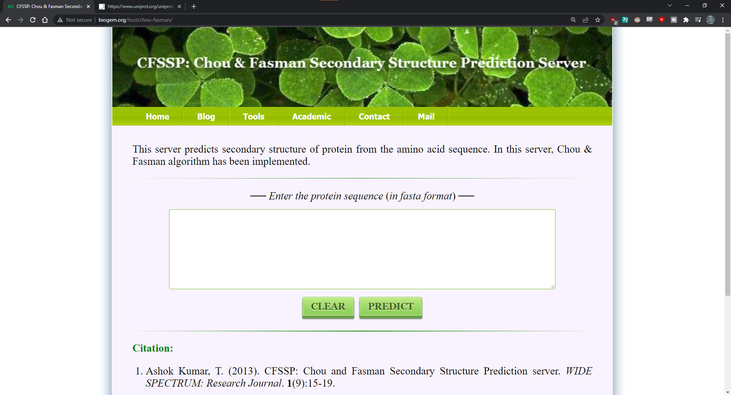

**Fig1: Homepage of Chou and fasman**

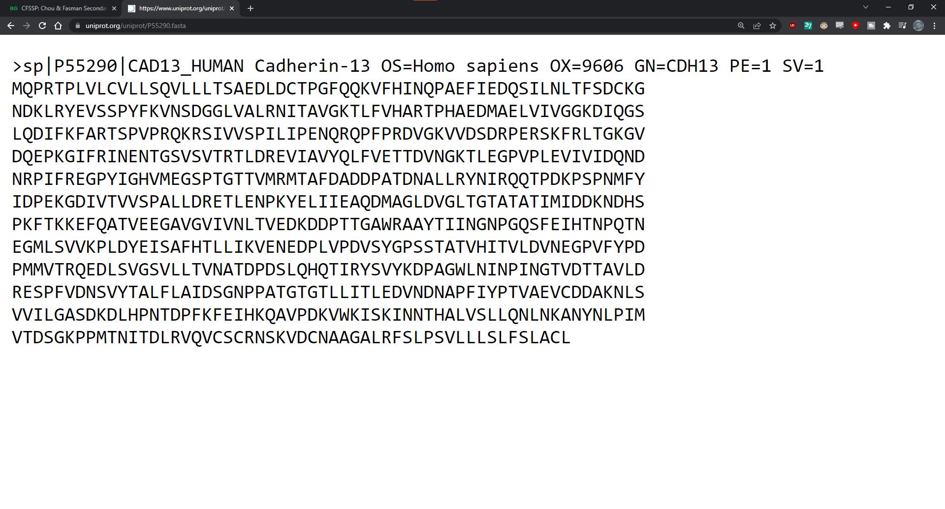**Fig2. FASTA sequence of CAD13_HUMAN Cadherin**

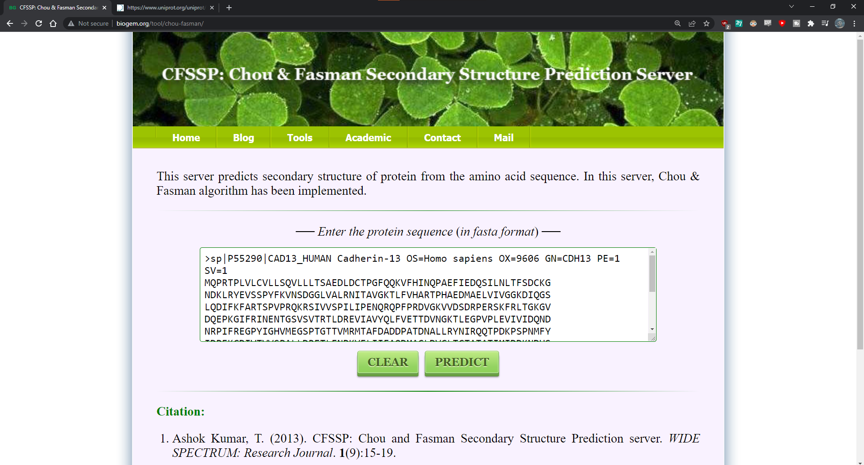**Fig3. Search bar with FASTA sequence of CAD13_HUMAN Cadherin**

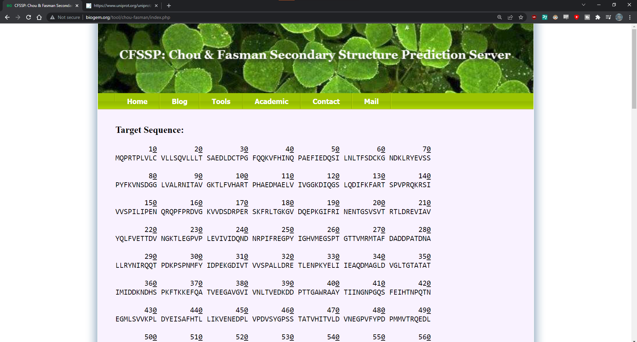**Fig4. Result page of Cadherin showing target sequence**

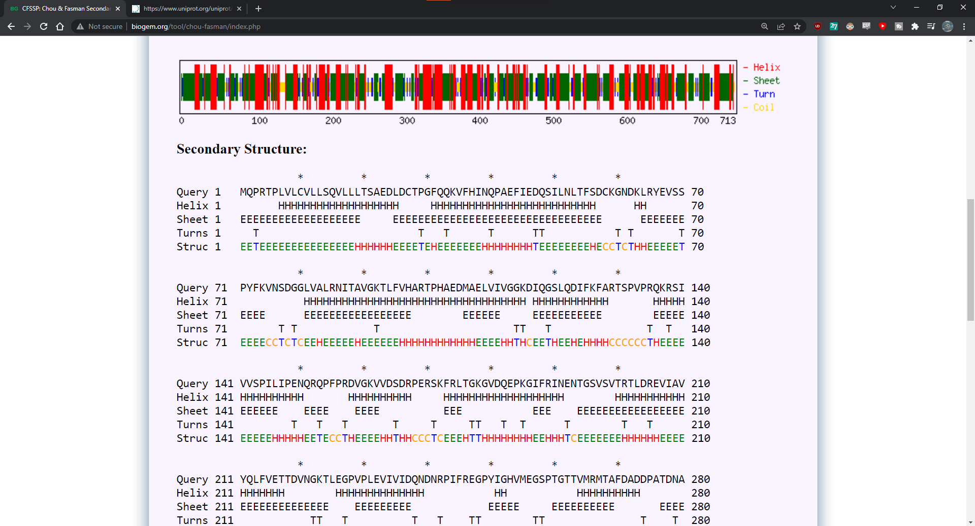**Fig5. Result page of Cadherin showing Secondary structure**

* **Secondary Generation: GOR IV**

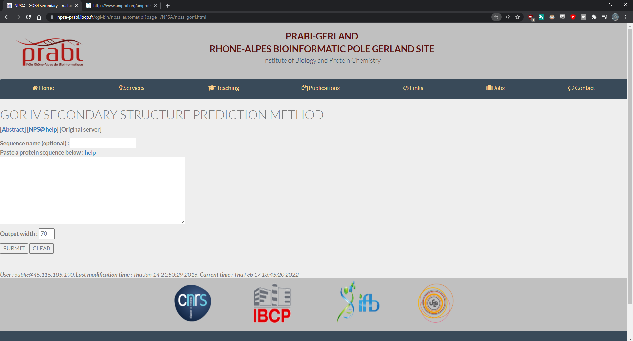**Fig1. Homepage of GOR IV**

**Fig2. FASTA sequence of CAD13_HUMAN Cadherin**

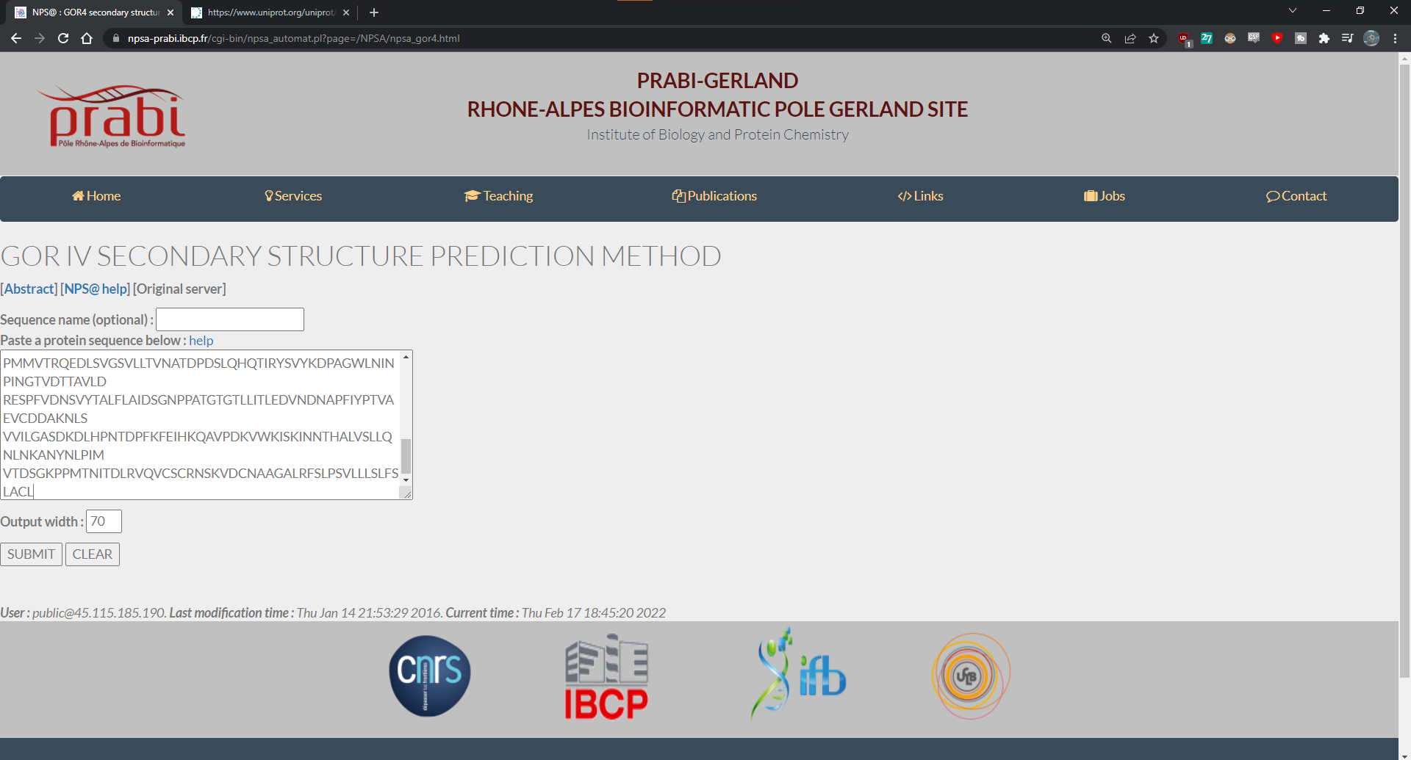**Fig3. Search bar with FASTA sequence of cadherin**

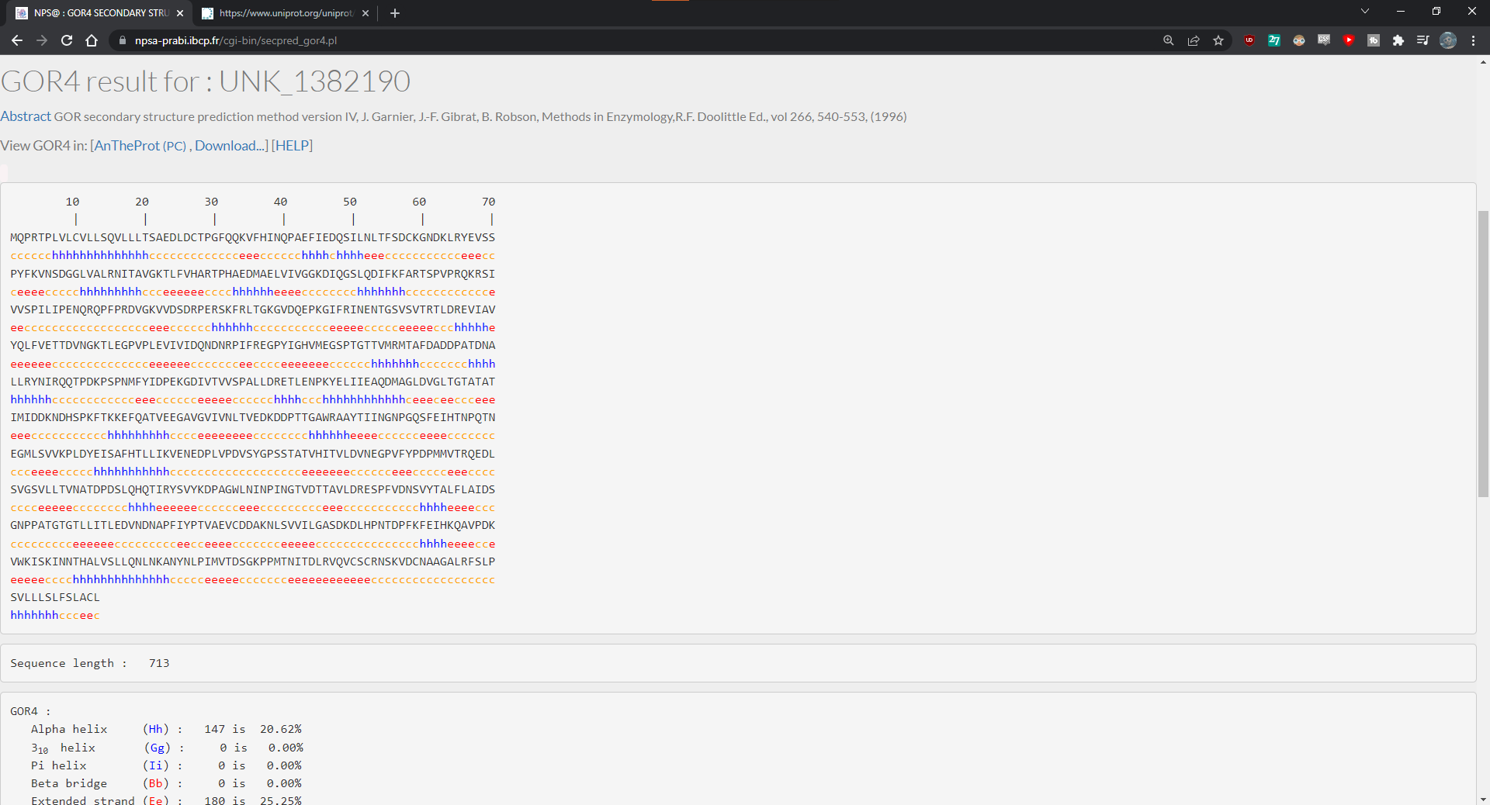**Fig4. Result page of GOR IV for Cadherin**

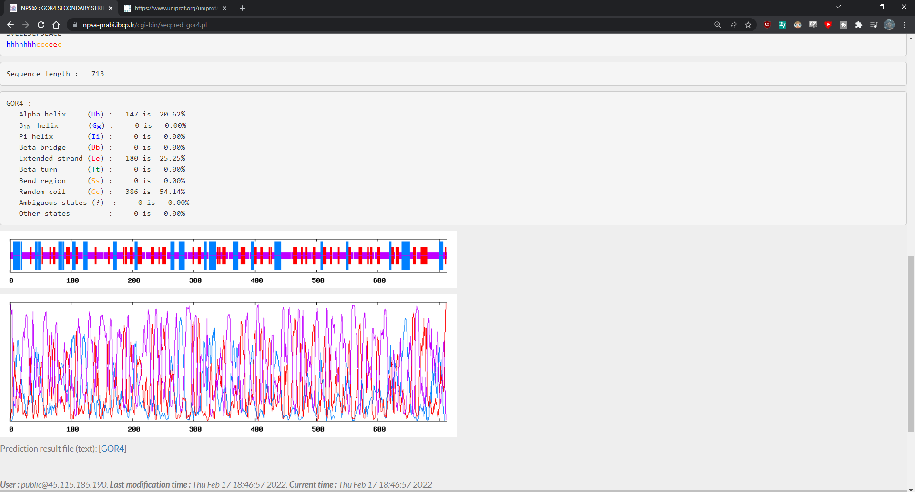**Fig5. Frequency graph for Cadherin**

* **Third Generation: PSIPRED**

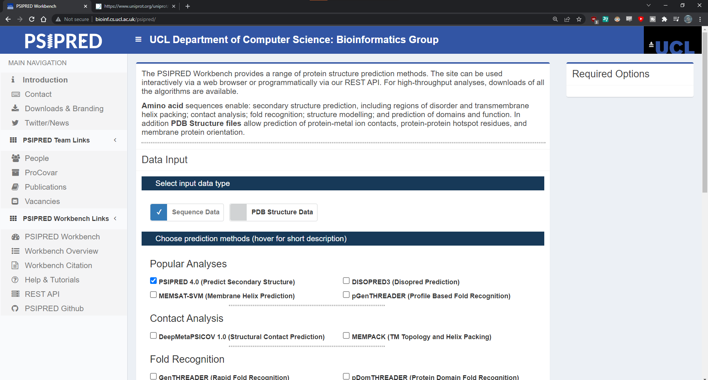**Fig1. Homepage for PSIPRED**

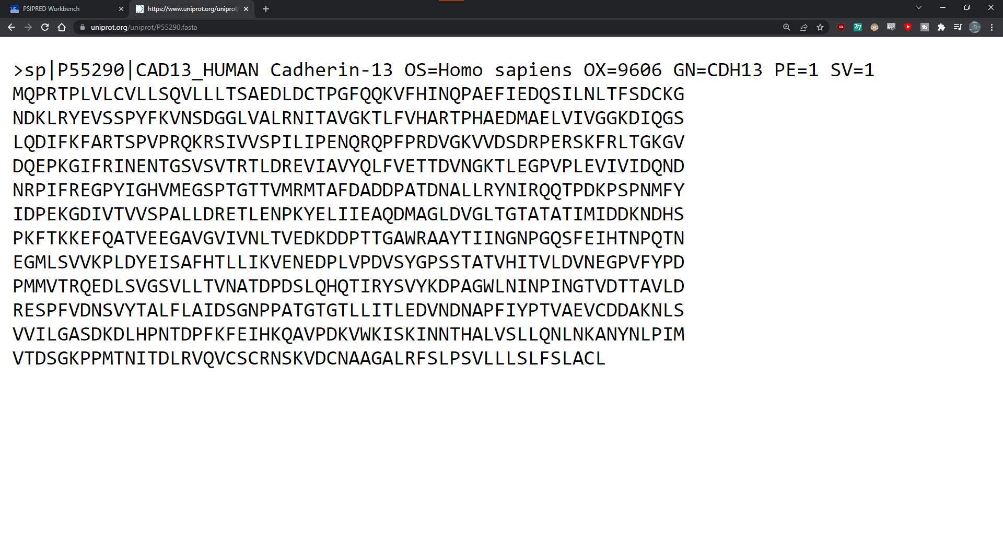**Fig2. FASTA sequence of CAD13_HUMAN Cadherin**

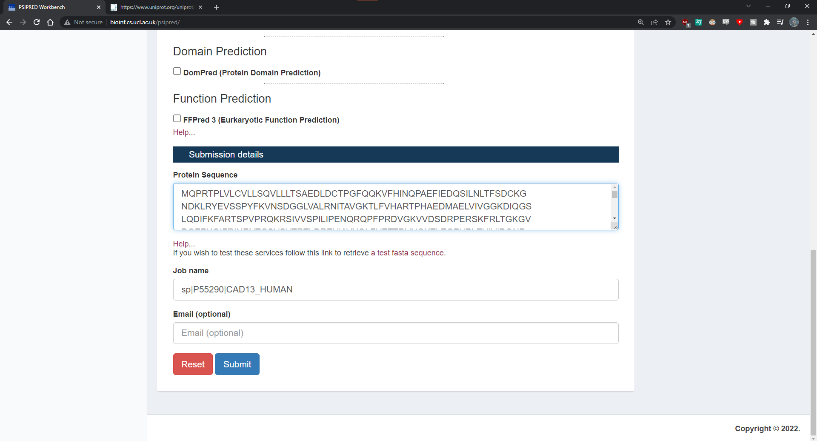**Fig3. Search bar of PSIPRED with FASTA sequence of Cadherin**

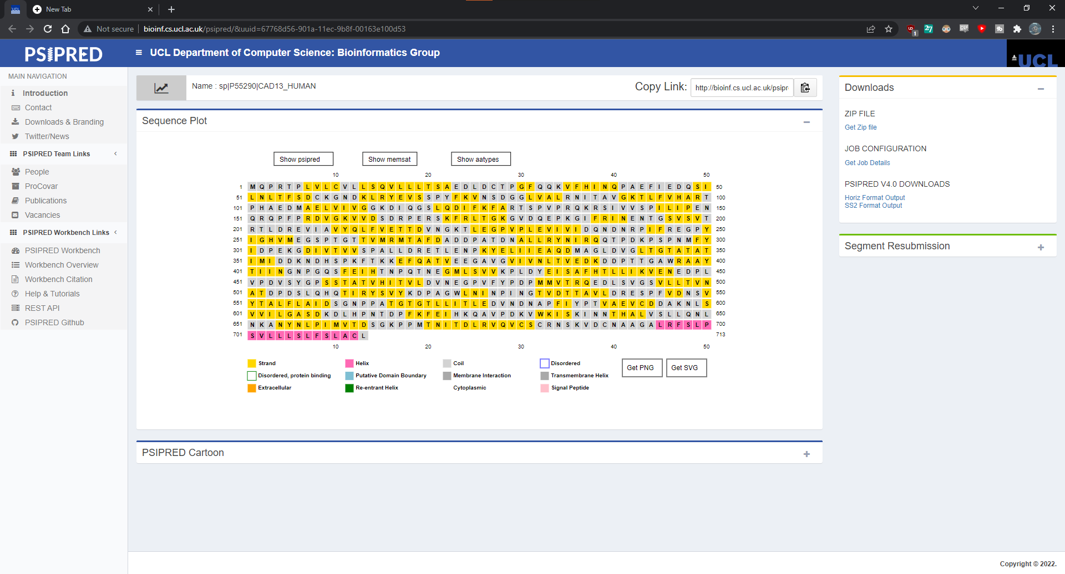**Fig4. Sequence plot of CAD13_HUMAN Cadherin in PSIPRED**

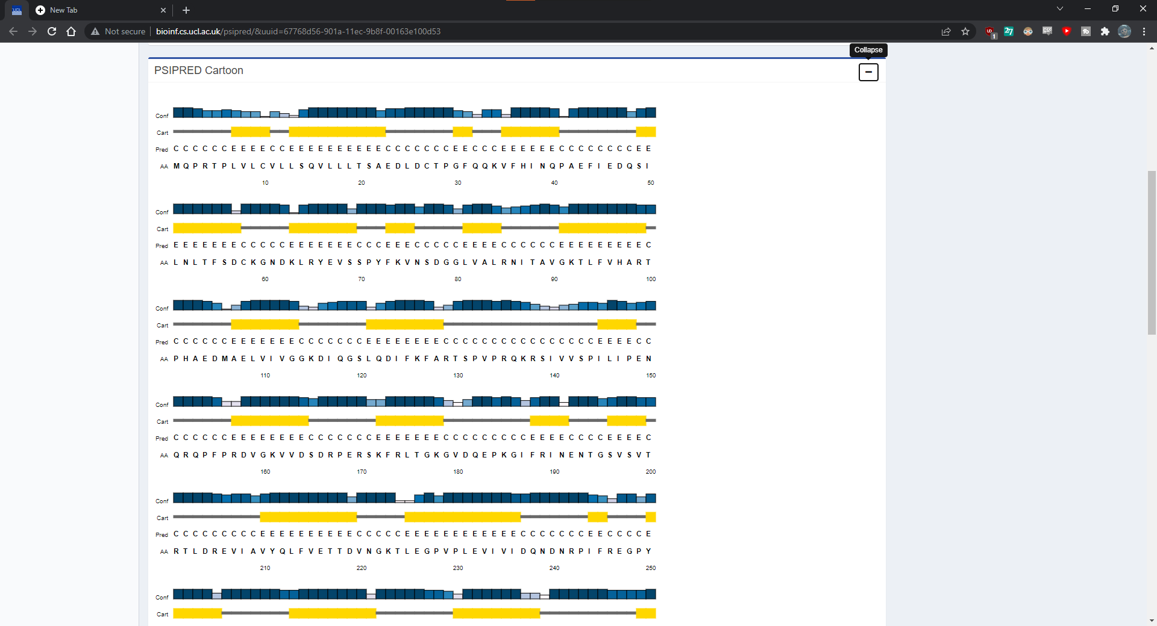**Fig5. Legend of Cadherin in PSIPRED**

**Results:**

* **First Generation: Chou and Fasman**
  + In secondary structure prediction using Chou and Fasman tools. The FASTA Sequence length of query Cadherin is 713 and their total residues are H: 455; E: 470; T:95; and the percentage is H: 63.8; E: 65.9; T:13.3;
* **Second Generation: GOR IV**
  + In secondary structure prediction using GOR IV tools. The FASTA Sequence length of query Cadherin is 713 and tota residues are Alpha helix: 147 (20.62%); Extended Strand: 180 (25.25%); Random coil: 386 (54.14%).
* **Third Generation: PSIPRED**
  + In secondary structure prediction using PSIPRED tools. The FASTA sequence length of query Cadherin is 713. Here the maximum helix residues are predicted and we can find legend of confidence of prediction, 3-state assignment cartoon and target sequence.

**Conclusion:**

* The secondary structure of the protein is Alpha helix and Beta sheet. Protein structure plays a key role in its function. Secondary structure prediction is important from the structural and functional point of view. Secondary structure is local interactions between stretches of a polypeptide chain and include alpha helix and beta pleated sheet structures.

**References:**

* Ranscht, B. (2010). Cadherin Regulation of Adhesive Interactions. Handbook of Cell Signaling, 1975–1988. <https://doi.org/10.1016/b978-0-12-374145-5.00242-4>
* CHOU-FASMAN. (2022, February 12). CHOU-FASMAN. Retrieved February 14, 2022, from <http://www.biogem.org/tool/chou-fasman/index.php>
* Ashok Kumar, T. (2013). CFSSP: Chou and Fasman Secondary Structure Prediction server. WIDE SPECTRUM: Research Journal. 1(9):15-19.
* GOR IV. (2022, February 12). GOR IV. Retrieved February 14, 2022, from <https://npsa-prabi.ibcp.fr/cgi-bin/npsa_automat.pl?page=/NPSA/npsa_gor4.html>
* PSIPRED. (2016, September 12). Http://Bioinf.Cs.Ucl.Ac.Uk/Psipred. Retrieved February 14, 2022, from <http://bioinf.cs.ucl.ac.uk/psipred>

**Date: 27-02-22**

**WEBLEM 2**

**INTRODUCTION TO PROTEIN CLASSIFICATION**

**Introduction:**

One of the applications of protein structure comparison is structural classification. The ability to compare protein structure allows classification of the structure data and identification of relationships among structures. The reason to develop a protein structure classification system is to establish hierarchical relationships among protein structures and to provide a comprehensive and evolutionary view of known structure. Once a hierarchical classification system is established, a newly obtained protein structure can find its place in a proper category. As a result, its functions can be better understood based on association with other proteins.

**CATH:**

CATH (www.biochem.ucl.ac.uk/bsm/cath new/index.html) classifies proteins based on the automatic structural alignment program SSAP as well as manual comparison. Structural domain separation is carried out also as a combined effort of a human expert and computer programs. Individual domain structures are classified at five major levels: class, architecture, fold/topology, homologous superfamily, and homologous family. In the CATH release version 2.5.1 (January 2004), there are 4 classes, 37 architectures, 813 topologies, 1,467 homologous superfamilies, and 4,036 homologous families. The definition for class in CATH is similar to that in SCOP, and is based on secondary structure content. Architecture is a unique level in CATH, intermediate between fold and class. This level describes the overall packing and arrangement of secondary structures independent of connectivity between the elements. The topology level is equivalent to the fold level in SCOP, which describes overall orientation of secondary structures and takes into account the sequence connectivity between the secondary structure elements. The homologous superfamily and homologous family levels are equivalent to the superfamily and family levels in SCOP with similar evolutionary definitions, respectively.

**SCOPe:**

Structural Classification of Proteins-extended (SCOPe, http://scop.berkeley.edu) is a database of protein structural relationships that extends the SCOP database. SCOP is a manually curated ordering of domains from the majority of proteins of known structure in a hierarchy according to structural and evolutionary relationships. Development of the SCOP 1.x series concluded with SCOP 1.75. The ASTRAL compendium provides several databases and tools to aid in the analysis of the protein structures classified in SCOP, particularly through the use of their sequences. SCOPe extends version 1.75 of the SCOP database, using automated curation methods to classify many structures released since SCOP 1.75. We have rigorously benchmarked our automated methods to ensure that they are as accurate as manual curation, though there are many proteins to which our methods cannot be applied. SCOPe is also partially manually curated to correct some errors in SCOP. SCOPe aims to be backward compatible with SCOP, providing the same parseable files and a history of changes between all stable SCOP and SCOPe releases. SCOPe also incorporates and updates the ASTRAL database. The latest release of SCOPe, 2.03, contains 59 514 Protein Data Bank (PDB) entries, increasing the number of structures classified in SCOP by 55% and including more than 65% of the protein structures in the PDB.

**References:**

1. Berman, H. M. (2000). The Protein Data Bank. *Nucleic Acids Research*, *28*(1), 235–242. https://doi.org/10.1093/nar/28.1.235
2. Murzin, A. G. (1995). *Journal of Molecular Biology*, *247*(4), 536–540. https://doi.org/10.1006/jmbi.1995.0159

**DATE: 27-02-22**

**WEBLEM 2A**

**(URL:**[**https://www.cathdb.info/**](https://www.cathdb.info/)**)**

**Aim:**

To study the structural classification of proteins (Leucine) using **CATH** and **SCOPe** database.

**Introduction:**

* **CATH:**
  + CATH (www.biochem.ucl.ac.uk/bsm/cath new/index.html) classifies proteins based on the automatic structural alignment program SSAP as well as manual comparison. Structural domain separation is carried out also as a combined effort of a human expert and computer programs. Individual domain structures are classified at five major levels: class, architecture, fold/topology, homologous superfamily, and homologous family. In the CATH release version 2.5.1 (January 2004), there are 4 classes, 37 architectures, 813 topologies, 1,467 homologous superfamilies, and 4,036 homologous families. The definition for class in CATH is similar to that in SCOP, and is based on secondary structure content. Architecture is a unique level in CATH, intermediate between fold and class.
* **SCOPe:**
  + Structural Classification of Proteins-extended (SCOPe, http://scop.berkeley.edu) is a database of protein structural relationships that extends the SCOP database. SCOP is a manually curated ordering of domains from the majority of proteins of known structure in a hierarchy according to structural and evolutionary relationships. Development of the SCOP 1.x series concluded with SCOP 1.75. The ASTRAL compendium provides several databases and tools to aid in the analysis of the protein structures classified in SCOP, particularly through the use of their sequences. SCOPe extends version 1.75 of the SCOP database, using automated curation methods to classify many structures released since SCOP 1.75.
* **Leucine:**
  + Leucine is one of nine essential amino acids in humans (provided by food), Leucine is important for protein synthesis and many metabolic functions. Leucine contributes to regulation of blood-sugar levels; growth and repair of muscle and bone tissue; growth hormone production; and wound healing. Leucine also prevents breakdown of muscle proteins after trauma or severe stress and may be beneficial for individuals with phenylketonuria. Leucine is available in many foods and deficiency is rare.
* **Methodology:**
  + Open Homepage of CATH and SCOPe
  + Enter the query Leucine in the search bar
  + Open the result page of each category
  + Interpret the results.

**Observation:**

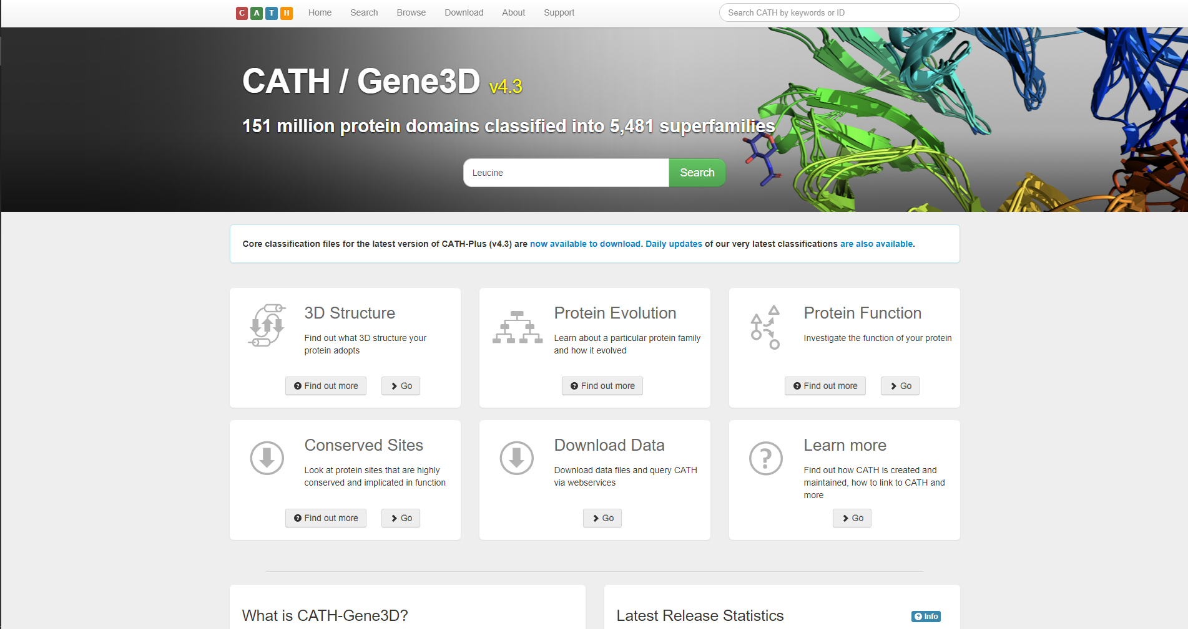**Fig1. Homepage of CATH database with query Leucine**

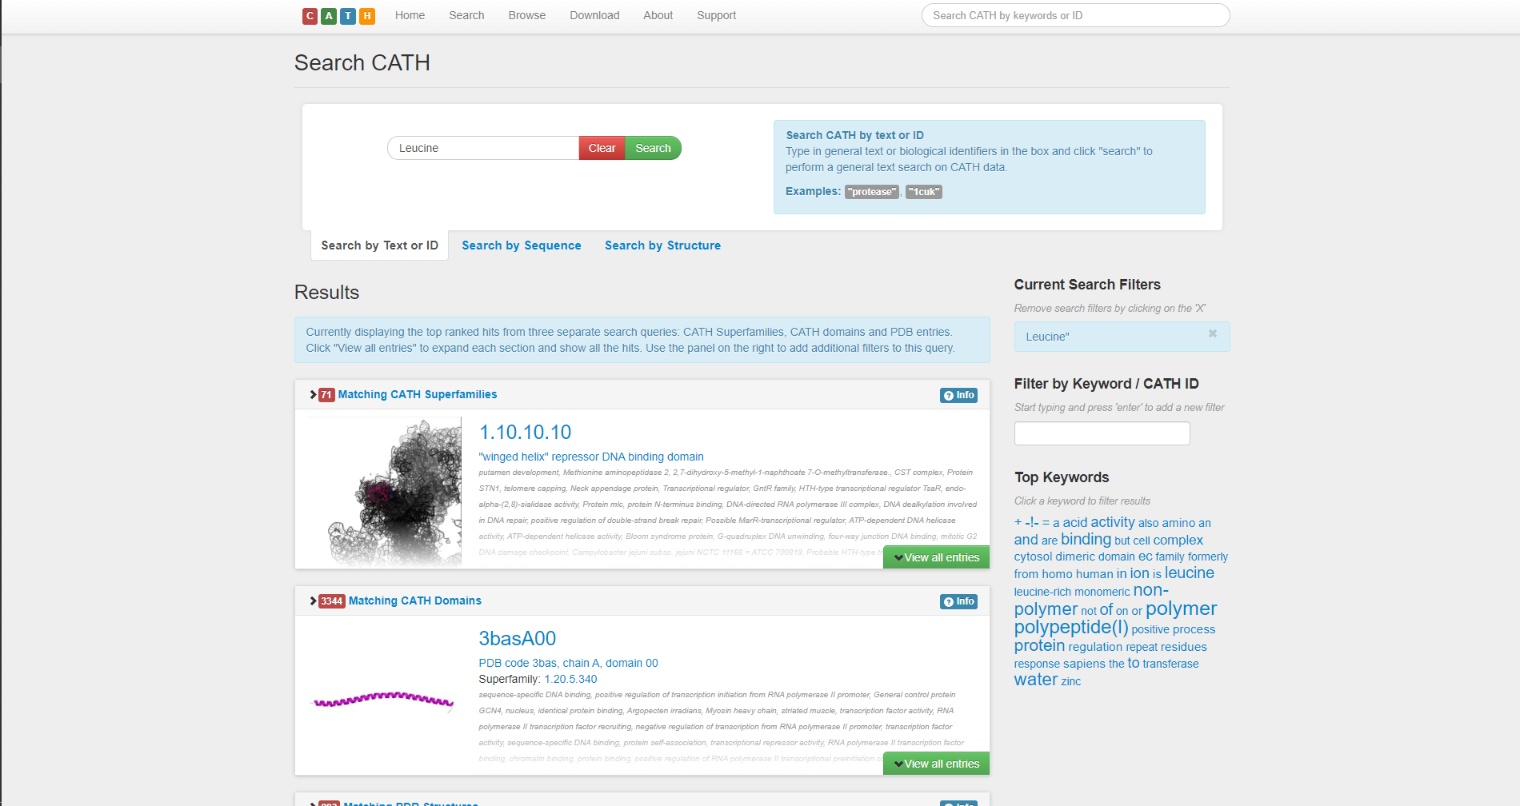**Fig2. Result page for leucine in CATH database**

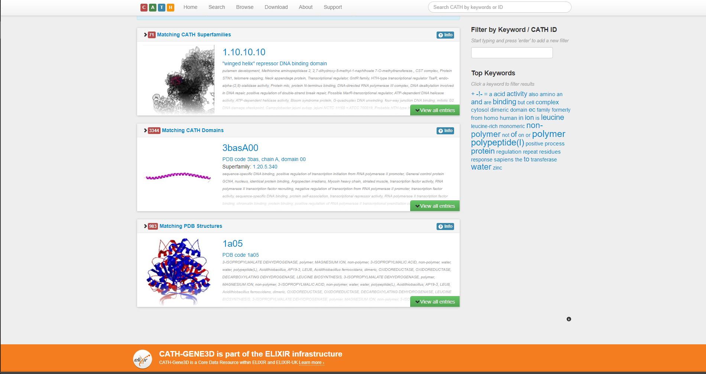**Fig3. Available CATH Superfamilies for leucine**

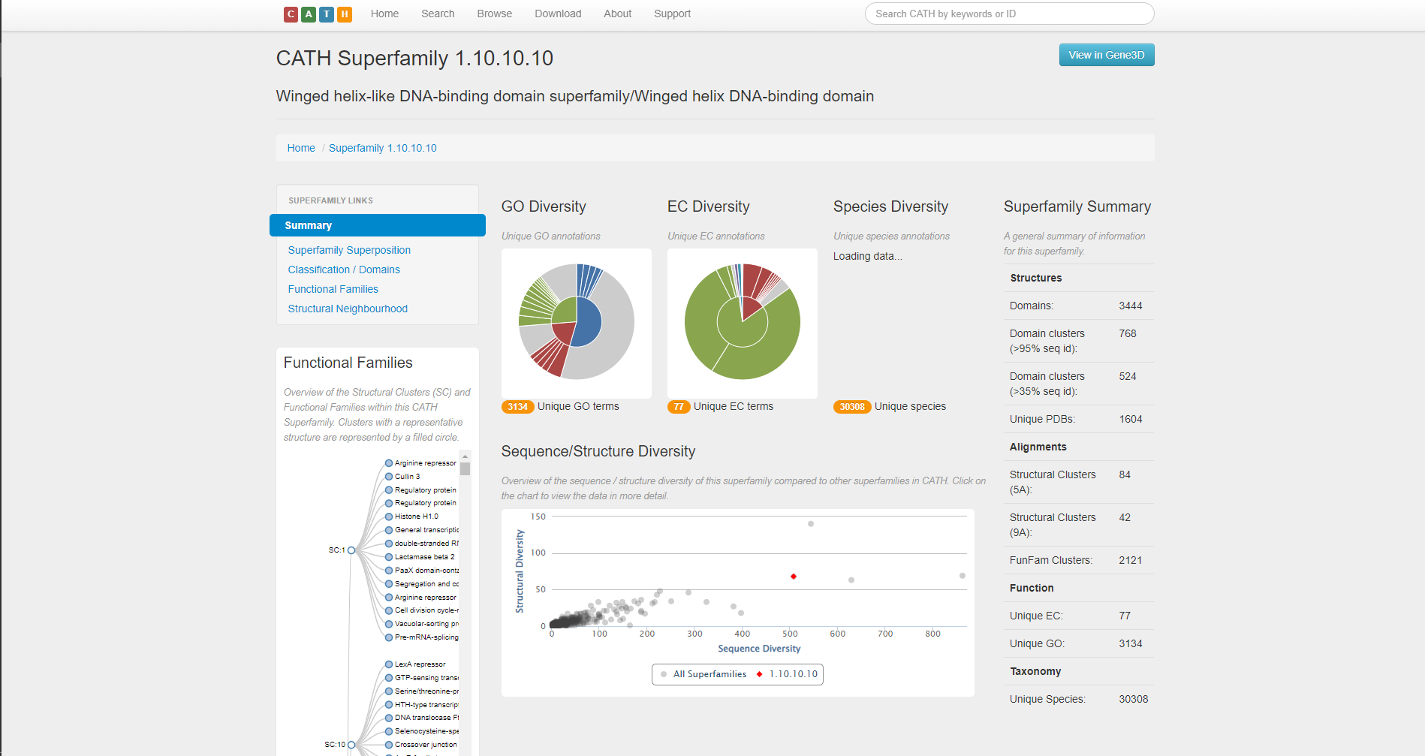**Fig3.1. Summary of CATH superfamily for Leucine**

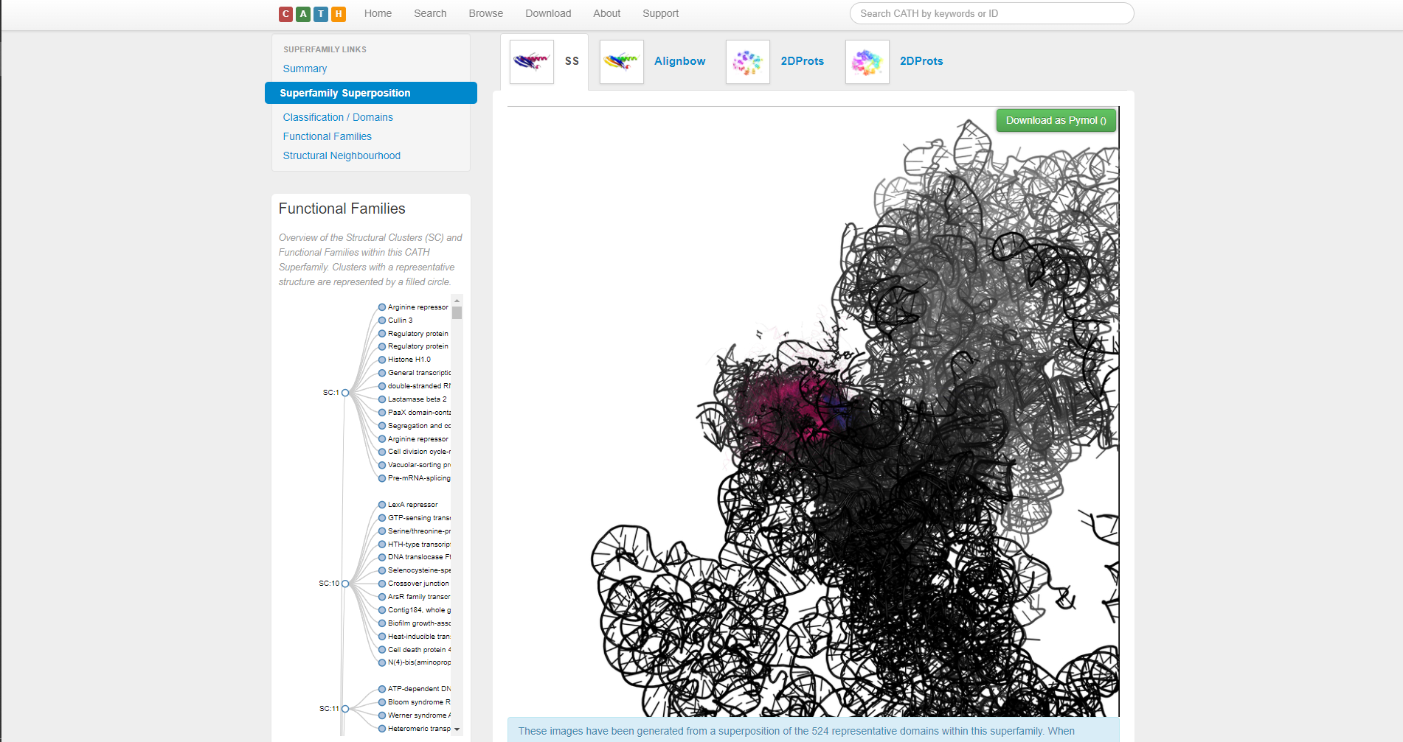**Fig3.2. Superfamily superposition under CATH superfamily for leucine**

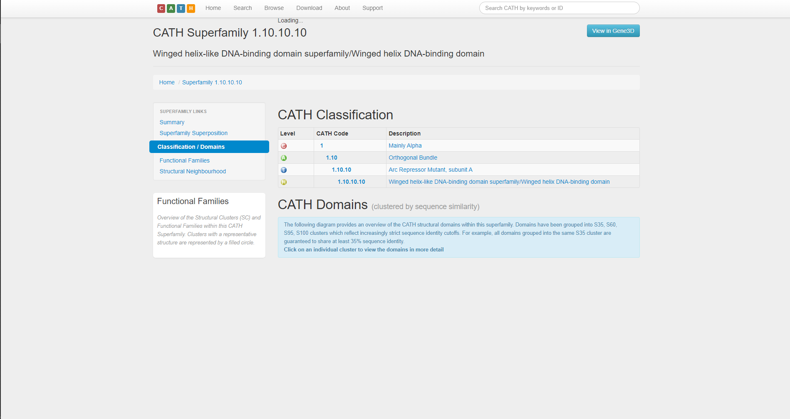

**Fig3.3. Classification / Domain of CATH superfamilies for Leucine**

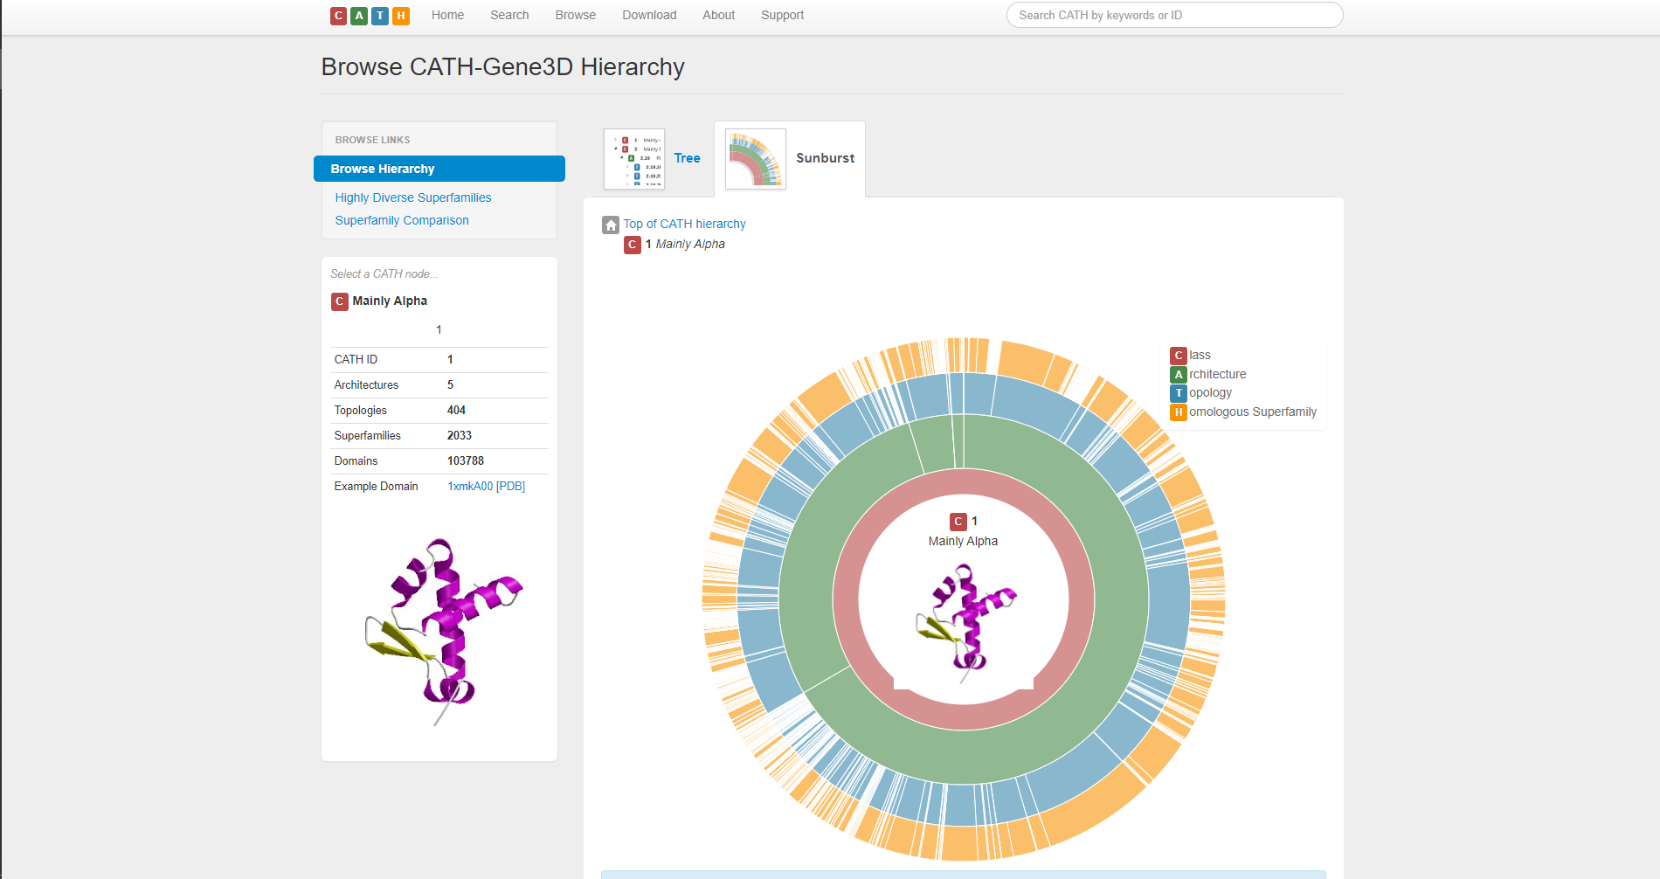**Fig3.4. Sunburst diagram of Alpha domain of CATH superfamilies for leucine**

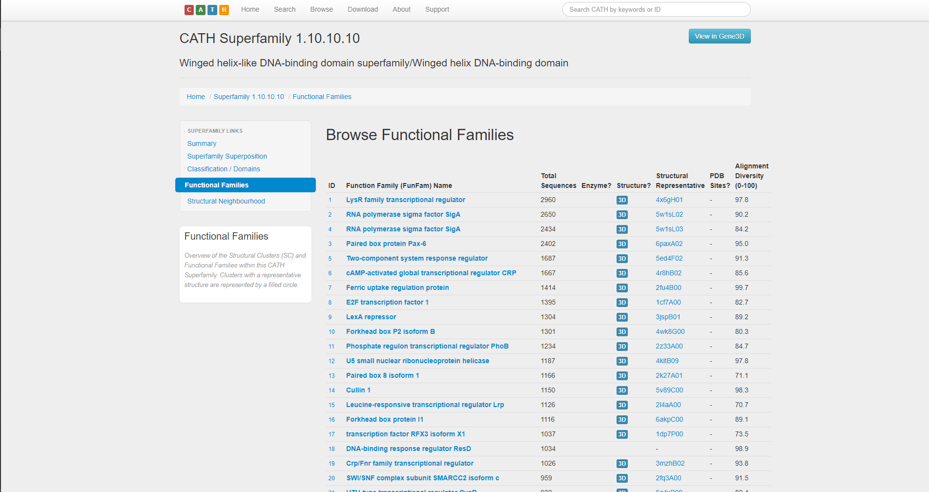

**Fig3.5. Functional Families of CATH superfamilies for leucine**

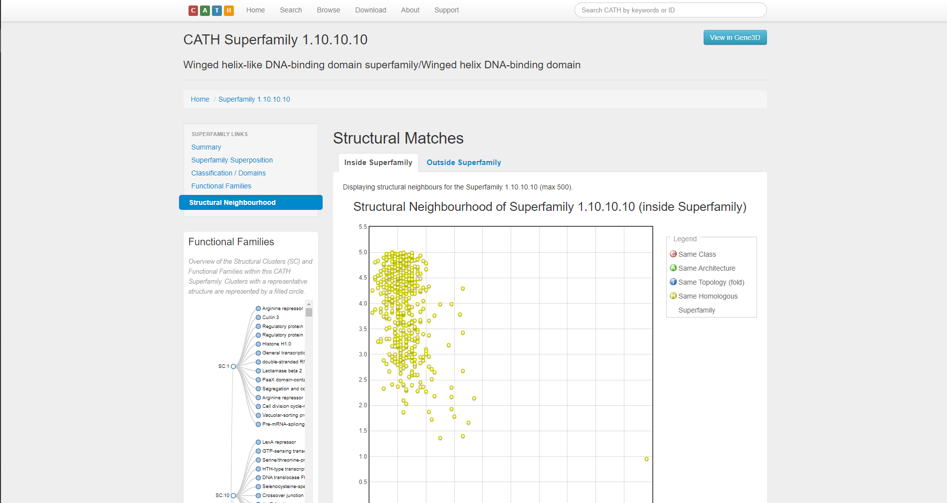

**Fig3.6. Structural neighborhood of CATH superfamilies for leucine (Inside Superfamily)**

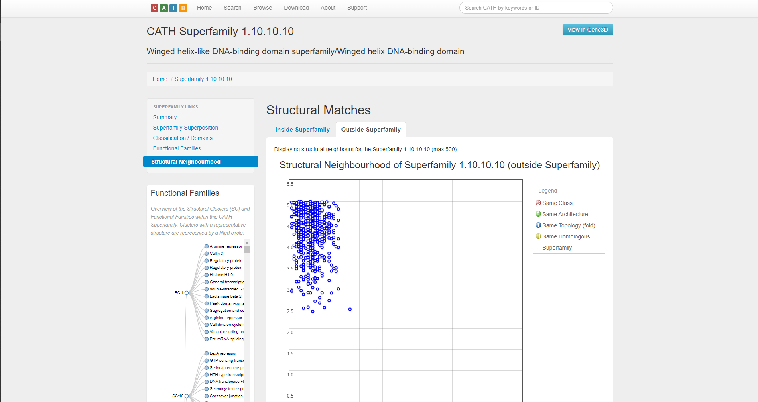

**Fig3.7. Structural neighborhood of CATH superfamilies for leucine (Outside Superfamily)**

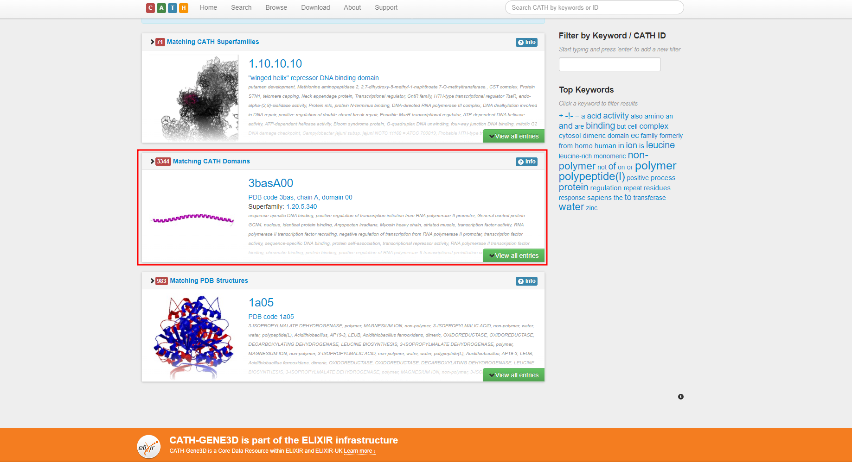**Fig4. Matching CATH domains for Leucine**

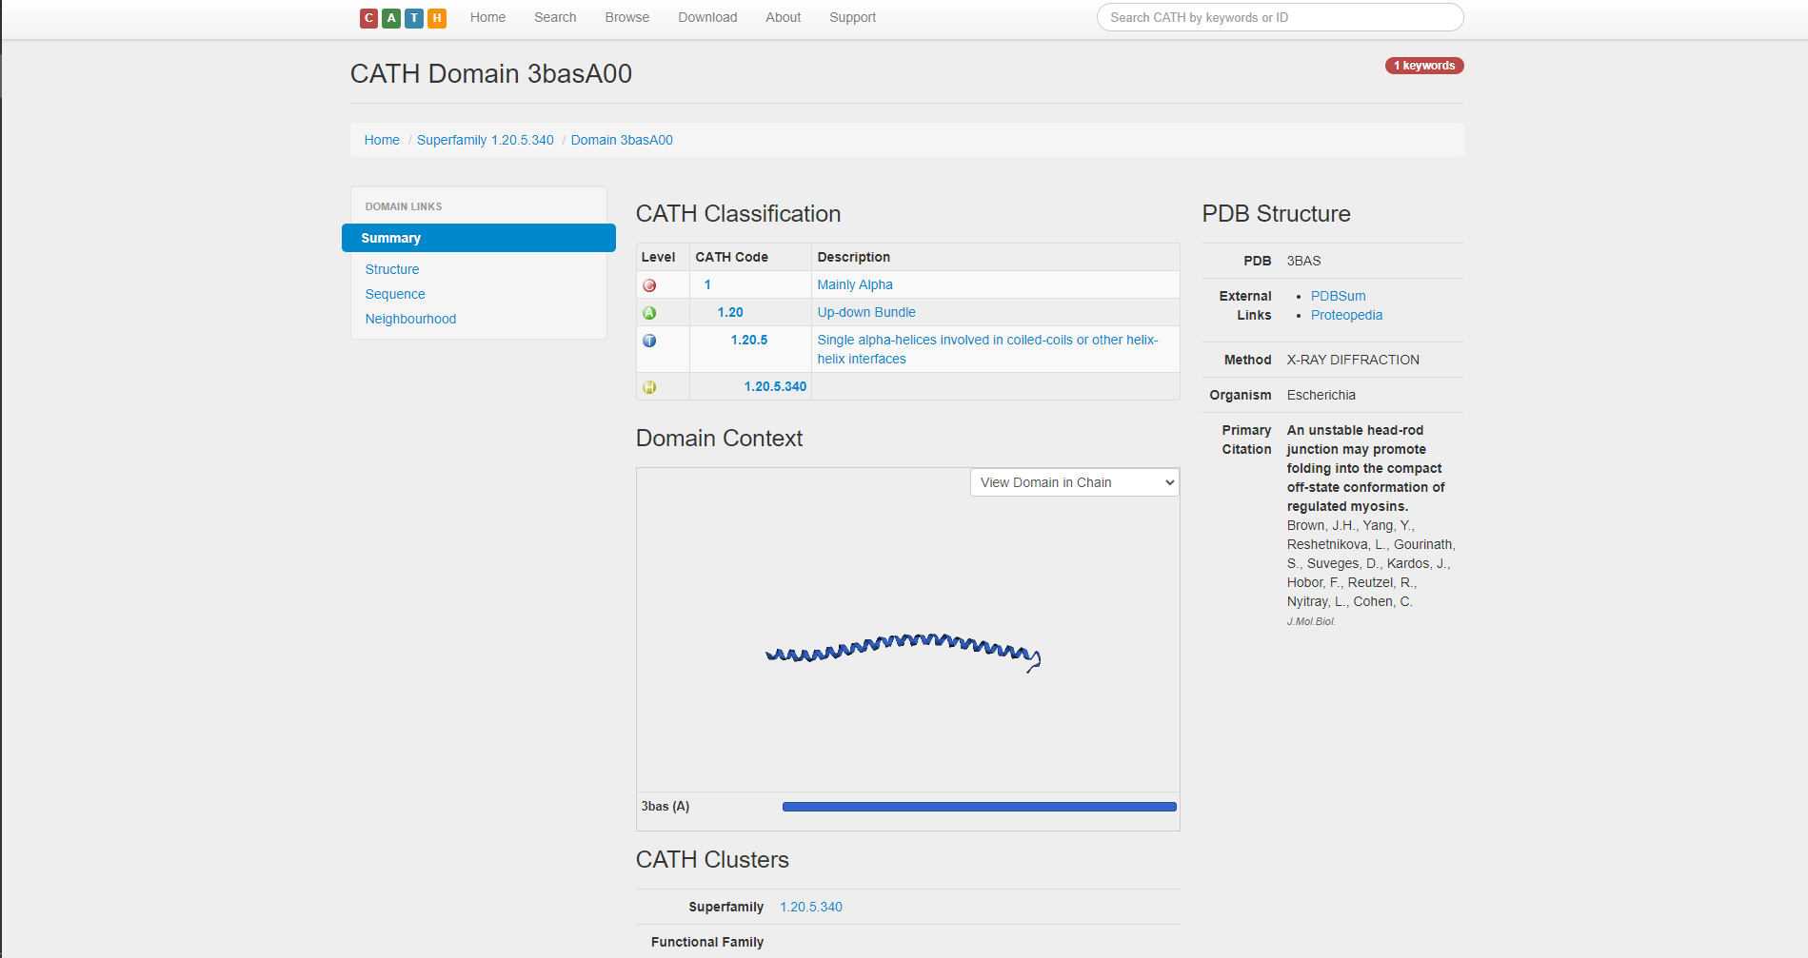**Fig4.1. Summary of matching CATH domains for Leucine**

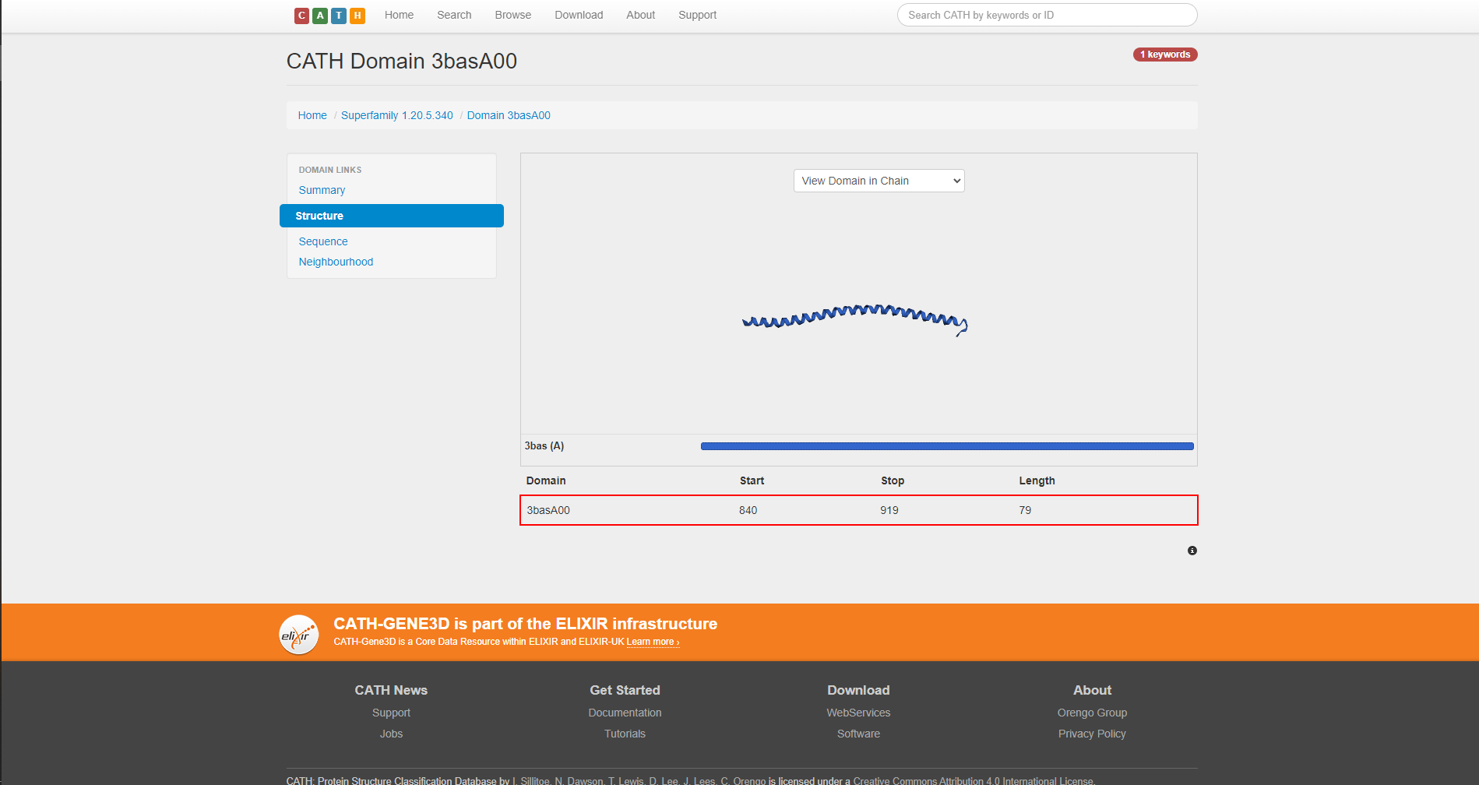**Fig4.2. Structure of matching CATH domains for Leucine**

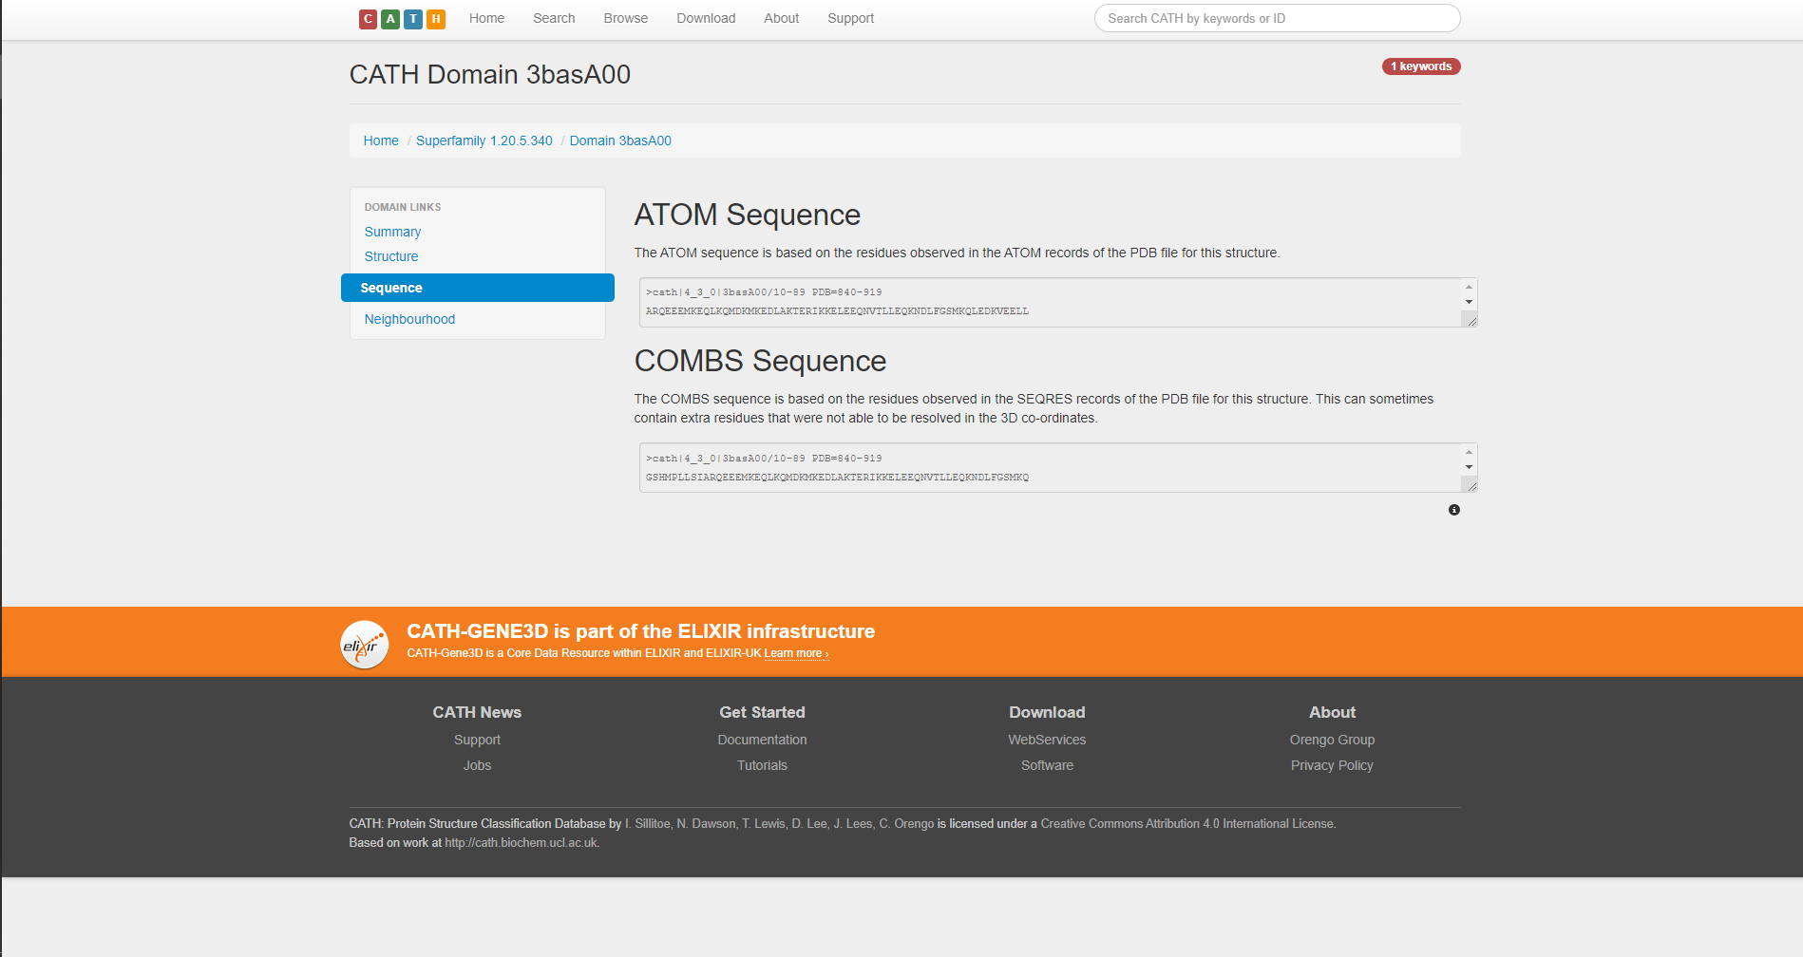

**Fig4.3. ATOM and COMBS sequence of matching CATH domains for Leucine**

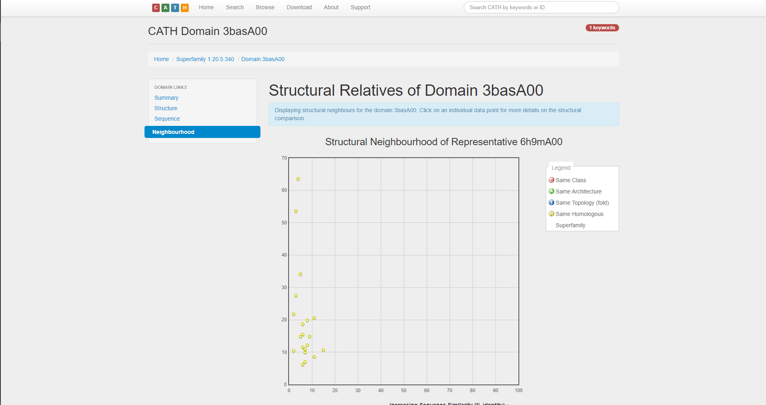**Fig4.4. Structural relatives of matching CATH domains for leucine**

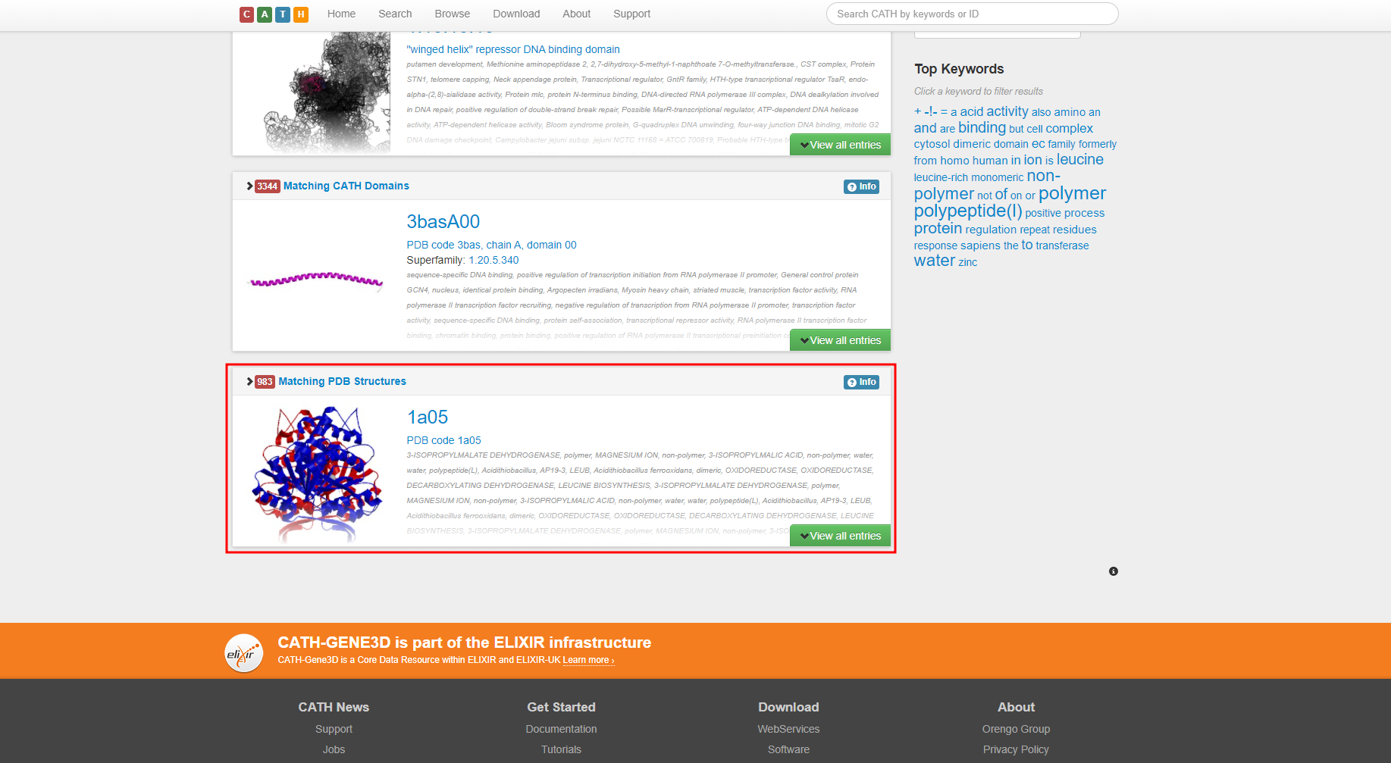**Fig5. Matching PDB structure for leucine**

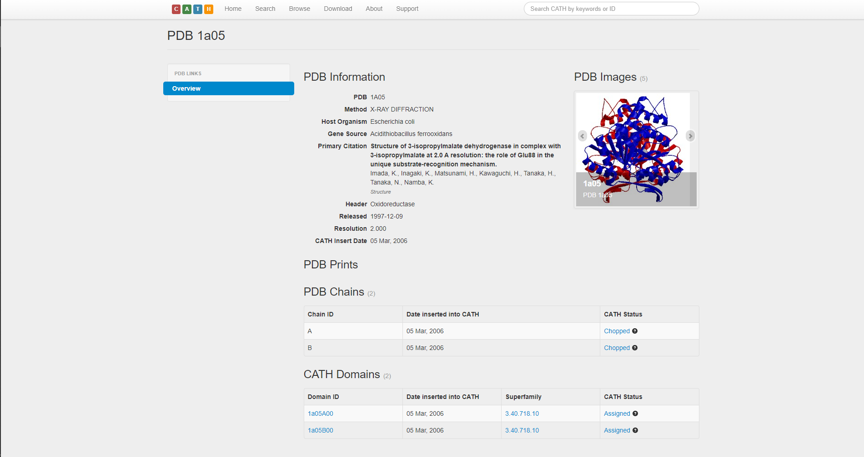**Fig5.1. Overview of matching PDB structures for leucine**

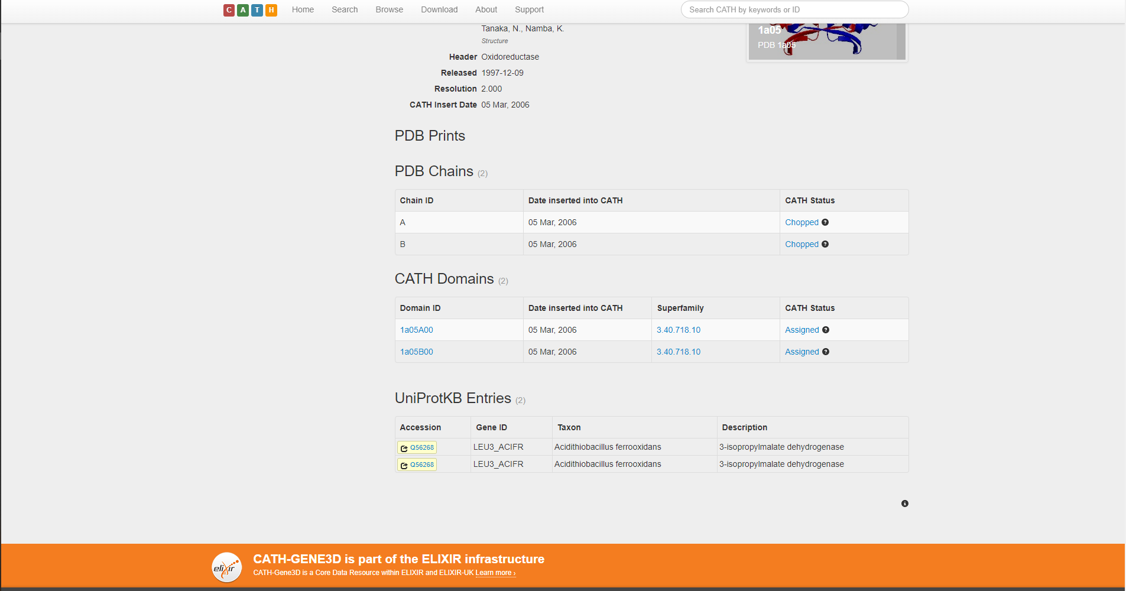

**Fig5.2. Prints, Chains, CATH domains and UniProtKB entries for matching PDB structure for leucine**

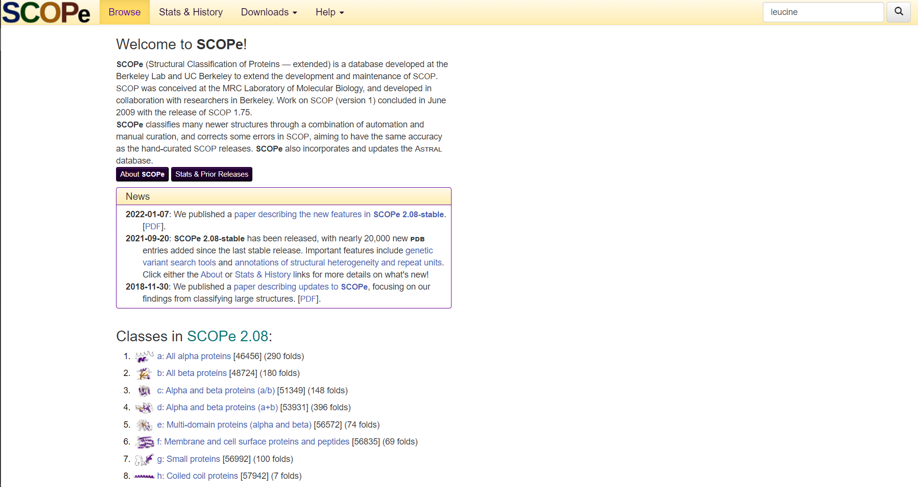**Fig6. Homepage of SCOPe Database with query leucine**

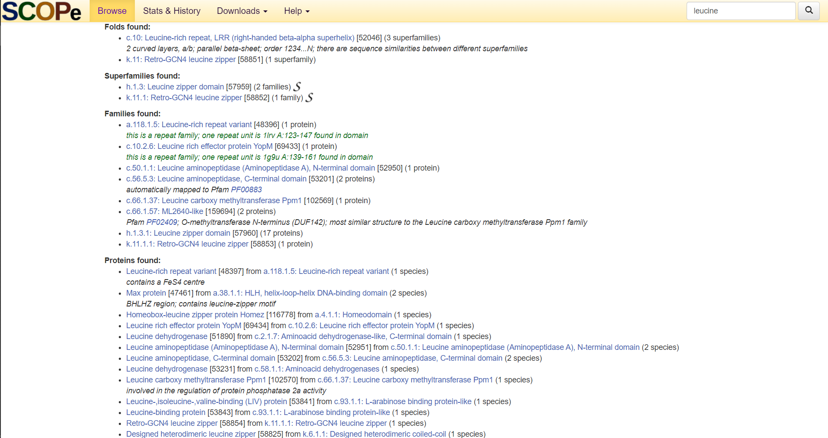**Fig7. Result page of SCOPe for query leucine**

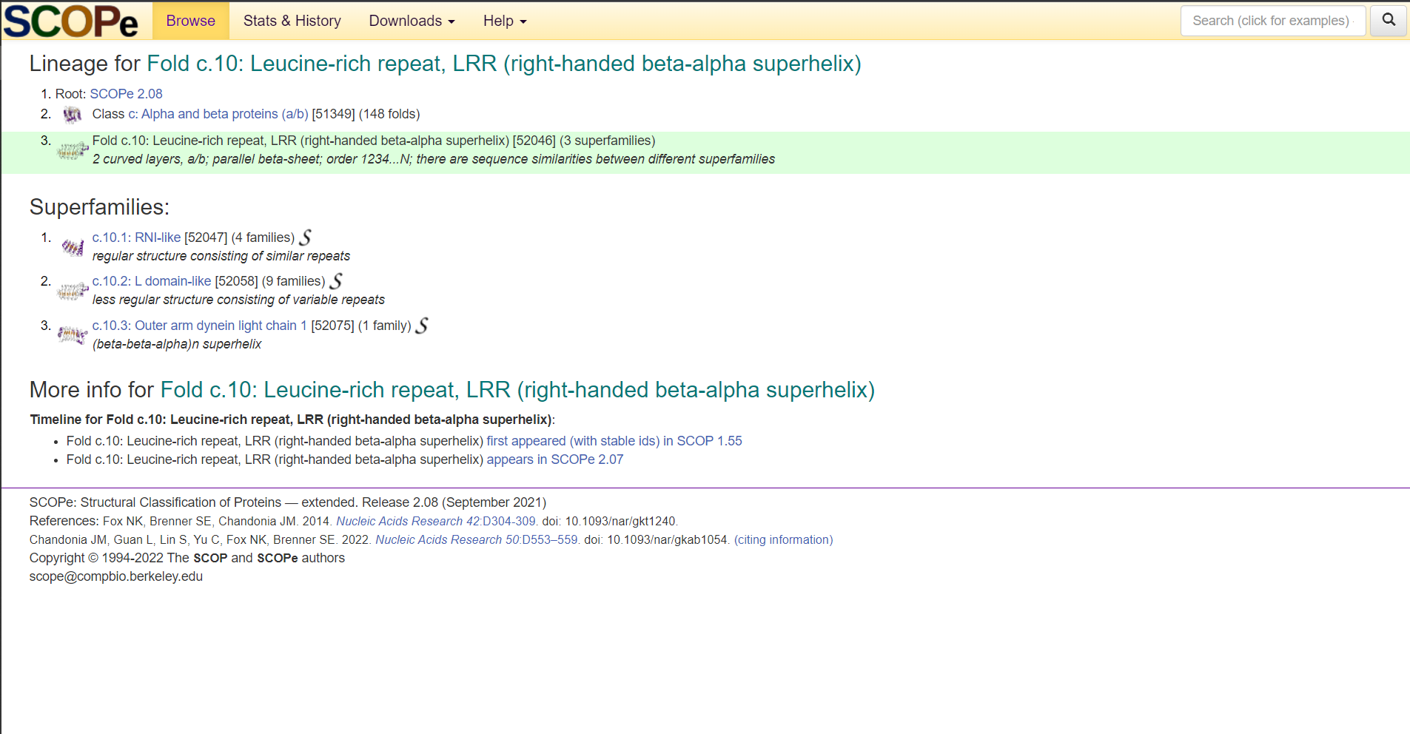**Fig8. Random result from “Folds found” of SCOPe database for leucine**

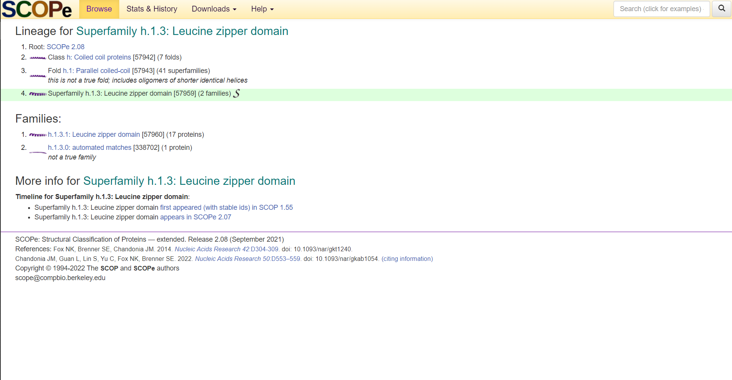**Fig8. Random result from “Superfamilies” of SCOPe database for leucine**

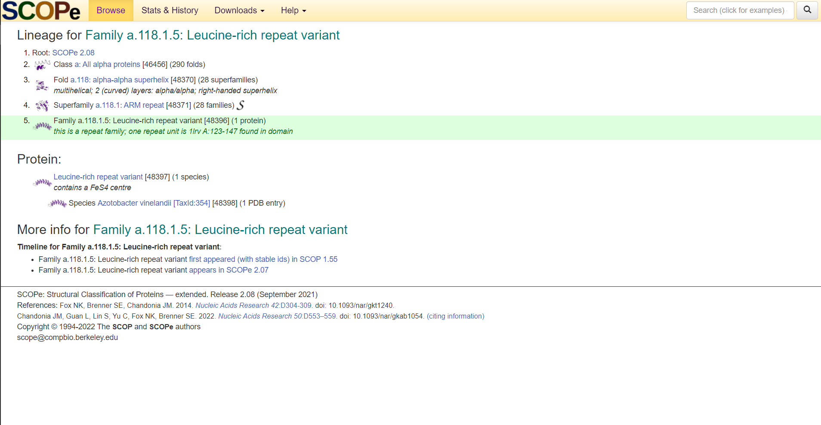**Fig9. Random result from “Families” of SCOPe database for leucine**

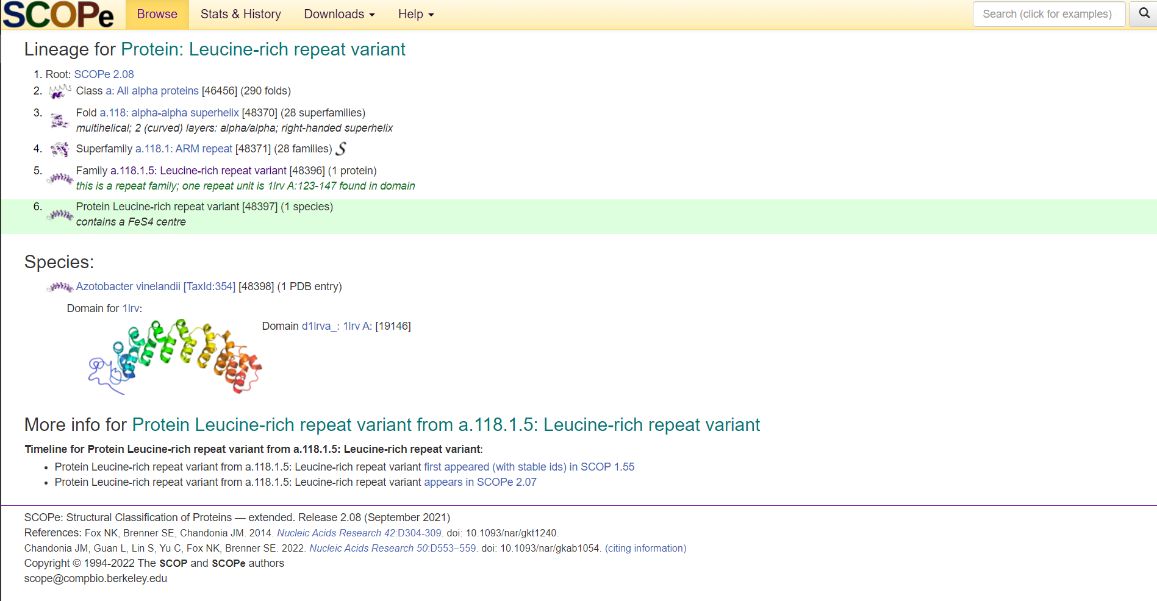 **Fig10. Random result from “Proteins found” of SCOPe database for leucine**

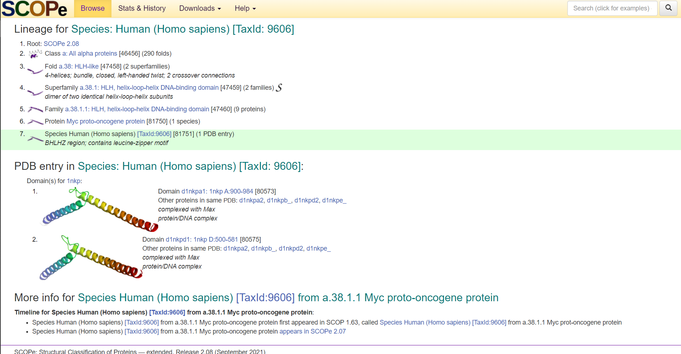 **Fig11. Random result from “Species found” of SCOPe database for leucine**

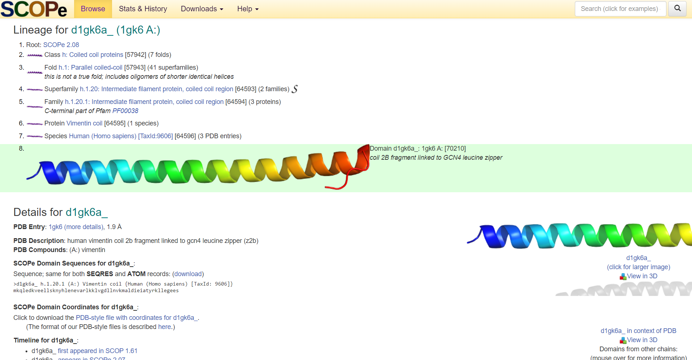 **Fig11. Random result from “Domains found” of SCOPe database for leucine**

**Results:**

**CATH:**

* In protein classification using CATH database for query leucine. It shows,
  + 71 matching CATH superfamilies.
  + 3344 matching CATH Domains
  + 983 matching PDB structures
* For CATH superfamilies we saw the Winged helix-like DNA-binding domain superfamily.
* For CATH Domains we saw CATH Domain 3basA00
* For PDB structures we saw PDB 1A05 from Escherichia Coli

**SCOPe:**

* In SCOPe database the result was divided into 6 sections:
  + Folds found [Fold c.10: Leucine-rich repeat, LRR (right-handed beta-alpha superhelix)]
  + Superfamilies found [Superfamily h.1.3: Leucine zipper domain]
  + Family found [Family a.118.1.5: Leucine-rich repeat variant]
  + Protein Found [Protein: Leucine-rich repeat variant]
  + Species found [Species: Human (Homo sapiens) [TaxId: 9606]]
  + Domains found [d1gk6a_ (1gk6 A:)]

**Conclusions:**

* The CATH database is valuable for biologists and bioinformaticians alike.
* For biologists with very specific tasks, browsing for individual domains is made easy by the user-friendly web interface.
* For bioinformaticians with a focus on large-scale analyses can find complete datasets available for downloading.
* Thus, working with CATH is remarkably uncomplicated.
* Updates are frequent, and, given the significant upcoming extension with horizontal layers complementary to the hierarchical structure, CATH is likely to become an even more valuable resource in the future.
* Since it was created, the development of SCOPe has been always guided by its user’s feedback and needs.
* The automation in crystallography and advances in cryo-electron microscopy open a new era in structural biology and with it come new demands for data suitable for modelling of large proteins and protein complexes.
* In addition to a range of new annotations, SCOPe has introduced new functionalities that support relatively easy retrieval and assembly of independently determined, structurally characterized parts of proteins of interest.
* They will continue updating the database and providing regular releases while working on steadily increasing the coverage of structural data and adding new functionalities to the web interface.

**References:**

1. *Leucine*. Leucine - Health Encyclopedia - University of Rochester Medical Center. (n.d.). Retrieved February 27, 2022, from https://www.urmc.rochester.edu/encyclopedia/content.aspx?contenttypeid=19&contentid=Leucine#:~:text=Leucine%20is%20one%20of%20the,enough%20of%20these%20amino%20acids.
2. Berman, H. M. (2000). The Protein Data Bank. *Nucleic Acids Research*, *28*(1), 235–242. https://doi.org/10.1093/nar/28.1.235
3. Murzin, A. G. (1995). *Journal of Molecular Biology*, *247*(4), 536–540. https://doi.org/10.1006/jmbi.1995.0159
4. CATH Database. (2022b, February 21). CATH Database. Retrieved February 21, 2022, from <https://www.cathdb.info/>
5. *Search cath*. CATH Search: Browse. (n.d.). Retrieved February 26, 2022, from <http://www.cathdb.info/search?q=Leucine>
6. Cath superfamily 1.10.10.10. (n.d.). Retrieved February 26, 2022, from http://www.cathdb.info/version/latest/superfamily/1.10.10.10
7. Cath superfamily 1.10.10.10. (n.d.). Retrieved February 26, 2022, from http://www.cathdb.info/version/latest/superfamily/1.10.10.10/superposition
8. Cath superfamily 1.10.10.10. (n.d.). Retrieved February 26, 2022, from http://www.cathdb.info/version/latest/superfamily/1.10.10.10/classification
9. Browse cath-gene3d hierarchy. (n.d.). Retrieved February 26, 2022, from http://www.cathdb.info/browse/sunburst?from_cath_id=1
10. *Cath superfamily 1.10.10.10 - cathdb.info*. (n.d.). Retrieved February 26, 2022, from https://www.cathdb.info/version/latest/superfamily/1.10.10.10/alignments
11. Cath superfamily 1.10.10.10. (n.d.). Retrieved February 26, 2022, from http://www.cathdb.info/version/latest/superfamily/1.10.10.10/structure
12. *Cath domain 3basA00*. CATH. (n.d.). Retrieved February 26, 2022, from http://www.cathdb.info/version/latest/domain/3basA00
13. *Cath domain 3basA00*. CATH. (n.d.). Retrieved February 26, 2022, from http://www.cathdb.info/version/latest/domain/3basA00/structure
14. *Cath domain 3basA00*. CATH. (n.d.). Retrieved February 26, 2022, from http://www.cathdb.info/version/latest/domain/3basA00/neighbourhood
15. *Cath domain 3basA00*. CATH. (n.d.). Retrieved February 26, 2022, from http://www.cathdb.info/version/latest/domain/3basA00/sequence
16. PDB 1A05. (n.d.). Retrieved February 26, 2022, from http://www.cathdb.info/pdb/1a05
17. *Scop.berkeley.edu*. (n.d.). Retrieved February 26, 2022, from https://scop.berkeley.edu/search/?ver=2.08&key=leucine
18. *Scope 2.08: Domain d1gk6a_: 1GK6 A:* SCOPe. (n.d.). Retrieved February 26, 2022, from https://scop.berkeley.edu/sunid=70210
19. *Scope 2.08: Family A.118.1.5: Leucine-rich repeat variant*. SCOPe. (n.d.). Retrieved February 26, 2022, from https://scop.berkeley.edu/sunid=48396
20. *Scope 2.08: Fold c.10: Leucine-rich repeat, LRR (right-handed beta-alpha superhelix)*. SCOPe. (n.d.). Retrieved February 26, 2022, from https://scop.berkeley.edu/sunid=52046
21. *Scope 2.08: Protein: Leucine-rich repeat variant*. SCOPe. (n.d.). Retrieved February 26, 2022, from https://scop.berkeley.edu/sunid=48397
22. *Scope 2.08: Species: Human (homo sapiens) [taxid: 9606]*. SCOPe. (n.d.). Retrieved February 26, 2022, from https://scop.berkeley.edu/sunid=81751
23. *Scope 2.08: Superfamily H.1.3: Leucine zipper domain*. SCOPe. (n.d.). Retrieved February 26, 2022, from https://scop.berkeley.edu/sunid=57959
24. *Structural classification of proteins - extended. release 2.08 (September 2021)*. SCOPe. (n.d.). Retrieved February 26, 2022, from https://scop.berkeley.edu/

**DATE: 20-03-22**

**WEBLEM 3**

**Introduction to tertiary structure prediction**

**Proteins** are involved in many cell activities (e.g., molecular transport, mechanical functions, message exchange) thus **knowing their 3D structure is crucial** in order to understand their function. **Protein tertiary structure prediction** is a research field which aims to **create models and software tools** able to predict the **three-dimensional shape of protein molecules** by describing the spatial disposition of each of its atoms starting from the sequence of its amino acids. There exist exact methods to **resolve the molecular structure with high precision**, but they are both time and resource consuming. **Computational based software techniques** can predict the tertiary structure of a protein with **acceptable precision** for many applications with high efficiency allowing for **genome-wide investigations**, otherwise not feasible.

Having a **computer-generated three-dimensional model** of a protein of interest has many ramifications, assuming it is reasonably correct. It may be of use for the **rational design of biochemical experiments**, such as **site-directed mutagenesis, protein stability, or functional analysis**. In addition to serving as a **theoretical guide to design experiments** for protein characterization, the model can help to **rationalize the experimental results** obtained with the protein of interest. In short, the modelling study helps to advance our **understanding of protein functions**.

**METHODS:**

There are **three computational approaches** to protein three-dimensional structural modelling and prediction. They are **homology modelling, threading,** and **ab initio prediction.**

**HOMOLOGY MODELLING:**

As the name suggests, **homology modelling** predicts protein structures based on **sequence homology** with known structures. It is also known as comparative modelling. The principle behind it is that if two proteins share a **high enough sequence similarity**, they are likely to have very **similar three-dimensional structures**. If one of the protein sequences has a **known structure**, then the structure **can be copied to the unknown protein** with a high degree of confidence. Homology modelling produces an **all-atom model** based on **alignment with template proteins.**

The overall homology modelling procedure consists of six steps.

1. **Template Selection** which involves identification of homologous sequences in the protein structure database to be used as templates for modelling
2. **Alignment** of target and template sequences.
3. **Building a framework structure** for the target protein consisting of main chain atoms.
4. **Refine and optimize** the entire model according to energy criteria.
5. **Evaluation** of the overall quality of the model obtained.

A number of **comprehensive modelling programs** are able to perform the complete procedure of homology modelling in an automated fashion. The **automation requires assembling a pipeline** that includes target **selection, alignment, model generation, and model evaluation.**

**MODELLER:**

**MODELLER** is a computer program for **comparative protein structure modelling**. In the simplest case, the input is an **alignment of a sequence** to be modelled with the **template structures**, the atomic coordinates of the templates, and a simple script file. **MODELLER** then automatically **calculates a model** containing all **non-hydrogen atoms**, within minutes on a modern PC and with no user intervention. Apart from model building, **MODELLER** can perform additional auxiliary tasks, including **fold assignment**, **alignment of two** **protein sequences** or their profiles, **multiple alignment** of protein sequences and/or structures, **calculation of phylogenetic trees**, and **de novo modelling of loops** in protein structures.

**THREADING AND FOLD RECOGNITION:**

There are only **small number of protein folds available** (<1,000), compared to millions of protein sequences. This means that protein structures tend to be **more conserved** than protein sequences. Consequently, many proteins can share a **similar fold** even in the absence of **sequence similarities**. This allowed the development of computational methods to predict protein structures **beyond sequence similarities**. To determine whether a **protein sequence adopts** a known **three-dimensional structure** fold relies on **threading and fold recognition** methods. By definition, threading or structural fold recognition predicts the **structural fold** of an **unknown protein sequence** by fitting the sequence into a **structural database** and selecting the **best-fitting fold**. The comparison emphasizes matching of **secondary structures**, which are most evolutionarily conserved. Therefore, this approach can **identify structurally similar proteins** even without detectable sequence similarity.

The algorithms can be classified into two categories, **pairwise energy based** and **profile based**. The pairwise energy–based method was originally referred to as **threading** and the profile-based method was originally defined as **fold recognition**. However, the two terms are now often used **interchangeably without distinction** in the literature. A number of threading and fold recognition programs are available using **either or both prediction strategies.**

**I-TASSER:**

**I-TASSER** server is an on-line platform that implements the **I-TASSER based algorithms** for protein structure and function predictions. It allows academic users to **automatically generate high-quality model predictions** of 3D structure and **biological function** of protein molecules from their amino acid sequences**.** When user submits an amino acid sequence, the server **first** **tries to retrieve template proteins of similar folds** (or super-secondary structures) from the PDB library by LOMETS, a locally installed meta-threading approach.

In the **second step**, the continuous fragments excised from the PDB templates are reassembled into full-length models by **replica-exchange Monte Carlo simulations** with the threading unaligned regions (mainly loops) built by **ab initio modelling**. In cases where no appropriate template is identified by **LOMETS, I-TASSER** will build the whole structures by ab initio modelling. The low free-energy states are identified by **SPICKER** through clustering the simulation decoys.

In the **third step**, the fragment assembly simulation is performed again starting from the **SPICKER** **cluster** **centroids**, where the spatial restrains collected from **both** the **LOMETS** templates and the **PDB** structures by TM-align are used to **guide the simulations**. The purpose of the **second iteration** is to **remove the steric clash** as well as to **refine the global topology** of the cluster centroids. The decoys generated in the second simulations are then clustered and the lowest energy structures are selected. The **final full-atomic models** are obtained by **REMO** which builds the atomic details from the selected I-TASSER decoys through the optimization of the **hydrogen-bonding network.**

For **predicting the biological function** of the protein, the I-TASSER server matches the **predicted 3D models** to the **proteins in 3 independent libraries** which consist of proteins of known **enzyme classification** **(EC) number**, **gene ontology (GO) vocabulary**, and **ligand-binding sites.** The final results of function predictions are deduced from the consensus of **top structural matches** with the function scores calculated based on the confidence score of the I-TASSER structural models, the **structural similarity** between model and templates as **evaluated by TM-score**, and the sequence identity in the structurally aligned regions.

1. **What is C-score?**

**C-score** is a **confidence score** for estimating the quality of predicted models by I-TASSER. It is calculated based on the **significance of threading template alignments** and the **convergence parameters** of the structure assembly simulations. C-score is typically in the **range of [-5,2],** where a C-score of **higher value** signifies a model with a **high confidence** and vice-versa.

1. **What is TM-score?**

**TM-score** is a recently proposed scale for measuring the **structural similarity between two structures**. The purpose of proposing TM-score is to **solve** the problem of **RMSD** which is sensitive to the local error. Because RMSD is an **average distance** of all residue pairs in **two structures**, a **local** error (e.g., a misorientation of the tail) will arise a **big RMSD value** although the global topology is correct. In TM-score, however, the **small distance** is **weighted stronger** than the **big distance** which makes the score **insensitive to the local modelling error**. A **TM-score >0.5** indicates a model of correct topology and a TM-score<0.17 means a random similarity. These cut-off does not depend on the protein length.

1. **What is difference and relationship between C-score and TM-score?**

**TM-score** (or RMSD) is a known **standard** for measuring **structural similarity** between two structures which are usually used to measure the **accuracy of structure modelling** when the native structure is known, while **C-score** is a metric that I-TASSER developed to **estimate the confidence of the modelling**. In case where the native structure is not known, it becomes necessary to predict the quality of the modelling prediction, i.e., what is the distance between the predicted model and the native structures? To answer this question, we tried **predicting** the **TM-score** and **RMSD** of the predicted models relative the native structures based on the **C-score**.

In a benchmark test set of 500 non-homologous proteins, we found that C-score is highly correlated with TM-score and RMSD. Correlation coefficient of C-score of the first model with TM-score to the native structure is 0.91, while the coefficient of C-score with RMSD to the native structure is 0.75. These data lay the base for the reliable prediction of the TM-score and RMSD using C-score. In the output section, I-TASSER only reports the quality prediction (TM-score and RMSD) for the first model, because it was found that the correlation between C-score and TM-score is weak for lower rank models. However, the C-score is listed for all models just for a reference.

**AB INITIO PROTEIN STRUCTURAL PREDICTION**

The limited knowledge of protein folding forms the basis of ab initio prediction. As the name suggests, the ab initio prediction method attempts to produce all-atom protein models based on sequence information alone without the aid of known protein structures. The perceived advantage of this method is that predictions are not restricted by known folds and that novel protein folds can be identified. However, because the physicochemical laws governing protein folding are not yet well understood, the energy functions used in the ab initio prediction are at present rather inaccurate. The folding problem remains one of the greatest challenges in bioinformatics today.

Current ab initio algorithms are not yet able to accurately simulate the protein folding process. They work by using some type of heuristics. Because the native state of a protein structure is near energy minimum, the prediction programs are thus designed using the energy minimization principle. These algorithms search for every possible conformation to find the one with the lowest global energy. However, searching for a fold with the absolute minimum energy may not be valid in reality. This contributes to one of the fundamental flaws of this approach. In addition, searching for all possible structural conformations is not yet computationally feasible. It has been estimated that, by using one of the world’s fastest supercomputers (one trillion operations per second), it takes 10 20 years to sample all possible conformations of a 40-residue protein. Therefore, some type of heuristics must be used to reduce the conformational space to be searched. Some recent ab initio methods combine fragment search and threading to yield a model of an unknown protein. The following web program is such an example using the hybrid approach.

**ROBETTA:**

The ROBETTA server provides automated tools for protein structure prediction and analysis. For structure prediction, sequences submitted to the server are parsed into putative domains and structural models are generated using either comparative modelling order novo structure prediction methods. If a confident match to a protein of known structure is found using BLAST, PSI-BLAST, FFAS03 or 3D-Jury, it is used as a template for comparative modelling. If no match is found, structure predictions are made using the de novo Rosetta fragment insertion method. Experimental nuclear magnetic resonance (NMR) constraints data can also be submitted with a query sequence for RosettaNMR de novo structure determination. Other current capabilities include the prediction of the effects of mutations on protein–protein interactions using computational interface alanine scanning. The Rosetta protein design and protein–protein docking methodologies will soon be available through the server as well.

**INPUT AND OUTPUT:**

Registration:

Users must register (http://robetta.bakerlab.org/register.jsp) before submitting jobs to Robetta.

Structure prediction server:

Sequences submitted to the structure prediction server must be in one-letter amino acid format. They can either be pasted into the submission form, or uploaded from a file. Users have the option to submit a sequence for either domain identification or full structure prediction. A user also has the option to specify the PDB id and chain for comparative modeling. For RosettaNMR submissions, a user must upload experimental NMR constraints data (chemical shifts, NOE data and/ or residual dipolar couplings). The required input format for each type of data is described at http://robetta.bakerlab.org/ documents/data_formats.jsp.

Results for a specific job are provided through the web interface by clicking on the job id listed in the queue table (http://robetta.bakerlab.org/queue.jsp). For full structure predictions, coordinates are also emailed to the user. For added insight, the following results are displayed along with the predicted models:

1. The prediction of transmembrane helices using TMHMM.
2. Low-complexity regions assigned by the program SEG
3. Coiled-coils prediction using COILS
4. The prediction of disordered regions using DISOPRED
5. Secondary structure predictions using PSIPRED, SAM-T99, Jufo and Jufo3D
6. The results listed above, domain predictions and the NR PSI-BLAST multiple sequence alignment used
7. For the last step in the domain prediction protocol condensed into an image to help corroborate the domain prediction results
8. Domain repeats prediction using REPRO predicted boundaries are given if repeats are detected
9. The top NR PSI-BLAST results and annotations for the top 20 species determined by lowest E-values.

The models for the full query are displayed as images at the bottom of the page. The coordinates for these models can be downloaded from the web site by clicking on the icons represented below each model image. Specific results are also provided for each domain by clicking on the domain number listed in the Ginzu domain prediction results table. For comparative models, the KSync alignment used for modelling is displayed. For de novo models, the Mammoth structure-model comparison results are displayed for the top 10 matches with Z-scores >4.5. The actual Mammoth structure-model alignment can be downloaded by clicking on the Z-score and viewed for further inspection using a molecular viewer such as RasMol. Users can download domain models by clicking on the icons below each domain model image.

Thus, modeller, I-TASSER and Robetta can be used to predict tertiary structures of proteins. These tools give faster results than x-ray or NMR techniques and can be used by researchers to understand protein functions.

**REFERENCES:**

1. Xiong, J. (2008).Tertiary structure prediction. Essential bioinformatics. Cambridge: Cambridge University Press. 214-228.
2. Tradigo, Giuseppe (2018). Reference Module in Life Sciences || Algorithms for Structure Comparison and Analysis: Prediction of Tertiary Structures of Proteins. , (), –. doi:10.1016/B978-0-12-809633- 8.20483-4
3. Bateman, Alex; Pearson, William R.; Stein, Lincoln D.; Stormo, Gary D.; Yates, John R. (2002). Current Protocols in Bioinformatics || Comparative Protein Structure Modeling Using MODELLER. , (), 5.6.1–5.6.37. doi:10.1002/cpbi.3
4. Tutorial. (n.d.). Salilab.org. Retrieved March 8, 2022, from <https://salilab.org/modeller/tutorial/basic.html>
5. I-TASSER server for protein structure and function prediction. (n.d.). Zhanggroup.org. Retrieved March 8, 2022, from <https://zhanggroup.org/I-TASSER/about.html>
6. Kim, D. E.; Chivian, D.; Baker, D. (2004). Protein structure prediction and analysis using the Robetta server. , 32(0), 0–0. doi:10.1093/nar/gkh468

**DATE: 20-03-22**

**WEBLEM 3a**

**MODELLER**

**(**[**URL:https://salilab.org/modeller/**](URL:https://salilab.org/modeller/)**)**

**AIM:**

To perform tertiary structure prediction by comparative Modelling/Homology Modelling method using Modeller for query Rhodopsin

**INTRODUCTION:**

Rhodopsin, also called visual purple, pigment-containing sensory protein that converts light into an electrical signal. Rhodopsin is found in a wide range of organisms, from vertebrates to bacteria. In many seeing animals, including humans, it is required for vision in dim light and is located in the retina of the eye—specifically, within the tightly packed disks that make up the outer segment of the retina’s photoreceptive rod cells, which are specially adapted for vision under low-light conditions.

**MODELLER** is a computer program for **comparative protein structure modelling**. In the simplest case, the input is an **alignment of a sequence** to be modelled with the **template structures**, the atomic coordinates of the templates, and a simple script file. **MODELLER** then automatically **calculates a model** containing all **non-hydrogen atoms**, within minutes on a modern PC and with no user intervention. Apart from model building, **MODELLER** can perform additional auxiliary tasks, including **fold assignment**, **alignment of two** **protein sequences** or their profiles, **multiple alignment** of protein sequences and/or structures, **calculation of phylogenetic trees**, and **de novo modelling of loops** in protein structures.

**METHODOLOGY:**

1. Install modeller. (URL: <https://salilab.prg/modeller>)
2. Retrieve FASTA sequence for enzyme rhodopsin
3. Follow the steps given in the tutorial section.
4. Run scripts for searching for structures related to query, selecting template target-template alignment and model building/
5. Observe and interpret the results.

**OBSERVATION:**

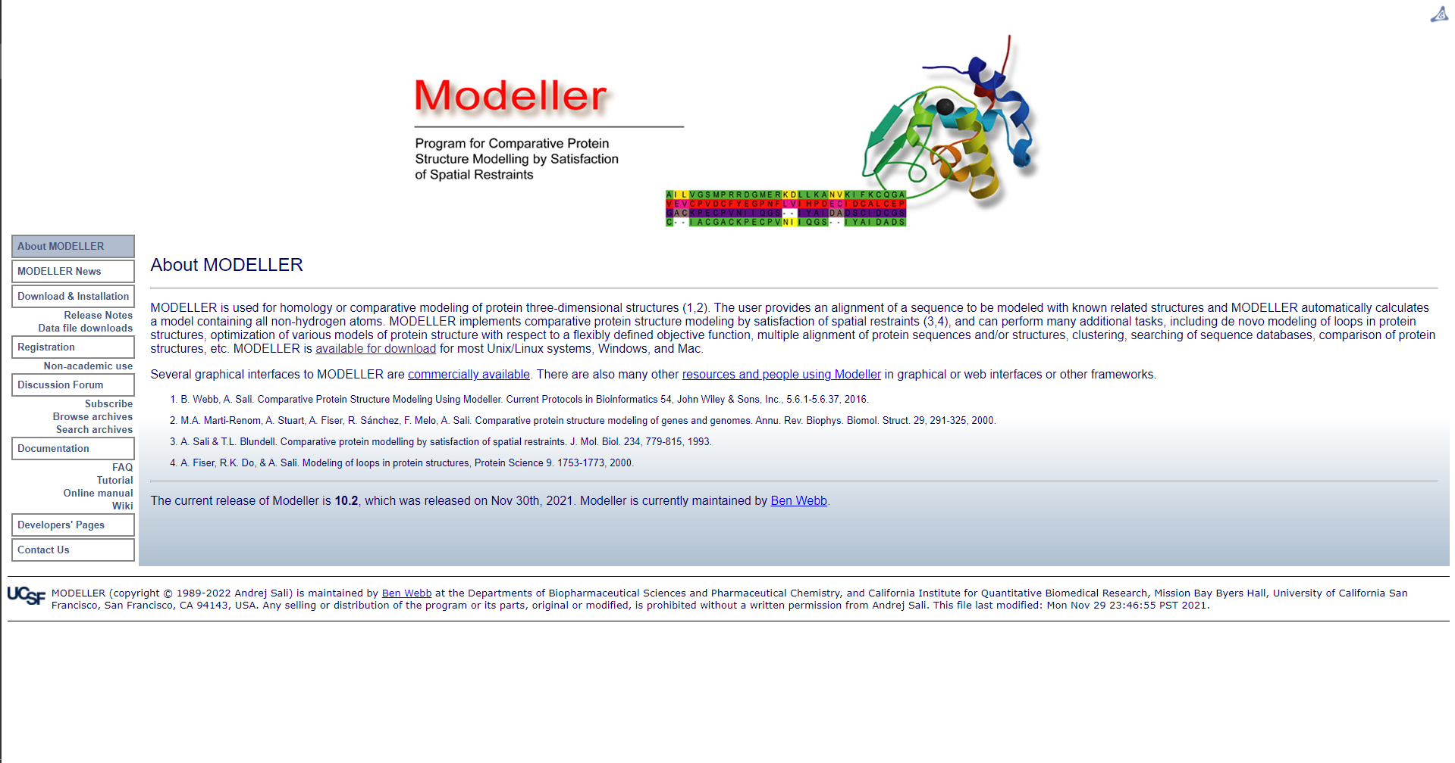**Fig1. Homepage for Modeller**

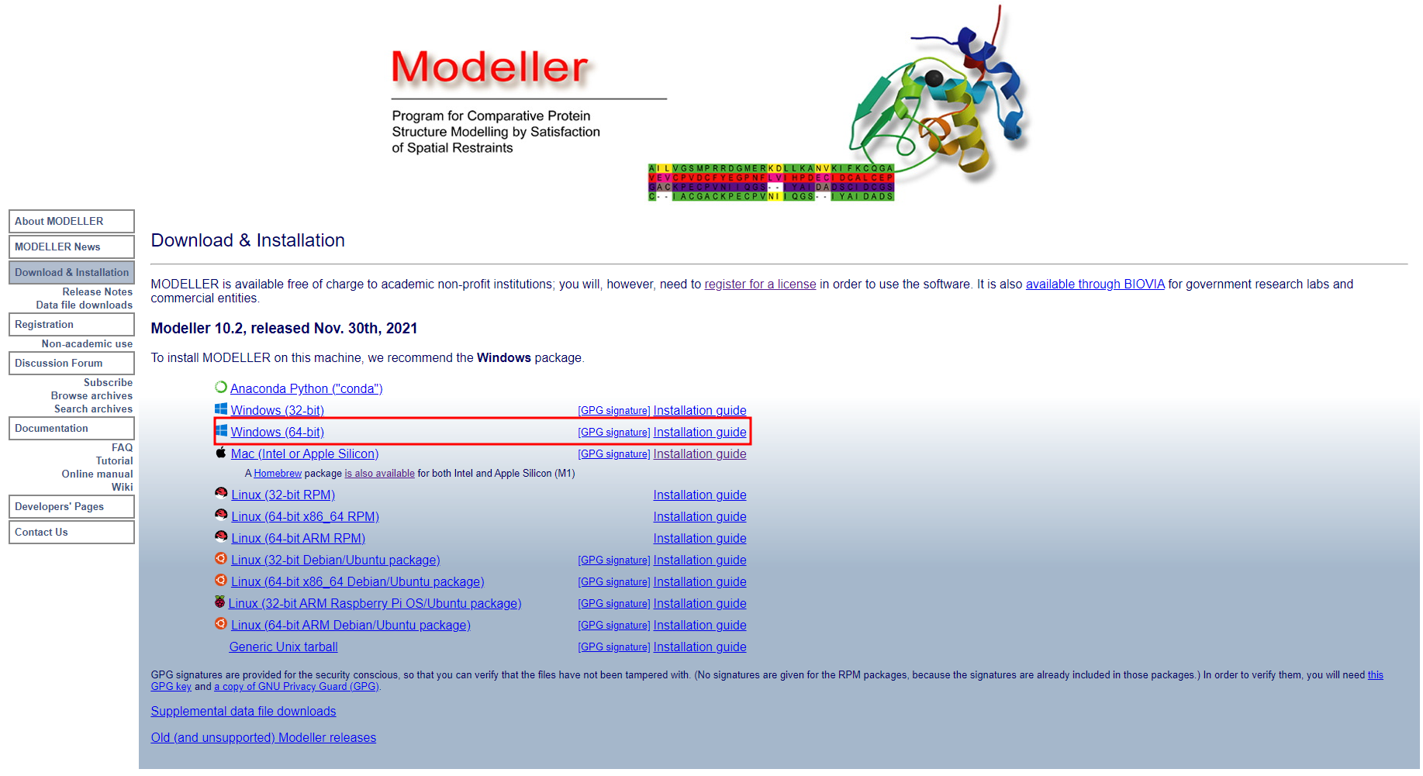**Fig2. Page to install Modeller**

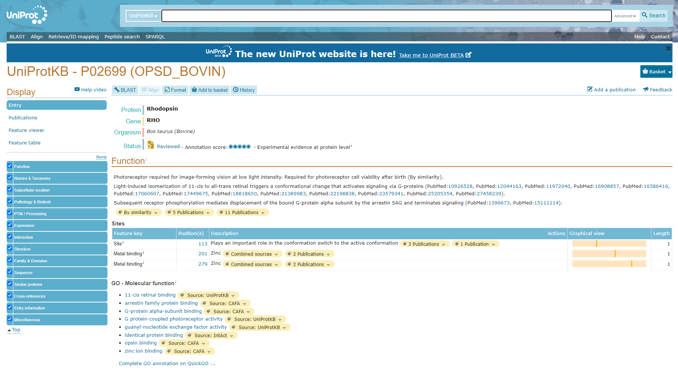**Fig3. Result page for Rhodopsin in UniProt database**

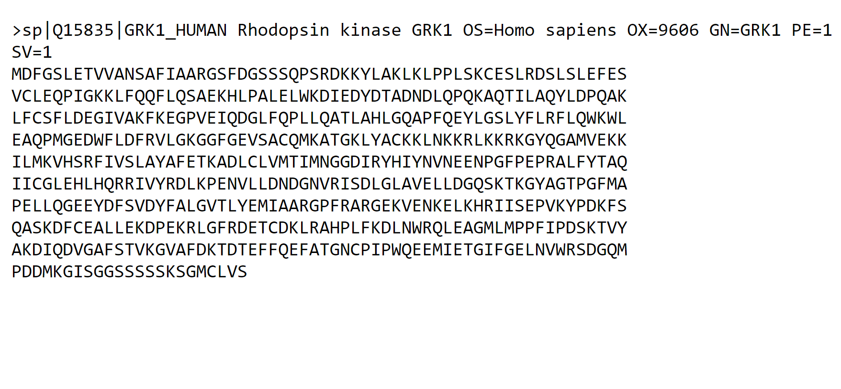**Fig4. FASTA sequence for Rhodopsin**

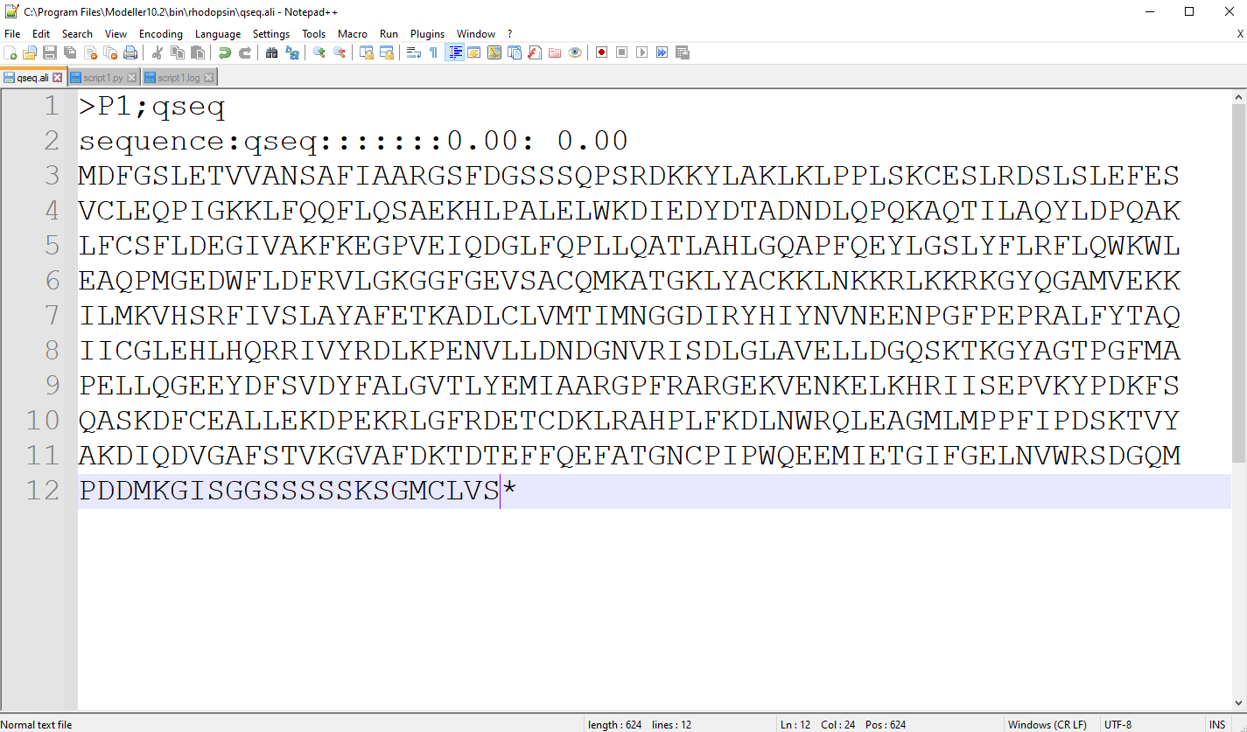**Fig5. FASTA sequence in PIR format**

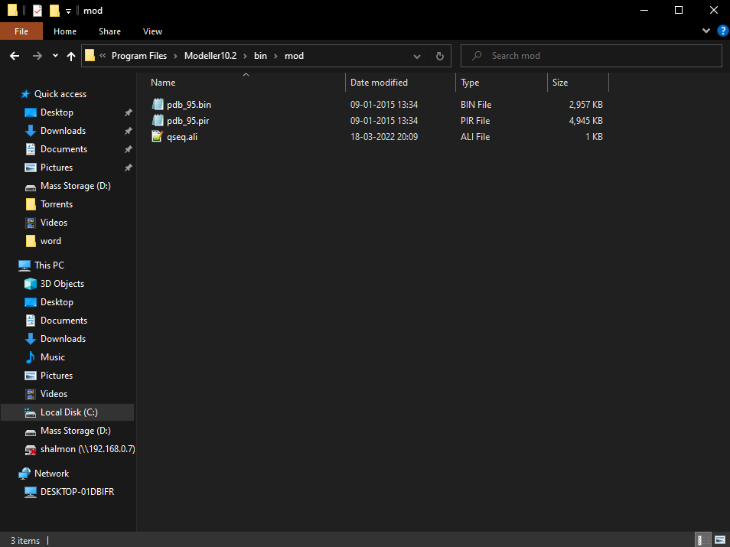**Fig6. Target sequence saved in .ali format**

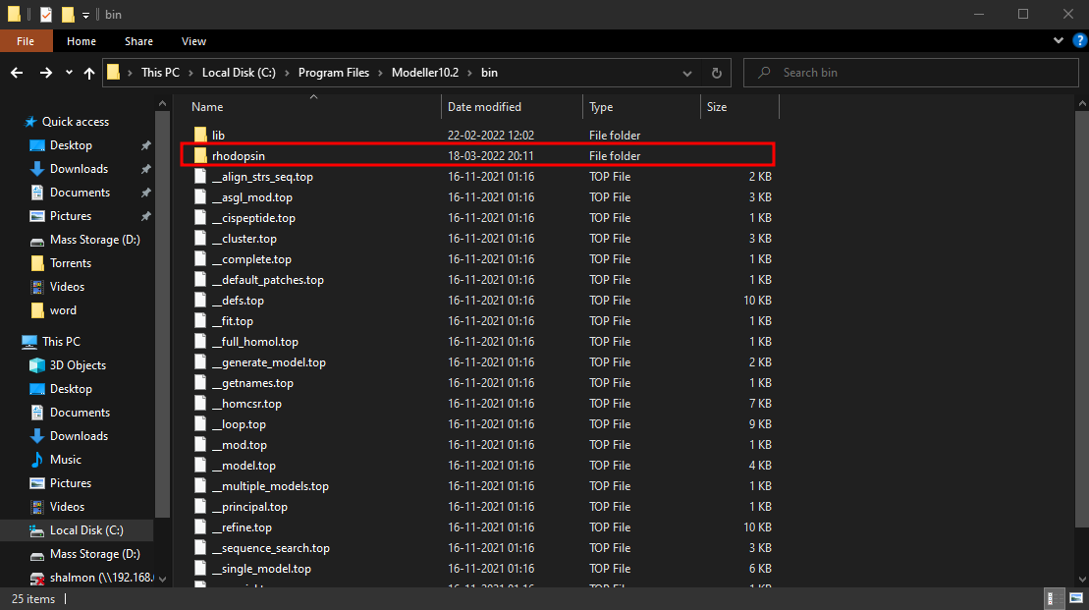**Fig7. Rhodopsin folder saved in the bin folder of modeller**

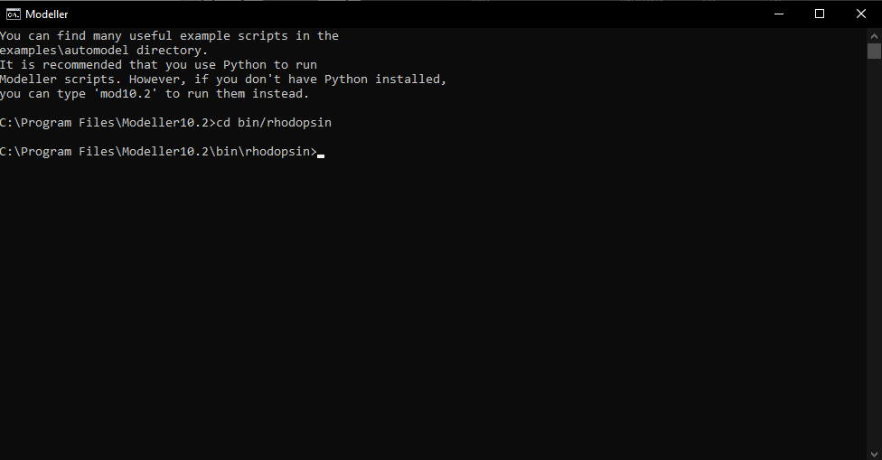**Fig8. Setting Working directory in Modeller command line**

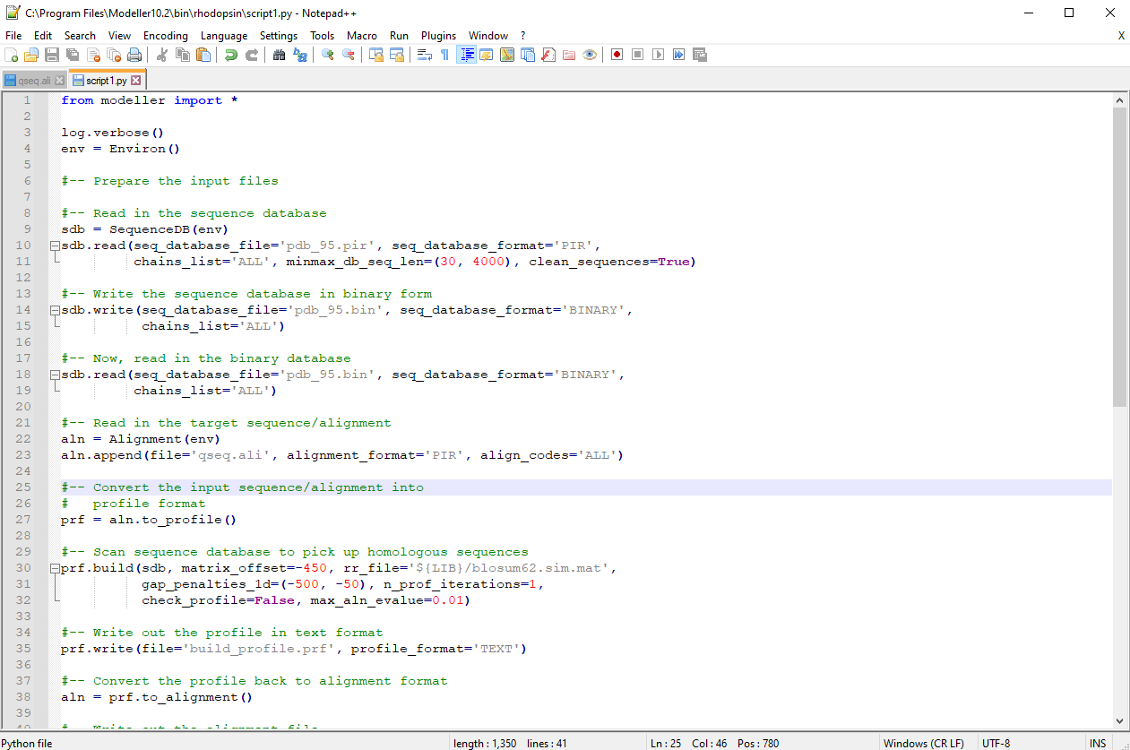**Fig9. Python script for searching for structures relation to rhodopsin**

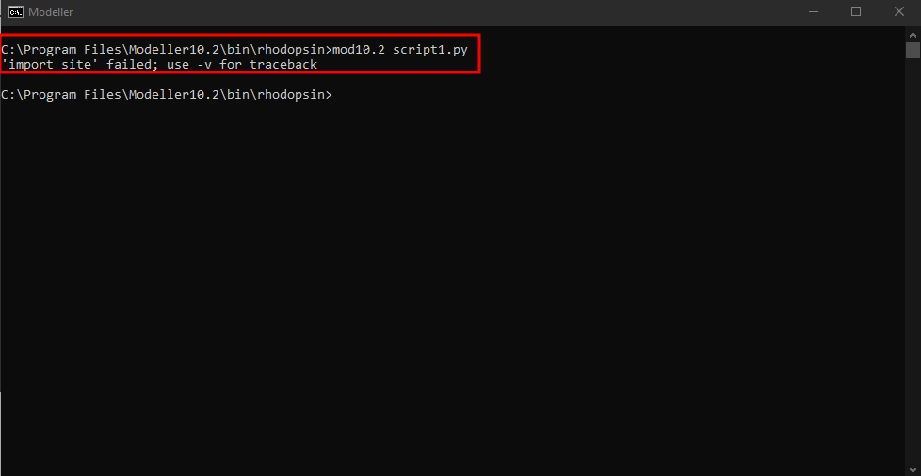**Fig10. Running script1.py**

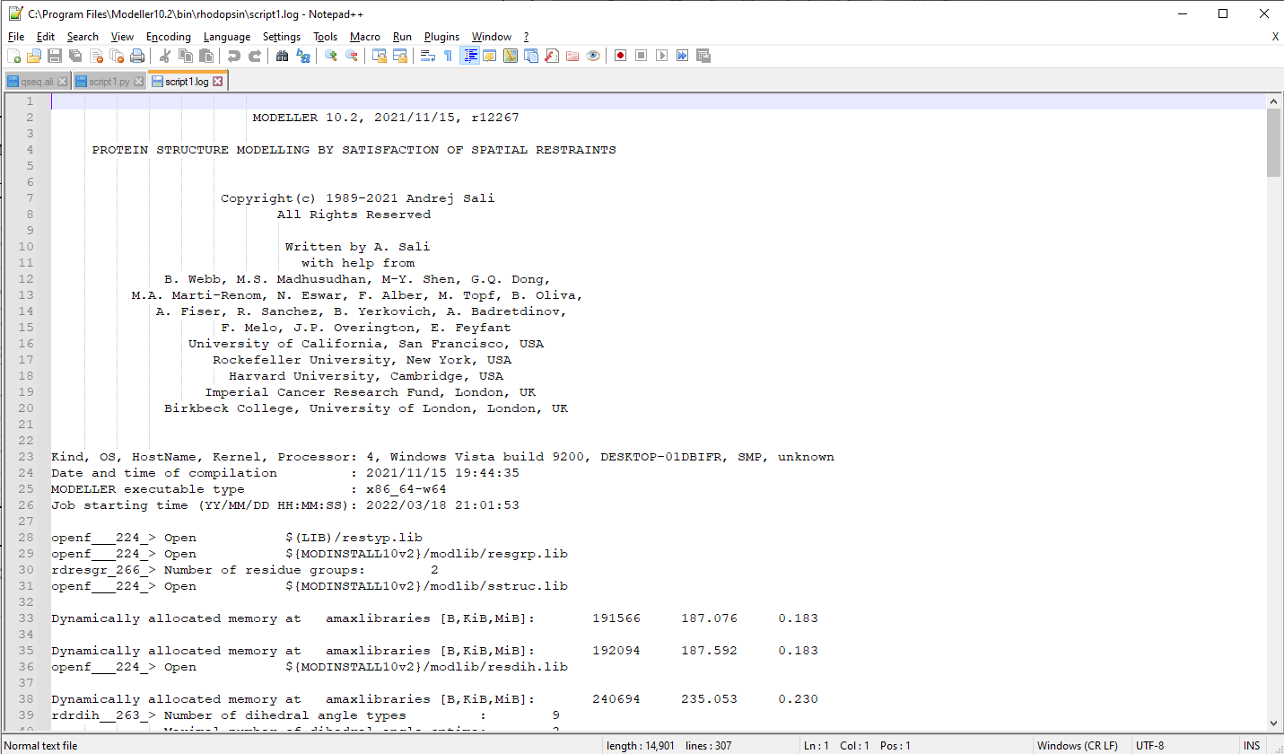**Fig11. Log file for script1.py**

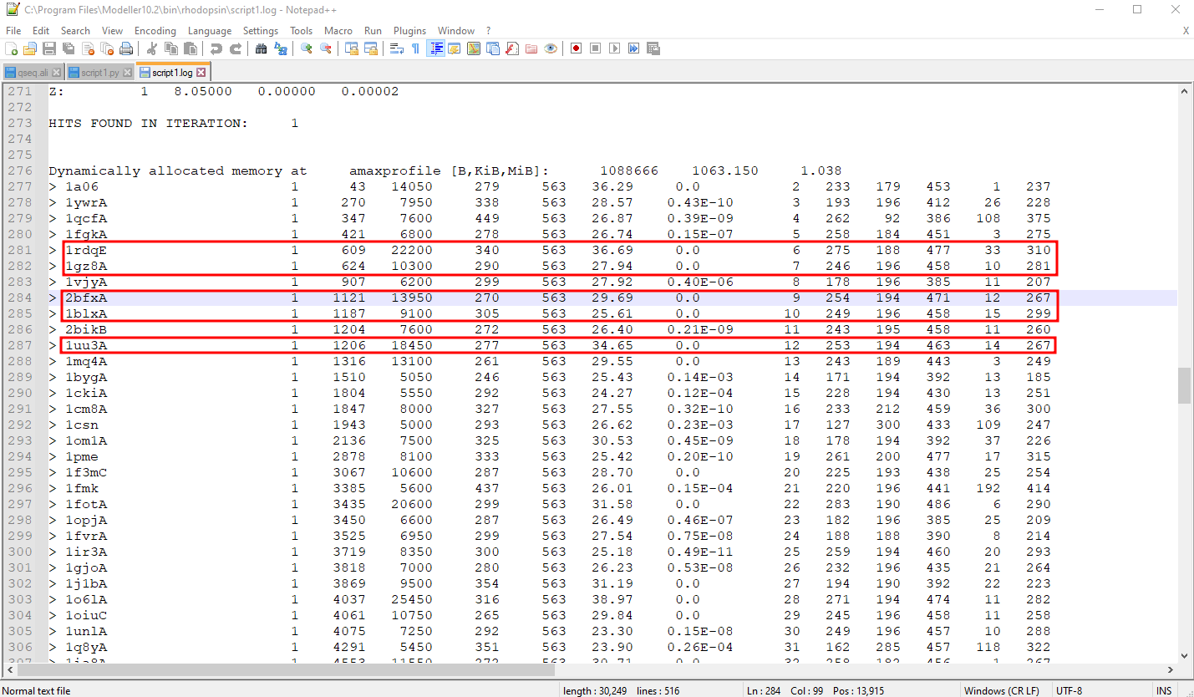**Fig11.1. Hits found for similar structures**

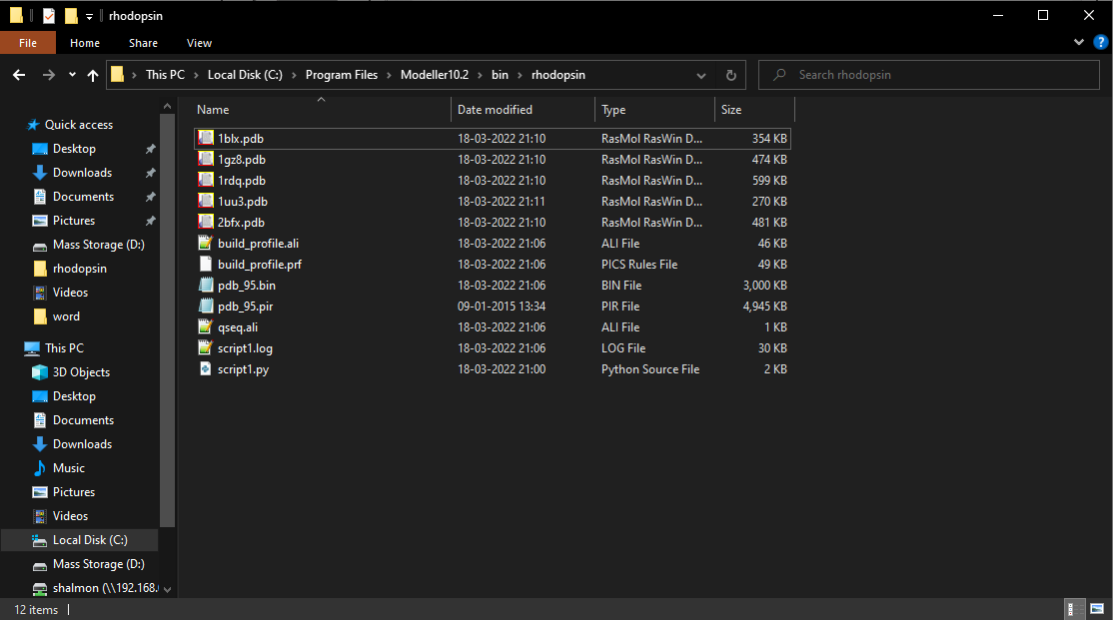**Fig12. Five structure download in PDB format**

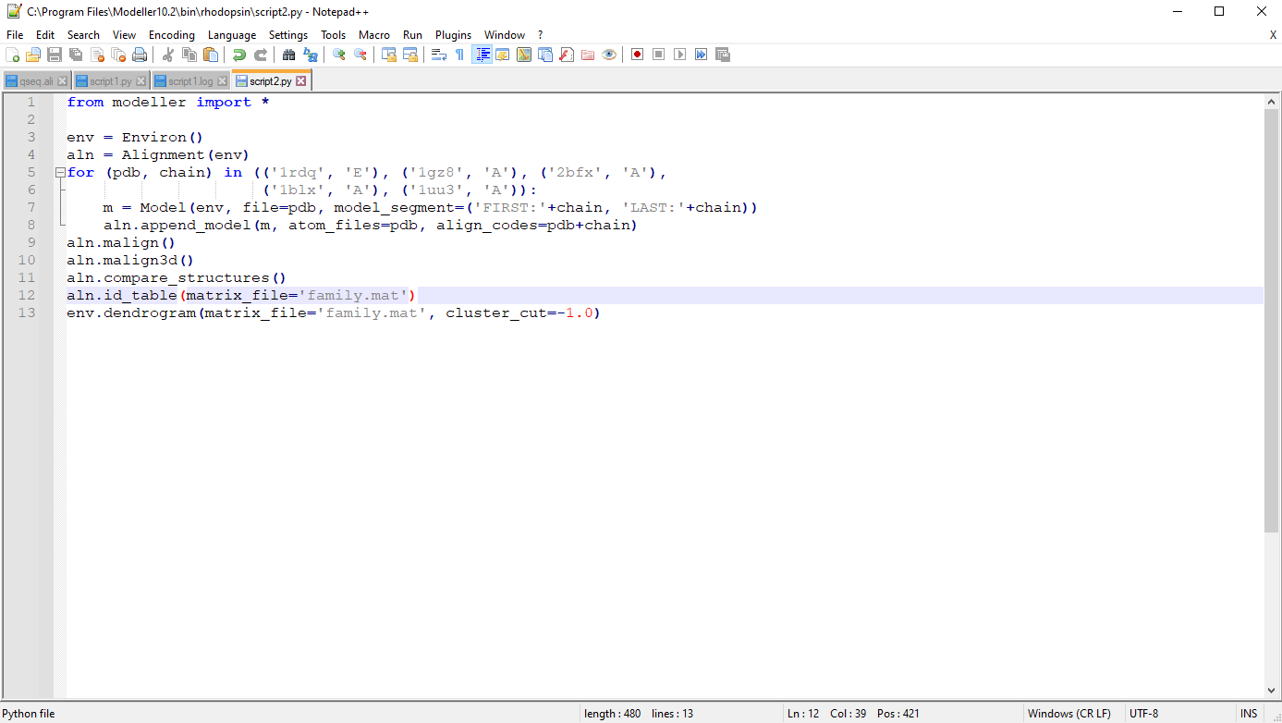**Fig13. Python script for selecting a template**

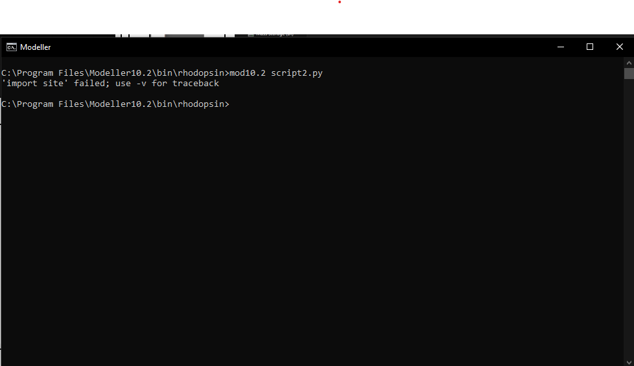**Fig14. Running script2.py**

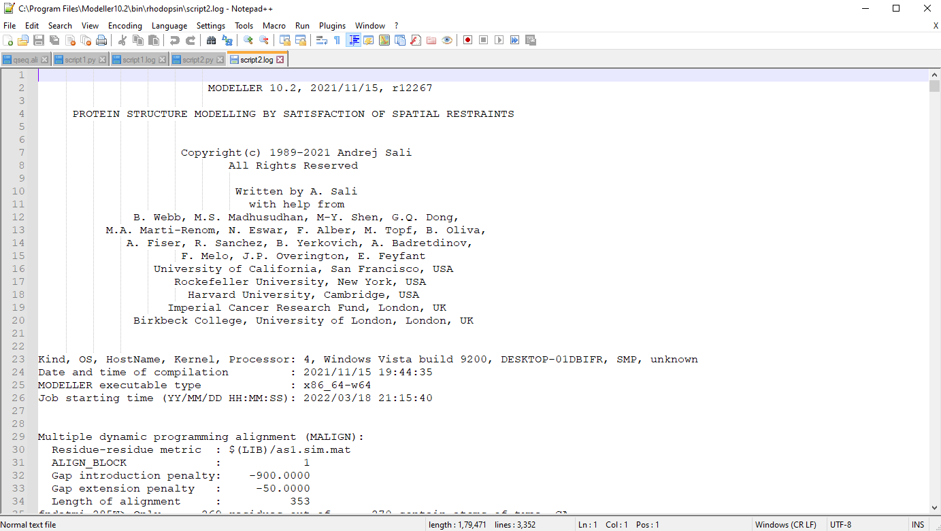**Fig15. Log file for script2**

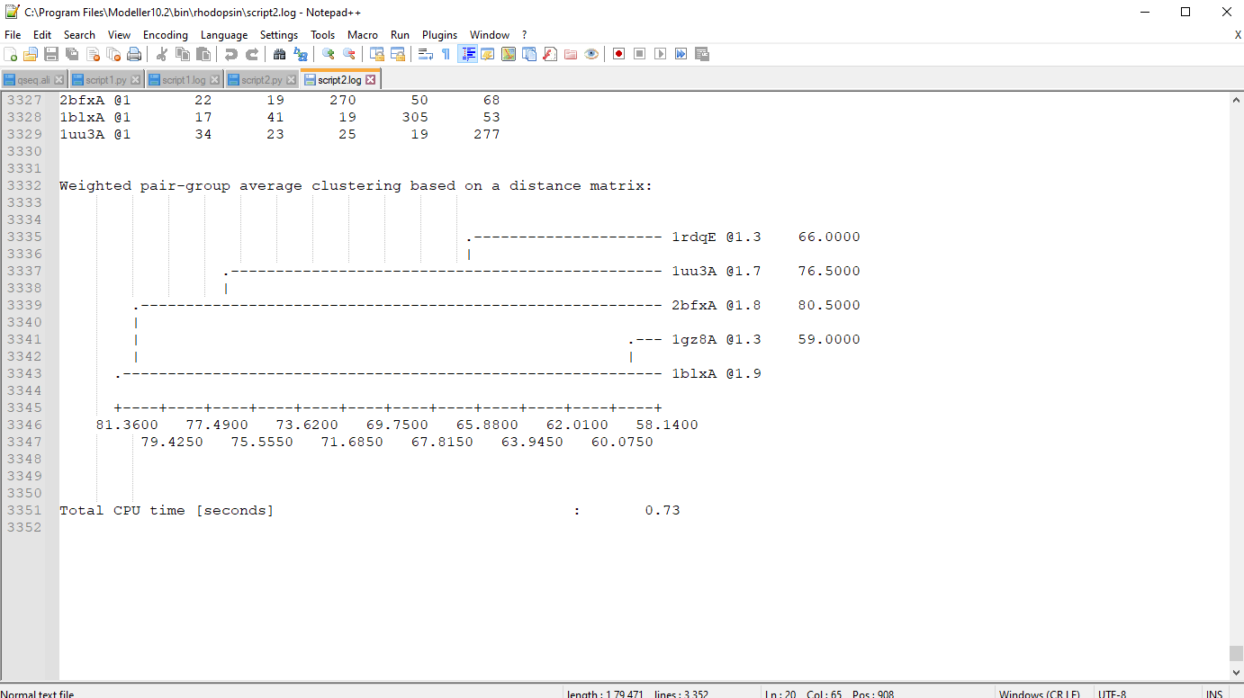**Fig15.1 Structure selected with low x=ray crystallography value and high NMR value**

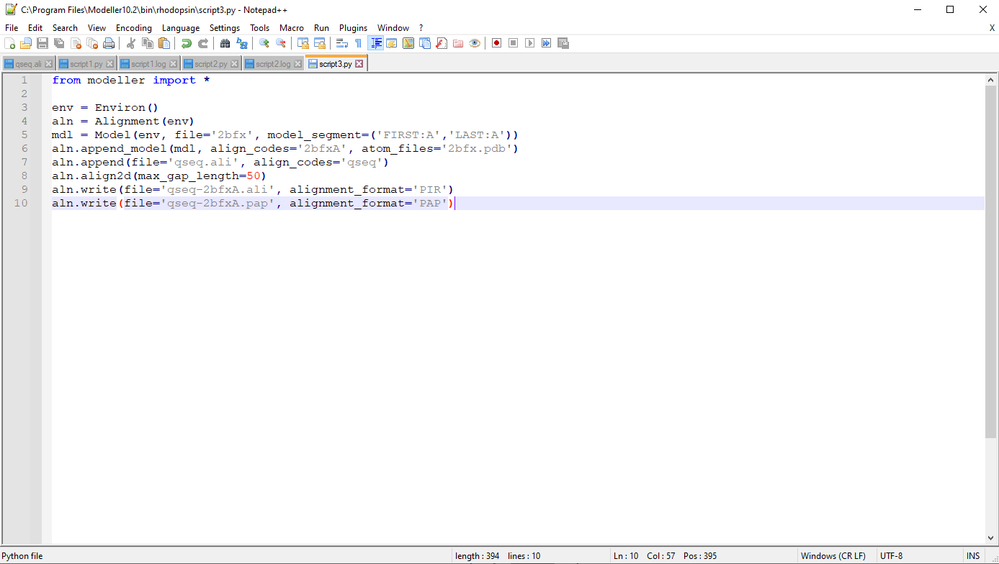**Fig16. Python script for aligning query with the template**

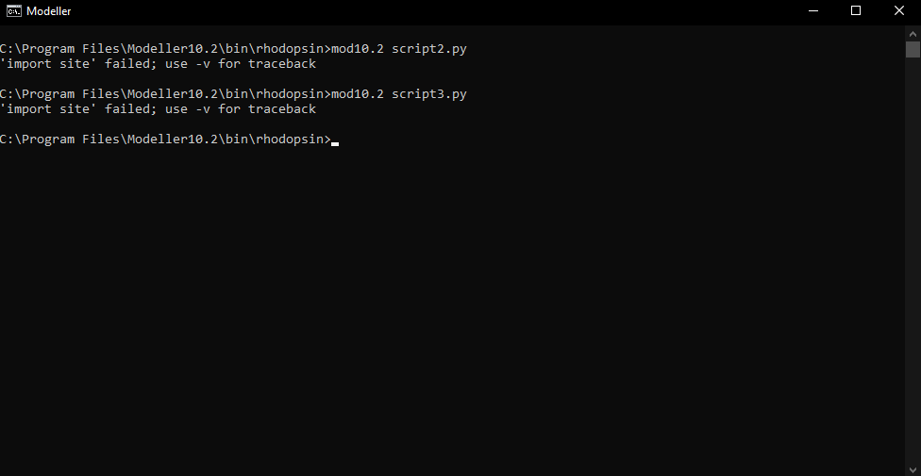**Fig17. Running script3.py**

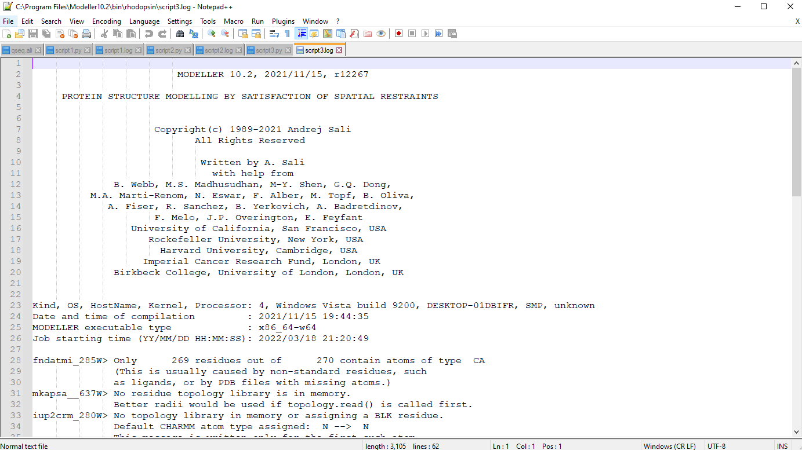**Fig18. Log file for script3**

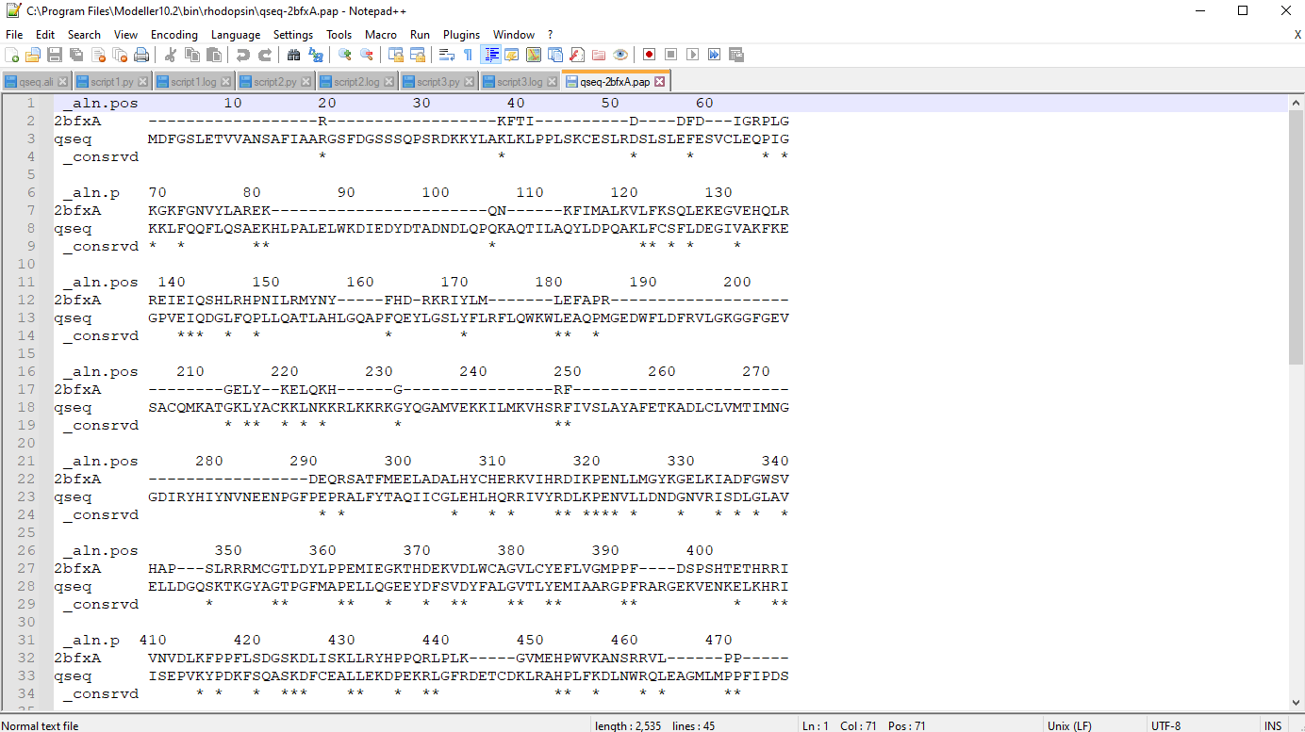**Fig19. Sequence alignment**

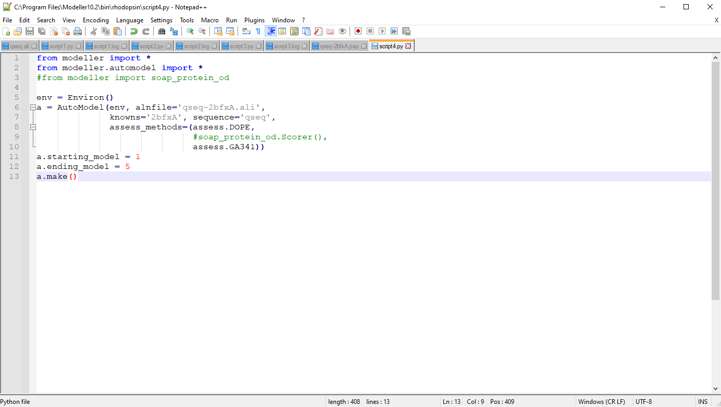**Fig20. Python script for model building**

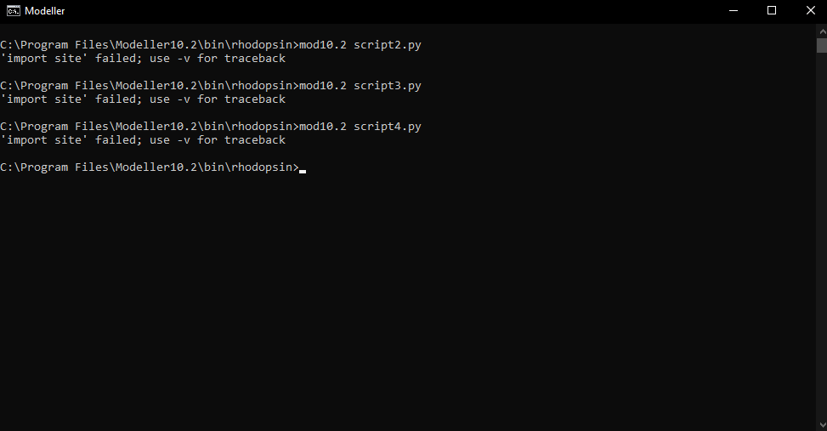**Fig21. Running script4.py**

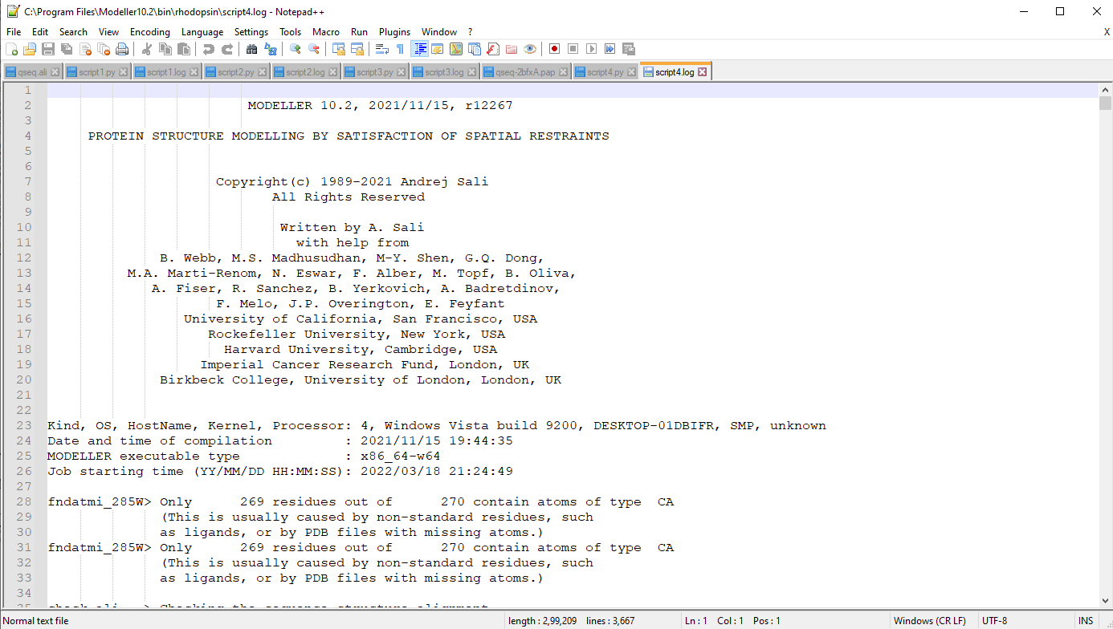**Fig22. Log file for script4**

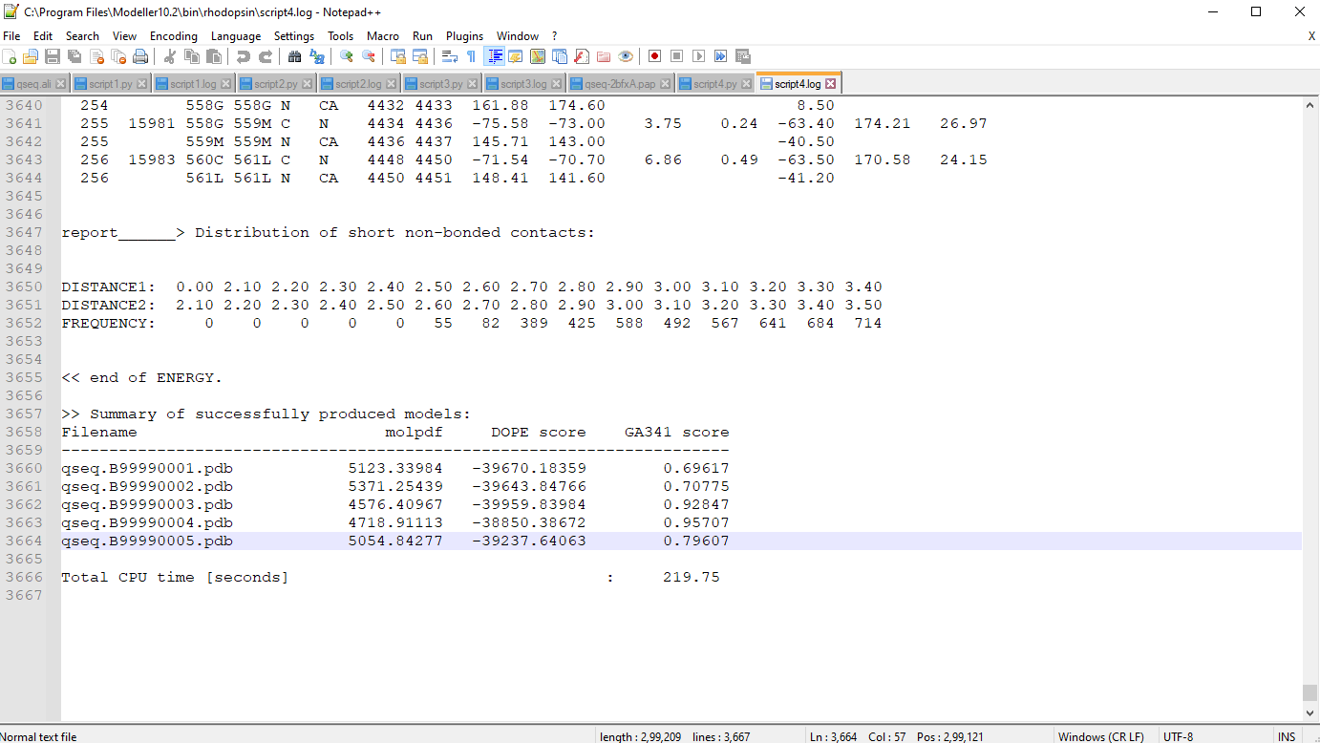**Fig23. Structure with lowest DOPE score selected as final model**

**RESULT:**

Modeller was used to predict the tertiary structure of Rhodopsin

**CONCLUSION:**

Thus, modeller can be used to predict tertiary structures of proteins by comparative protein structure modelling. These tools give faster results than x-ray or NMR techniques and can be used by researchers to understand protein functions and drug designing.

**REFERENCES:**

1. Xiong, J. (2008).Tertiary structure prediction. Essential bioinformatics. Cambridge: Cambridge University Press. 214-228.
2. Encyclopædia Britannica, inc. (n.d.). *Rhodopsin*. Encyclopædia Britannica. Retrieved March 18, 2022, from https://www.britannica.com/science/rhodopsin
3. Uniprot. (n.d.). Retrieved March 18, 2022, from https://www.uniprot.org/uniprot/Q15835.fasta

**DATE: 20-03-22**

**WEBLEM 3b**

**I-TASSAR**

**(URL:** [**https://zhanggroup.org/I-TASSER/**](https://zhanggroup.org/I-TASSER/)**)**

**AIM:**

To perform tertiary structure prediction by threading approach using I-TASSER server for query rhodopsin.

**INTRODUCTION:**

Rhodopsin, also called visual purple, pigment-containing sensory protein that converts light into an electrical signal. Rhodopsin is found in a wide range of organisms, from vertebrates to bacteria. In many seeing animals, including humans, it is required for vision in dim light and is located in the retina of the eye—specifically, within the tightly packed disks that make up the outer segment of the retina’s photoreceptive rod cells, which are specially adapted for vision under low-light conditions.

I-TASSER server is an on-line platform that implements the I-TASSER based algorithms for protein structure and function predictions. It allows academic users to automatically generate high-quality model predictions of 3D structure and biological function of protein molecules from their amino acid sequences.

**METHODOLOGY:**

1. Open homepage for I-TASSER. (URL: https://zhanggroup.org/I-TASSER/)
2. Complete registration.
3. Submit FASTA sequence for kinase.
4. Observe and interpret results.

**OBSERVATION:**

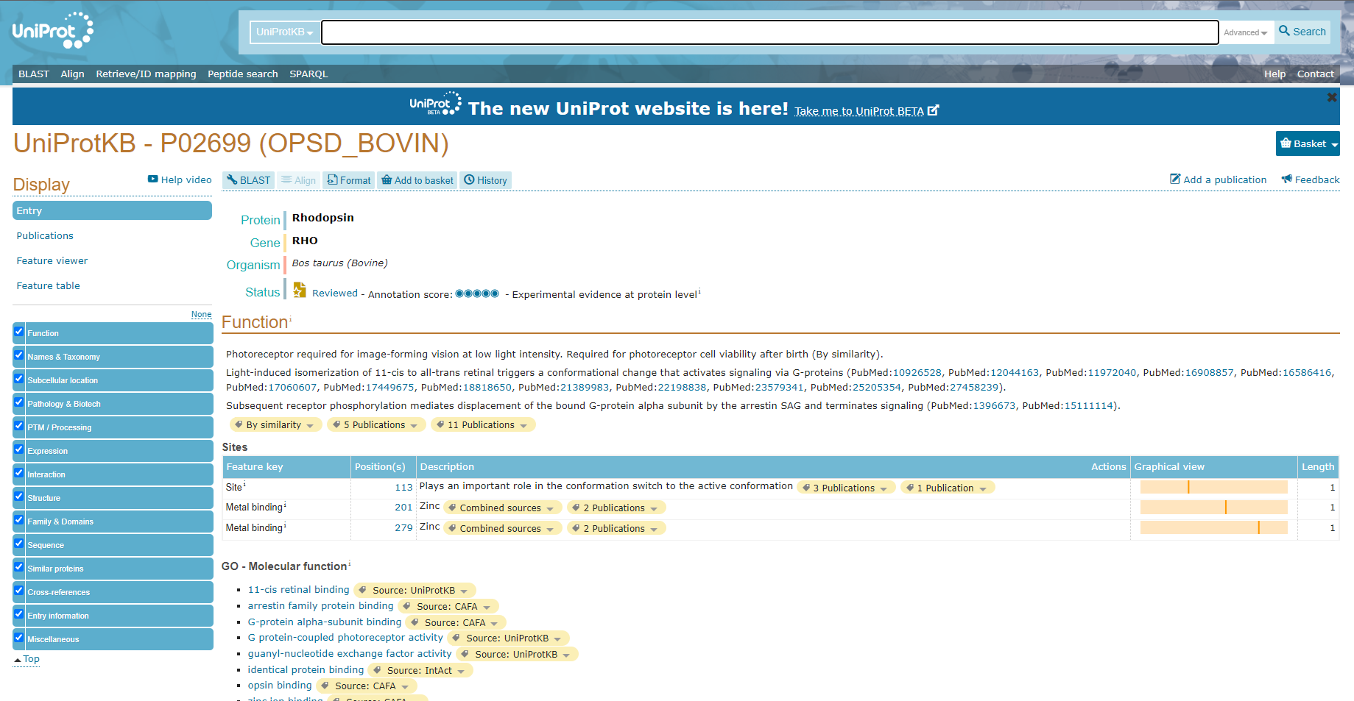**Fig1. Result page for Rhodopsin in UniProt database**

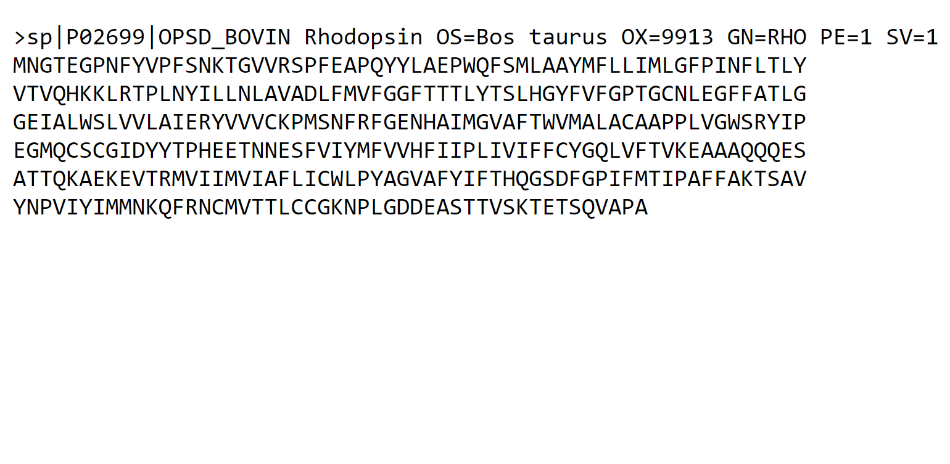**Fig2. FASTA sequence for Rhodopsin**

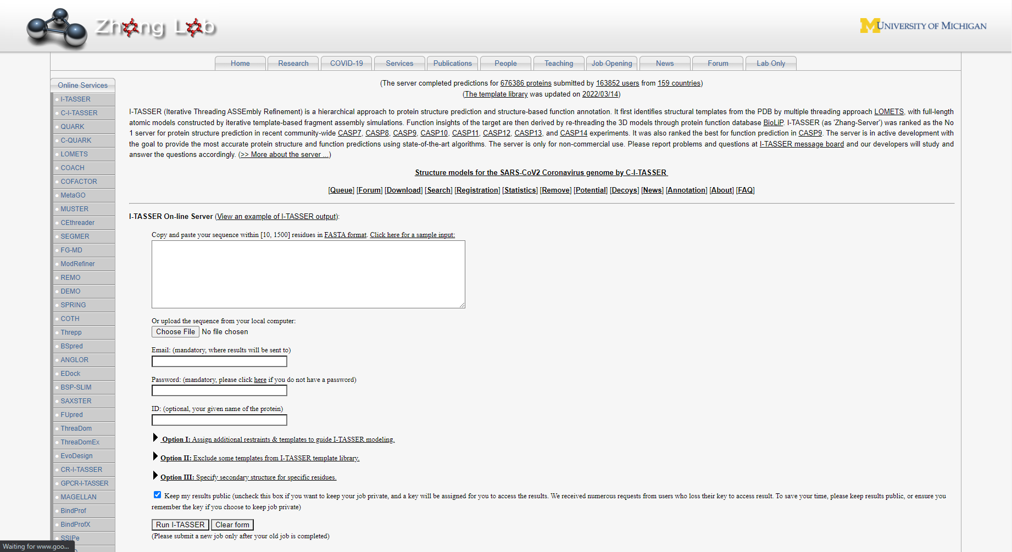**Fig3. Homepage for I-TASSAR**

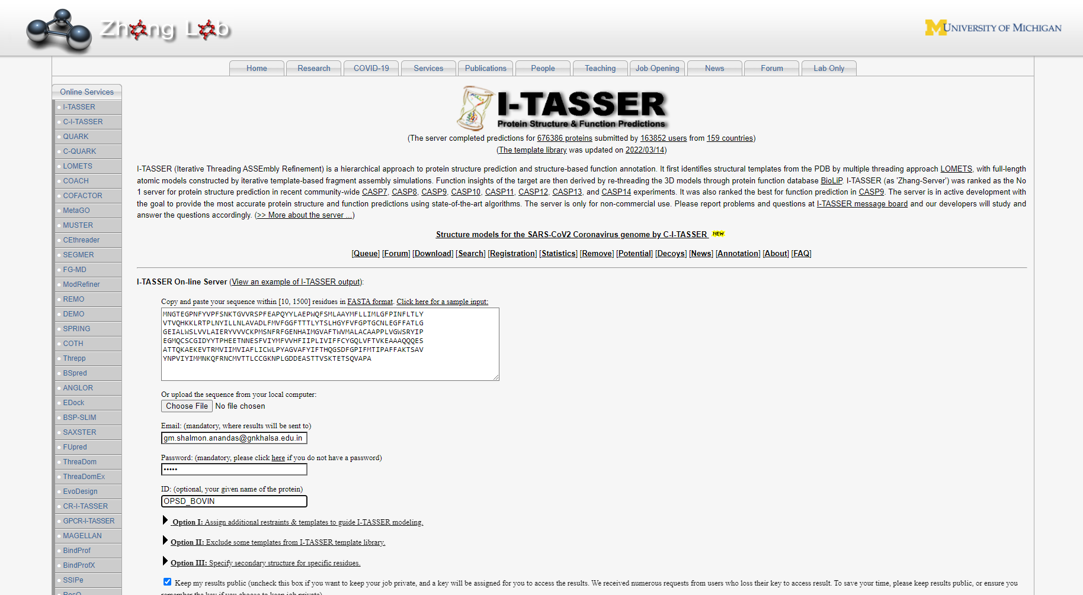**Fig4. Submission of query**

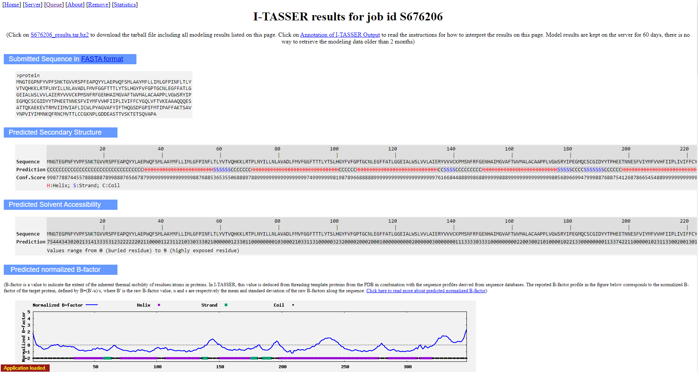**Fig5. Result for predicted secondary structure and normalized B-factor**

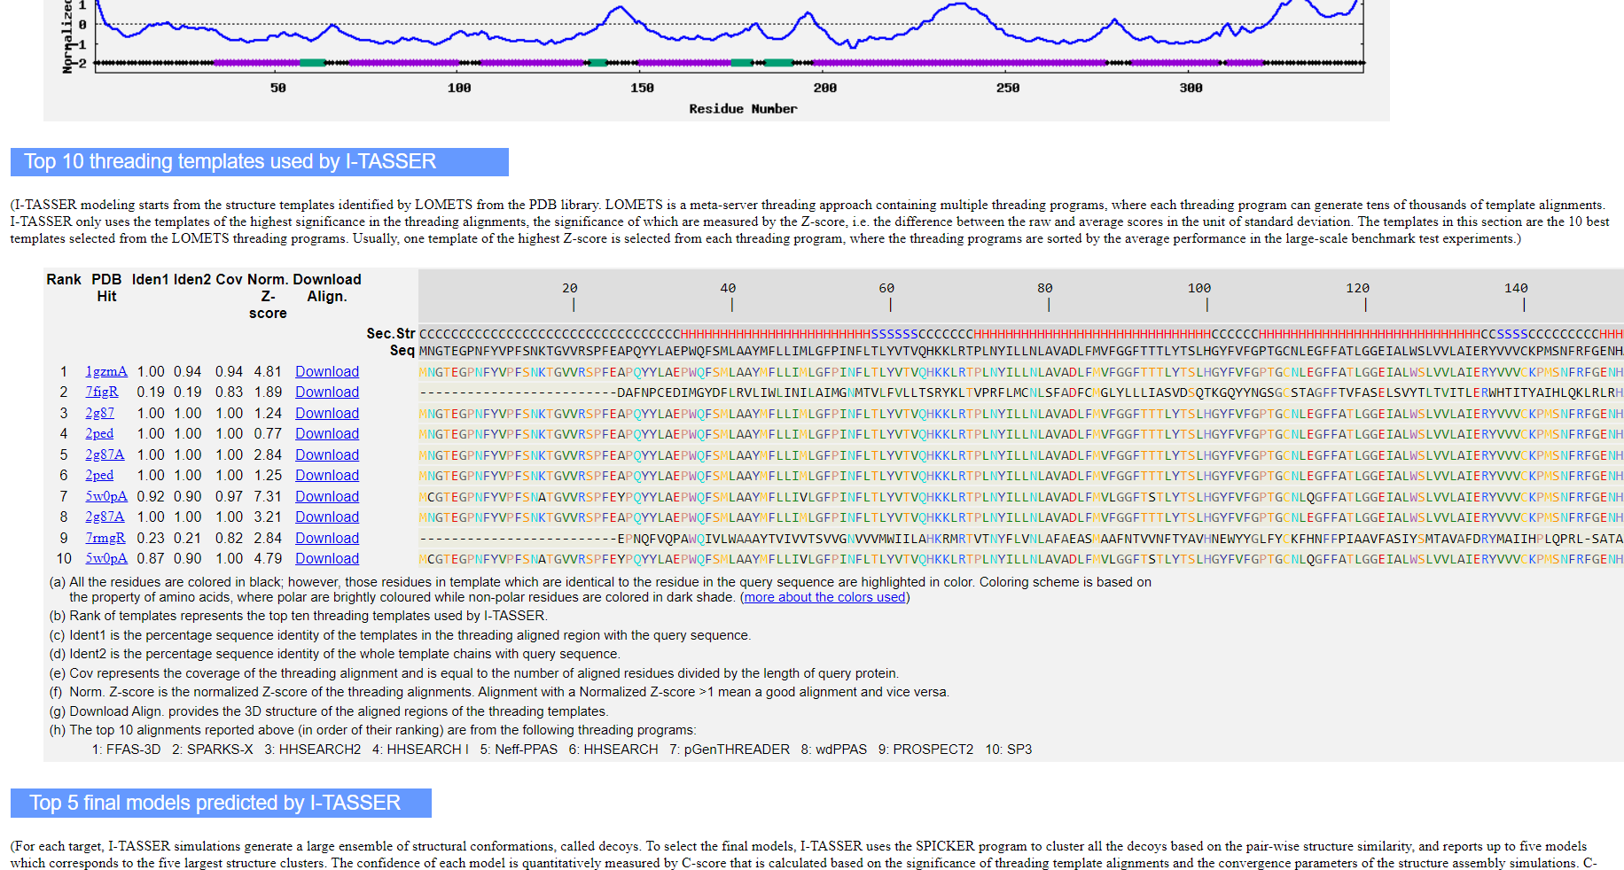**Fig7. Result for top 10 threading templates**

1. All the residues are coloured in black; however, those residues in template which are identical to the residue in the query sequence are highlighted in colour. Colouring scheme is based on the property of amino acids, where polar are brightly coloured while non-polar residues are coloured in dark shade. (More about the colours used)
2. Rank of templates represents the top ten threading templates used by I-TASSER.
3. Iden1 is the percentage sequence identity of the templates in the threading aligned region with the query sequence.
4. Iden2 is the percentage sequence identity of the whole template chains with query sequence.
5. Cov represents the coverage of the threading alignment and is equal to the number of aligned residues divided by the length of query protein.
6. Norm. Z-score is the normalized Z-score of the threading alignments. Alignment with a Normalized Z-score >1 mean a good alignment and vice versa.
7. Download Align. provides the 3D structure of the aligned regions of the threading templates.
8. The top 10 alignments reported above (in order of their ranking) are from the following threading programs: 1: FFAS-3D 2: SPARKS-X 3: HHSEARCH2 4: HHSEARCH I 5: Neff-PPAS 6: HHSEARCH 7: pGenTHREADER 8: wdPPAS 9: PROSPECT2 10: SP3

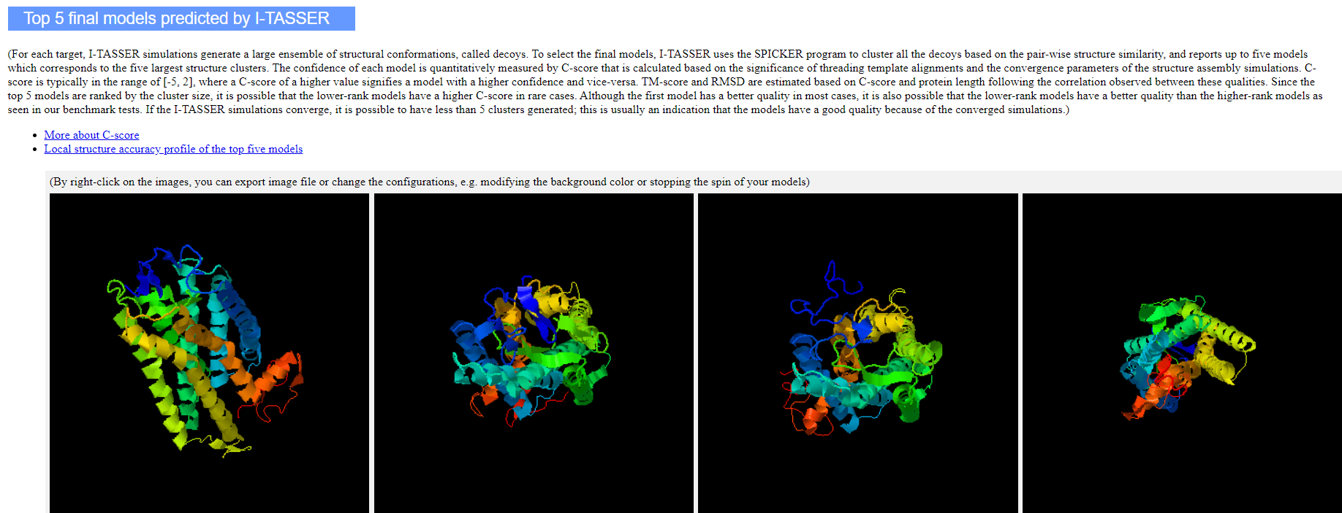**Fig8. Result for top 5 final models predicted**

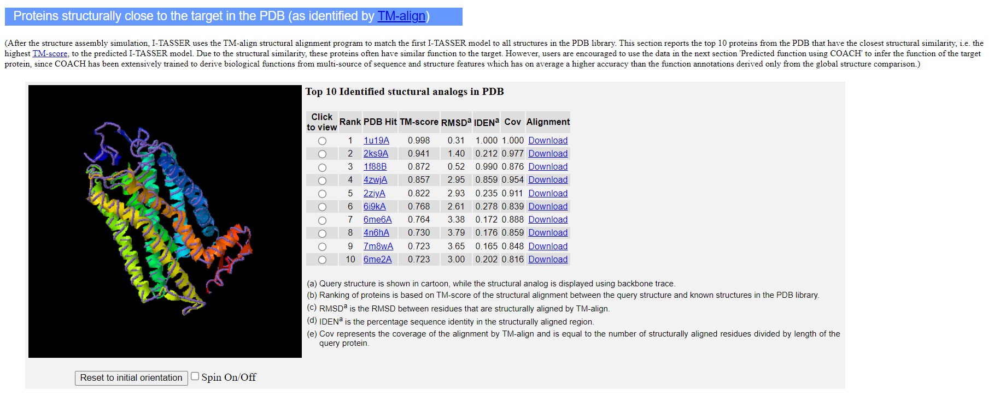**Fig9. Result for proteins that are structurally close to target**

1. Query structure is shown in cartoon, while the structural analog is displayed using backbone trace.
2. Ranking of proteins is based on TM-score of the structural alignment between the query structure and known structures in the PDB library
3. RMSDa is the RMSD between residues that are structurally aligned by TM-align
4. IDENa is the percentage sequence identity in the structurally aligned region.
5. Cov represents the coverage of the alignment by TM-align and is equal to the number of structurally aligned residues divided by length of the query protein.

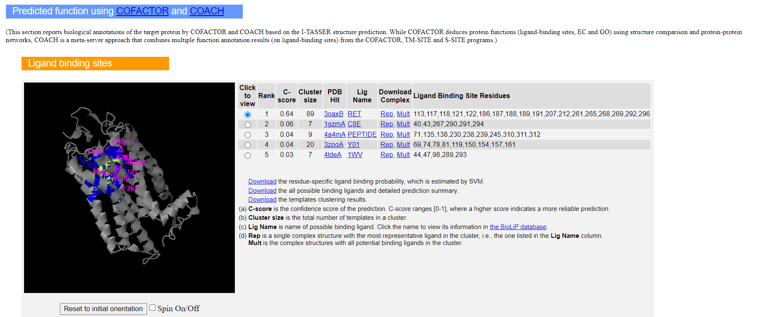**Fig10. Result for predicted fuctions**

1. C-score is the confidence score of the prediction. C-scores ranges [0-1], where a higher score indicated a more reliable prediction.
2. Cluster size is the total number of templates in a cluster.
3. Lig Name is name of possible binding ligand. Click the name to view its information in the BioLiP database.
4. Rep is a single complex structure with the most representative ligand in the cluster, i.e., the one listed in the Lig Name column. Mult is the complex structures with all potential binding ligands in the cluster.

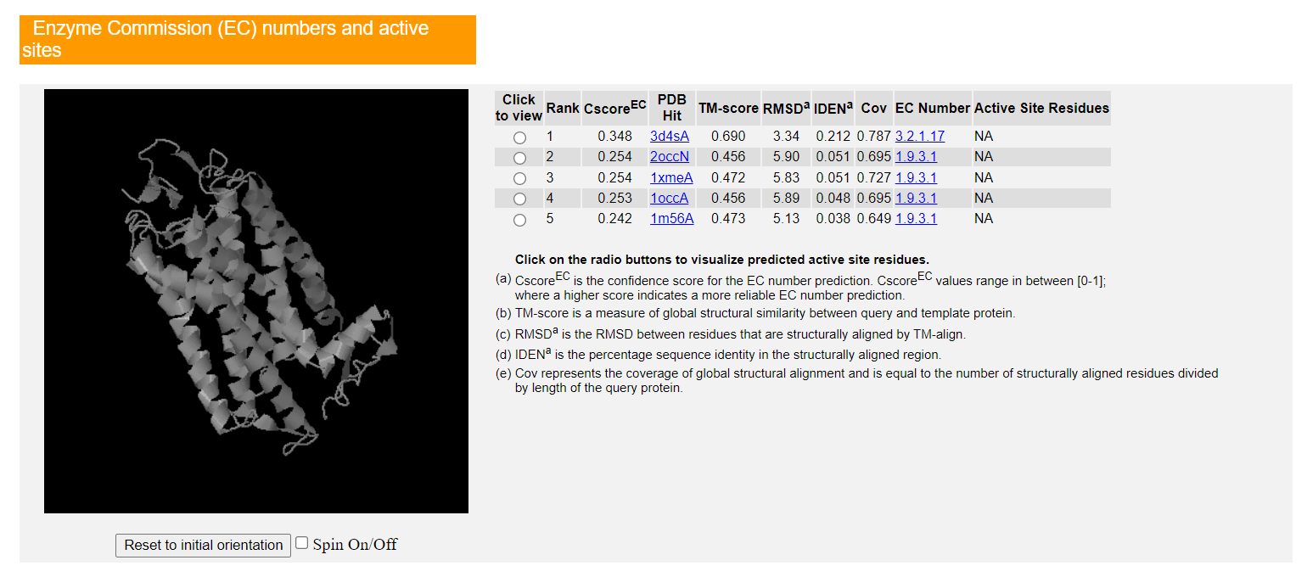**Fig11. Enzyme commission (EC) numbers and active sites**

1. CscoreEC is the confidence score for the EC number prediction. CscoreEC values range in between [0-1]; where a higher score indicates a more reliable EC number prediction.
2. TM-score is a measure of global structural similarity between query and template protein.
3. RMSDa is the RMSD between residues that are structurally aligned by TM-align.
4. IDENa is the percentage sequence identity in the structurally aligned region.
5. Cov represents the coverage of global structural alignment and is equal to the number of structurally aligned residues divided by length of the query protein.

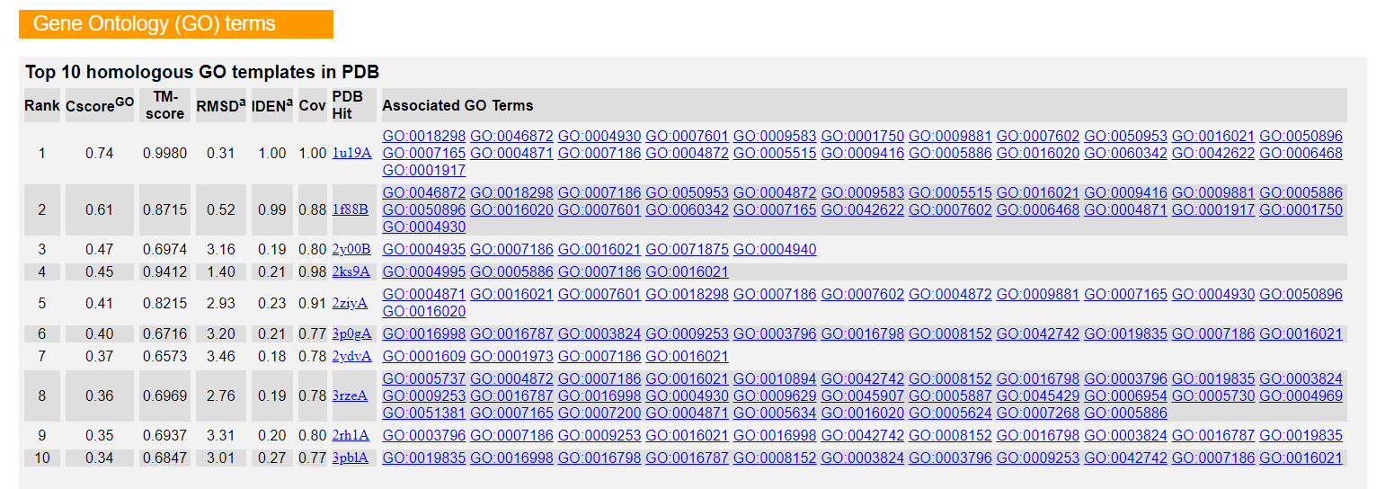**Fig12. Gene Ontology (GO) terms**

1. CscoreGO is a combined measure for evaluating global and local similarity between query and template protein. It's range is [0-1] and higher values indicate more confident predictions.
2. TM-score is a measure of global structural similarity between query and template protein.
3. RMSDa is the RMSD between residues that are structurally aligned by TM-align.
4. IDENa is the percentage sequence identity in the structurally aligned region.
5. Cov represents the coverage of global structural alignment and is equal to the number of structurally aligned residues divided by length of the query protein.
6. The second table shows a consensus GO terms amongst the top scoring templates. The GO-Score associated with each prediction is defined as the average weight of the GO term, where the weights are assigned based on CscoreGO of the template.

**RESULT:**

I-TASSER was used to predict the tertiary structure of Kinase based on threading approach. The information regarding solvent accessibility, normalized B-factor, top 10 threading templates, top 5 final models, proteins that are structurally close to target, functions and active sites were predicted.

**CONCLUSION:**

Thus, I-TASSER can be used to predict tertiary structures of proteins by threading method. These tools give faster results than x-ray or NMR techniques and can be used by researchers to understand protein functions and drug designing.

**REFERENCES:**

1. Xiong, J. (2008).Tertiary structure prediction. Essential bioinformatics. Cambridge: Cambridge University Press. 214-228.
2. kinase | Definition, Biology, & Function. (n.d.). Encyclopedia Britannica. Retrieved March 8, 2022, from <https://www.britannica.com/science/kinase>
3. I-TASSER server for protein structure and function prediction. (n.d.-b). Zhanggroup.org. Retrieved March 8, 2022, from <https://zhanggroup.org/I-TASSER/>
4. I-TASSER results. (n.d.). Zhanggroup.org. Retrieved March 8, 2022, from <https://zhanggroup.org//I-> TASSER/output/S673761/

**DATE: 20-03-22**

**WEBLEM 3c**

**ROBETTA**

**(URL:** [**https://robetta.bakerlab.org/**](https://robetta.bakerlab.org/)**)**

**AIM:**

To perform tertiary structure prediction by Ab-Initio approach using ROBETTA server for query Rhodopsin.

**INTRODUCTION:**

Rhodopsin, also called visual purple, pigment-containing sensory protein that converts light into an electrical signal. Rhodopsin is found in a wide range of organisms, from vertebrates to bacteria. In many seeing animals, including humans, it is required for vision in dim light and is located in the retina of the eye—specifically, within the tightly packed disks that make up the outer segment of the retina’s photoreceptive rod cells, which are specially adapted for vision under low-light conditions.

The Robetta server provides automated tools for protein structure prediction and analysis. For structure prediction, sequences submitted to the server are parsed into putative domains and structural models are generated using either comparative modeling orde novo structure prediction methods. If a confident match to a protein of known structure is found using BLAST, PSI-BLAST, FFAS03 or 3D-Jury, it is used as a template for comparative modeling. If no match is found, structure predictions are made using the de novo Rosetta fragment insertion method. Experimental nuclear magnetic resonance (NMR) constraints data can also be submitted with a query sequence for RosettaNMR de novo structure determination. Other current capabilities include the prediction of the effects of mutations on protein–protein interactions using computational interface alanine scanning. The Rosetta protein design and protein–protein docking methodologies will soon be available through the server as well.

**METHODOLOGY:**

1. Open homepage for Robetta (URL: <https://robetta.bakerlab.org/>)
2. Complete registration
3. Submit FASTA sequence for kinase.
4. Observe and interpret results.

**OBSERVATION:**

**Fig1. Result page for Rhodopsin in UniProt database**

**Fig2. FASTA sequence for Rhodopsin**

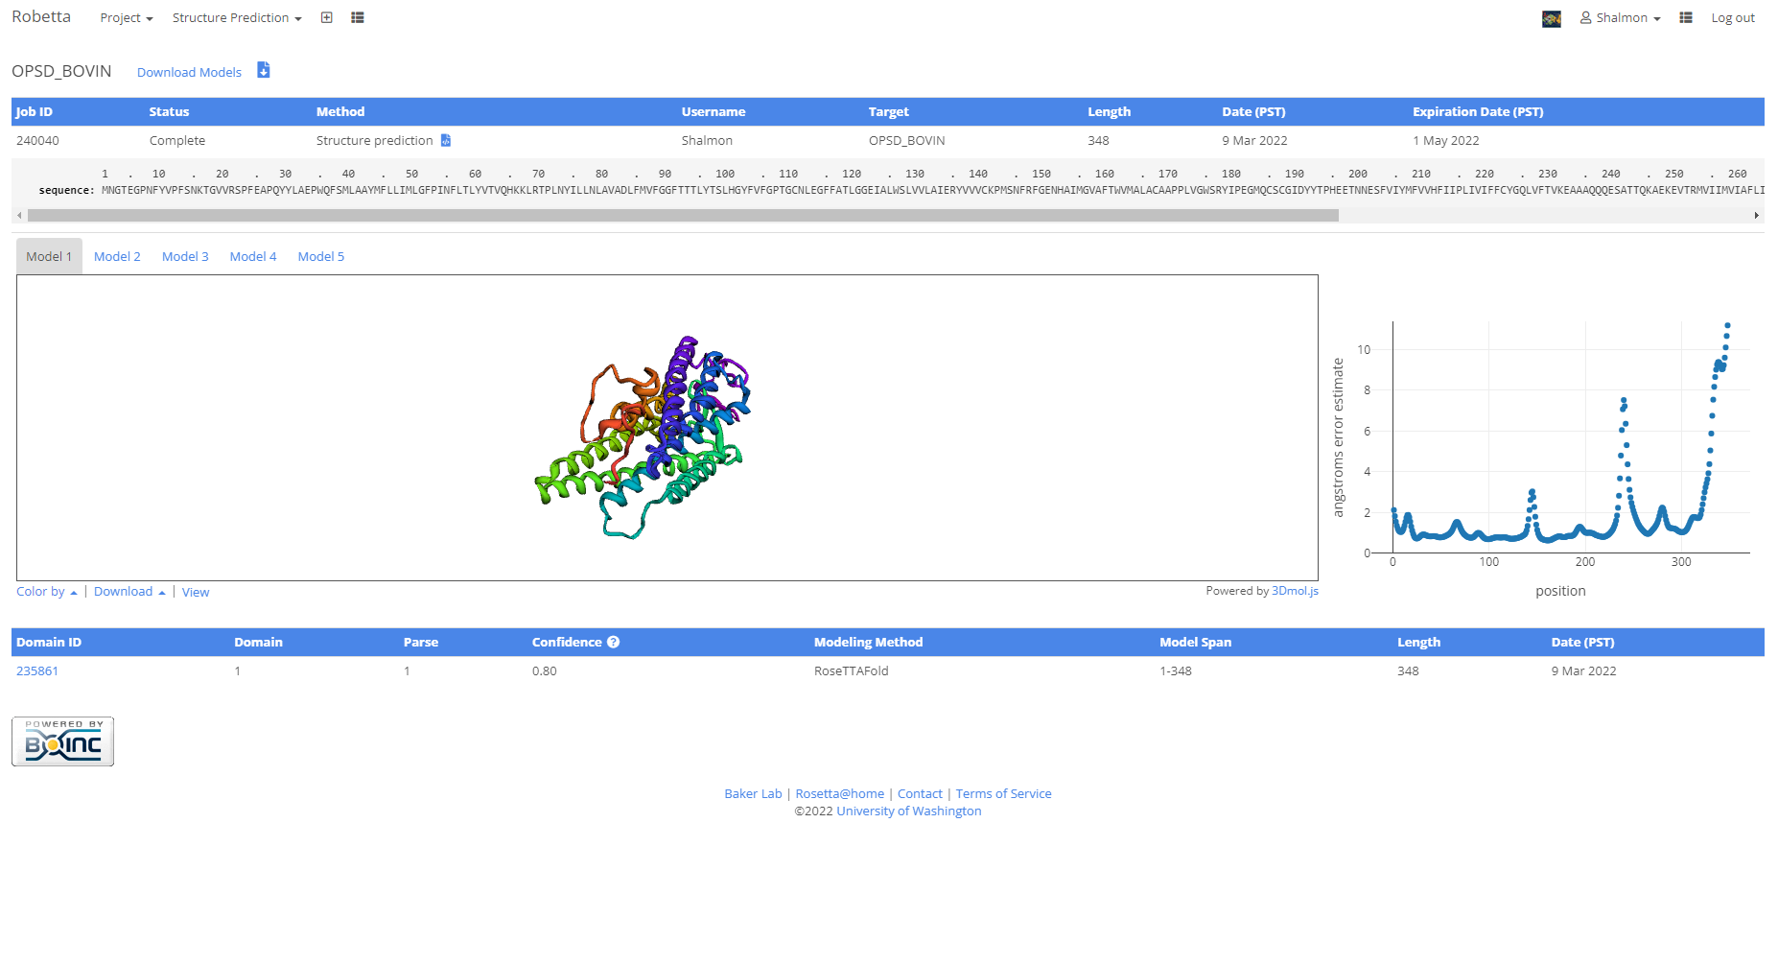**Fig3. Model 1 with atom co-ordinates**

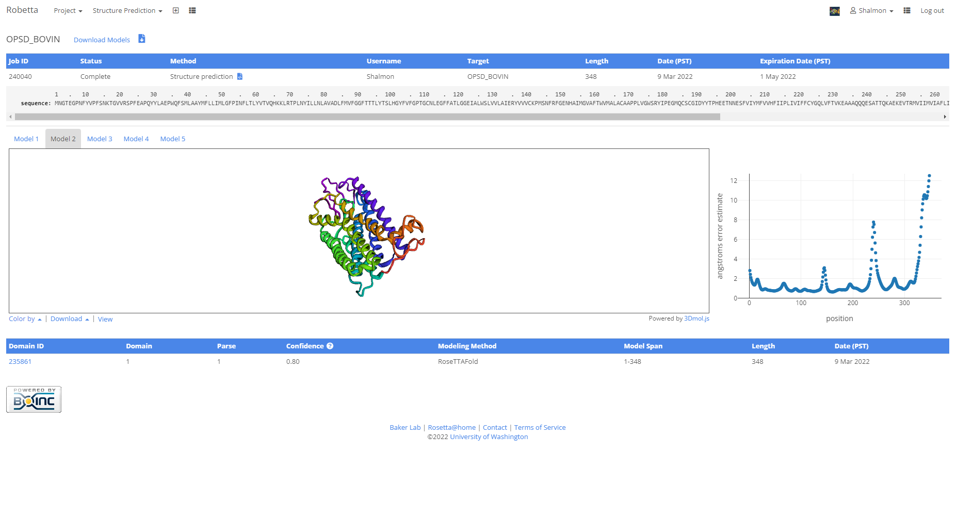**Fig4. Model 2 with atom co-ordinates**

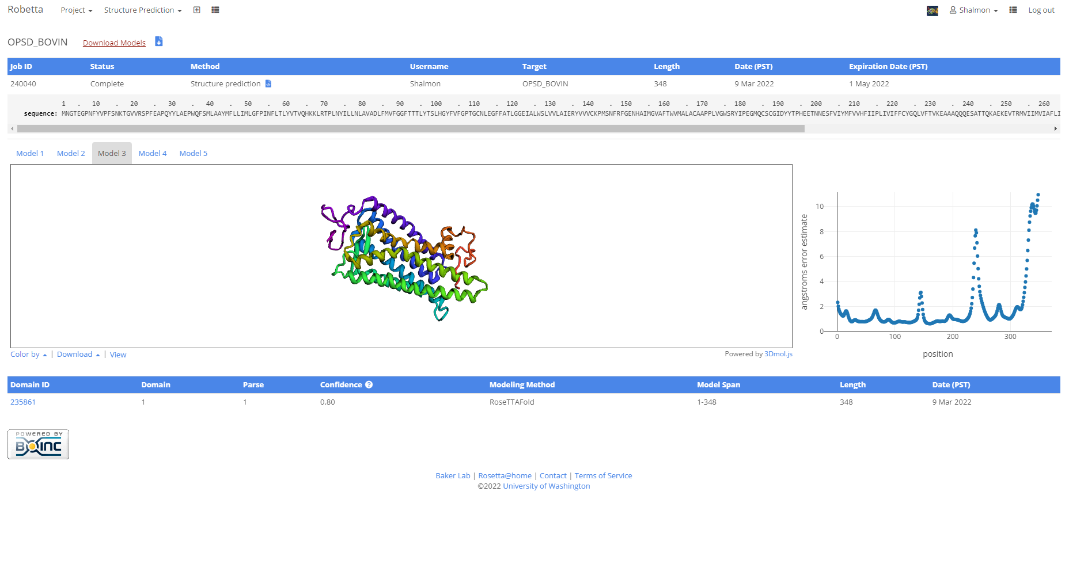**Fig5. Model 3 with atom co-ordinates**

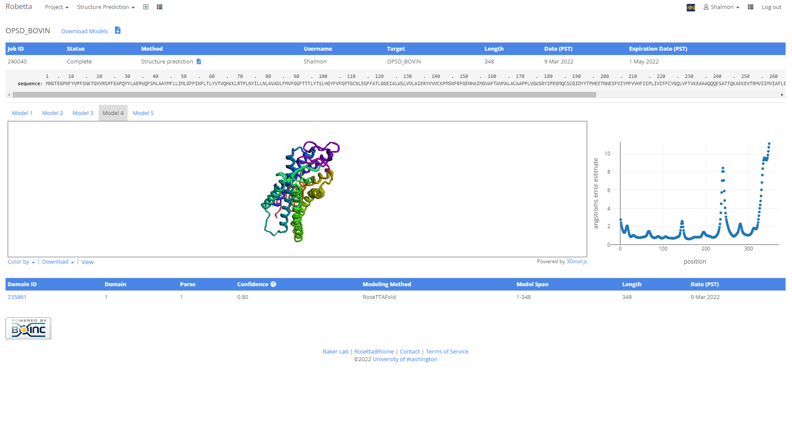**Fig6. Model 4 with atom co-ordinates**

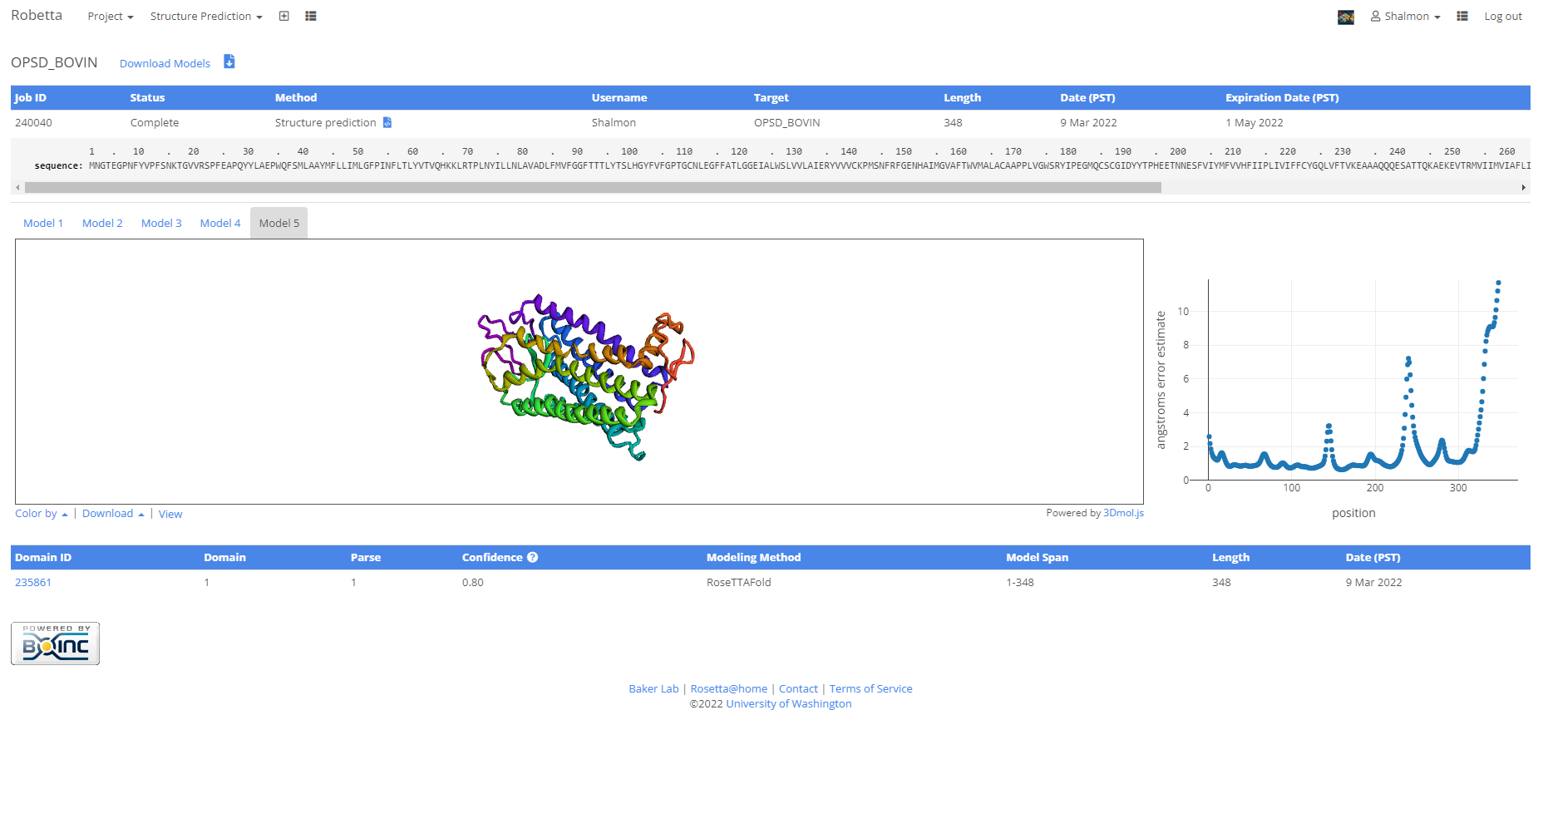**Fig7. Model 5 with atom co-ordinates**

**RESULT:**

Robetta was used to predict the tertiary structure of Rhodopsin based on ab-initio approach.

**CONCLUSION:**

Thus, Robetta can be used to predict tertiary structures of proteins by ab-initio method. These tools give faster results than x-ray or NMR techniques and can be used by researchers to understand protein functions and drug designing.

**REFERENCES:**

1. Xiong, J. (2008).Tertiary structure prediction. Essential bioinformatics. Cambridge: Cambridge University Press. 214-228.
2. Encyclopædia Britannica, inc. (n.d.). *Rhodopsin*. Encyclopædia Britannica. Retrieved March 18, 2022, from https://www.britannica.com/science/rhodopsin
3. Robetta (2021b). Bakerlab.org. Retrieved March 18, 2022, from <https://robetta.bakerlab.org/results.php?id=240040>

**DATE: 10-03-22**

**WEBLEM 4**

**Introduction to Validation server – SAVES server**

Homology model, threading method and ab-initio method of tertiary structure prediction all have to be evaluated to make sure that the structural features of the model are consistent with the physicochemical rules. This involves checking anomalies in φ–ψ angles, bond lengths, close contacts, and so on. Another way of checking the quality of a protein model is to implicitly take these stereochemical properties into account. This is a method that detects errors by compiling statistical profiles of spatial features and interaction energy from experimentally determined structures. By comparing the statistical parameters with the constructed model, the method reveals which regions of a sequence appear to be folded normally and which regions do not. If structural irregularities are found, the region is considered to have errors and has to be further refined.

**SAVES server:**

SAVES server contains various tools for structure validation that are all integrated in one single server. The tool available are:

**ERRAT:**

A novel method for differentiating between correctly and incorrectly determined regions of protein structures based on characteristic atomic interaction is described. Different types of atoms are distributed nonrandomly with respect to each other in proteins. Errors in model building lead to more randomized distributions of the different atom types, which can be distinguished from correct distributions by statistical methods. Atoms are classified in one of three categories: carbon (C), nitrogen (N), and oxygen (O). This leads to six different combinations of pairwise noncovalently bonded interactions (CC, CN, CO, NN, NO, and OO). A quadratic error function is used to characterize the set of pairwise interactions from nine-residue sliding windows in a database of 96 reliable protein structures. Regions of candidate protein structures that are mistraced or misregistered can then be identified by analysis of the pattern of nonbonded interactions from each window.

Errat is a program for verifying protein structures determined by crystallography. Error values are plotted as a function of the position of a sliding 9-residue window. The error function is based on the statistics of non- bonded atom-atom interactions in the reported structure (compared to a database of reliable high-resolution structures).

A plot of an initial model and a final model is retrieved. Regions of the structure that can be rejected at the 95% confidence level are yellow; 5% of a good protein structure is expected to have an error value above this level. Regions that can be rejected at the 99% level are shown in red. Generally speaking, the method is sensitive to smaller errors than 3-D Profile analysis.

**Verify3D:**

It is another server using the statistical approach. It uses a precomputed database containing eighteen environmental profiles based on secondary structures and solvent exposure, compiled from high-resolution protein structures. To assess the quality of a protein model, the secondary structure and solvent exposure propensity of each residue are calculated. It determines the compatibility of an atomic model (3D) with its own amino acid sequence (1D) by assigning a structural class based on its location and environment (alpha, beta, loop, polar, nonpolar etc) and comparing the results to good structures. If the parameters of a residue fall within one of the profiles, it receives a high score, otherwise a low score. The result is a two-dimensional graph illustrating the folding quality of each residue of the protein structure. The threshold value is normally set at zero. Residues with scores below zero are considered to have an unfavourable environment.

**PROVES:**

It calculates the volumes of atoms in macromolecules using an algorithm which treats the atoms like hard spheres and calculates a statistical Z-score deviation for the model from highly resolved (2.0 Å or better) and refined (R-factor of 0.2 or better) PDB-deposited structures.

Standard ranges of atomic and residue volumes are computed in 64 highly resolved and well-refined protein crystal structures using the classical Voronoi procedure. Deviations of the atomic volumes from the standard values, evaluated as the volume Z-scores, are used to assess the quality of protein crystal structures. To score a structure globally, we compute the volume Z-score root mean square deviation (Z-score rms), which measures the average magnitude of the volume irregularities in the structure. We find that the Z-score rms decreases as the resolution and R-factor improve, consistent with the fact that these improvements generally reflect more accurate models. From the Z-score rms distribution in structures with a given resolution or R- factor, we determine the normal limits in Z-score rms values for structures solved at that resolution or R- factor. Structures whose Z-score rms exceeds these limits are considered as outliers. Such structures also exhibit unusual stereochemistry, as revealed by other analyses. Absolute Z-scores of individual atoms are used to identify problems in specific regions within a protein model. These Z-scores correlate fairly well with the atomic B-factors, and atoms having absolute Z-scores > 3, occur at or near regions in the model where programs such as PROCHECK identify unusual stereochemistry. Atomic volumes, themselves not directly restrained in crystallographic refinement, can thus provide an independent, rather sensitive, measure of the quality of a protein structure.

**WHAT_CHECK:**

Derived from a subset of protein verification tools from the WHAT IF program, this does extensive checking of many sterochemical parameters of the residues in the model. WHAT IF is a comprehensive protein analysis server that validates a protein model for chemical correctness. It has many functions, including checking of planarity, collisions with symmetry axes (close contacts), proline puckering, anomalous bond angles, and bond lengths. It also allows the generation of Ramachandran plots as an assessment of the quality of the model.

**PROCHECK:**

It is a UNIX program that is able to check general physicochemical parameters such as φ–ψ angles, chirality, bond lengths, bond angles, and so on. It checks the stereochemical quality of a protein structure by analyzing residue-by-residue geometry and overall structure geometry. The parameters of the model are used to compare with those compiled from well-defined, high-resolution structures. If the program detects unusual features, it highlights the regions that should be checked or refined further.

**CRYST:**

This program searches the Protein Data Bank for entries that have a unit cell similar to your input file. CRYST1 record required. Use the standalone CRYST server for more options.

The assessment results can be different using different verification programs. Because no single method is clearly superior to any other, a good strategy is to use multiple verification methods and identify the consensus between them. It is also important to keep in mind that the evaluation tests performed by these programs only check the stereochemical correctness, regardless of the accuracy of the model, which may or may not have any biological meaning. Thus, SAVES server is an excellent platform that provides various validation methods to accurately validate the structures.

**REFERENCES:**

1. SAVESv6.0 - Structure Validation Server. (n.d.-b). Saves.mbi.ucla.edu. Retrieved March 8, 2022, from <https://saves.mbi.ucla.edu/>
2. ERRAT – UCLA-DOE Institute. (n.d.). Retrieved March 8, 2022, from <https://www.doembi.ucla.edu/errat/>
3. Chris Colovos; Todd O. Yeates (1993). Verification of protein structures: Patterns of nonbonded atomic interactions. , 2(9), 1511–1519. doi:10.1002/pro.5560020916
4. Xiong, J. (2008).Tertiary structure prediction. Essential bioinformatics. Cambridge: Cambridge University Press. 220-222.
5. Joan Pontius; Jean Richelle; Shoshana J. Wodak (1996). Deviations from Standard Atomic Volumes as a Quality Measure for Protein Crystal Structures. , 264(1), 0–136. doi:10.1006/jmbi.1996.0628

**DATE: 10-03-22**

**WEBLEM 4a**

**SAVES server**

**(URL:** [**https://saves.mbi.ucla.edu/**](https://saves.mbi.ucla.edu/)**)**

**AIM:**

To validate structure qseq.B99990005 generated from modeller.

**Introduction:**

qseq.B99990005 is the structure predicted using homology modelling using modeller. The structure has to be evaluated to make sure that the structural features of the model are consistent with the physicochemical rules. This can be done using SAVES server.

SAVES is a structure validation server that has various tools like Errat, Verify3D, Prove, Whatcheck, Procheck.and Cryst integrated in one single platform. This involves checking anomalies in φ–ψ angles, bond lengths, close contacts, and so on. Another way of checking the quality of a protein model is to implicitly take these stereochemical properties into account. This is a method that detects errors by compiling statistical profiles of spatial features and interaction energy from experimentally determined structures. By comparing the statistical parameters with the constructed model, the method reveals which regions of a sequence appear to be folded normally and which regions do not. If structural irregularities are found, the region is considered to have errors and has to be further refined.

**METHODOLOGY:**

1. Open homepage for SAVES server. (URL: <https://saves.mbi.ucla.edu/>)
2. Upload structure retrieved from Modeller in PDB format.
3. Obtain results for Errat, Verify3D, Prove, Whatcheck and Procheck.
4. Observe and interpret the results.

**OBSERVATION:**

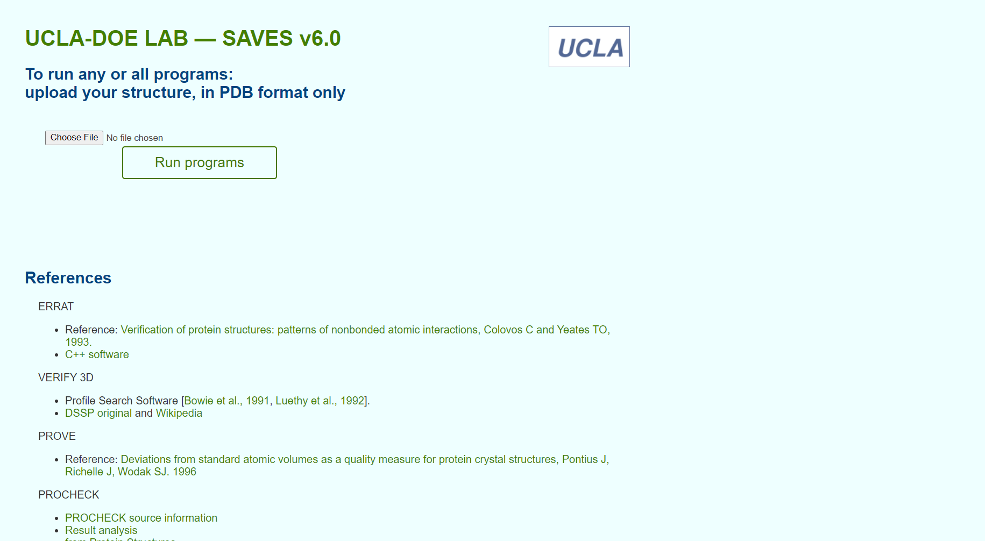**Fig1. Homepage for SAVES server**

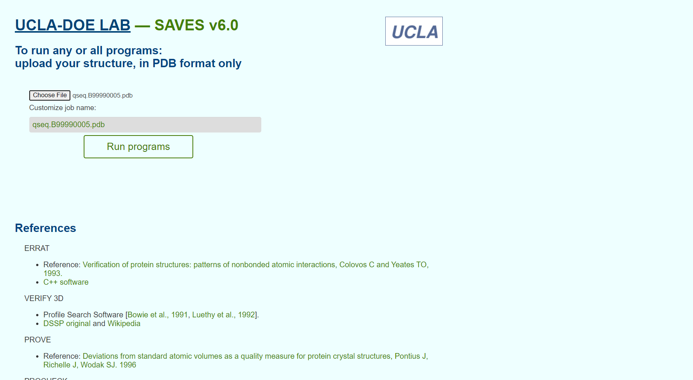**Fig2. Structure from Modeller for validation**

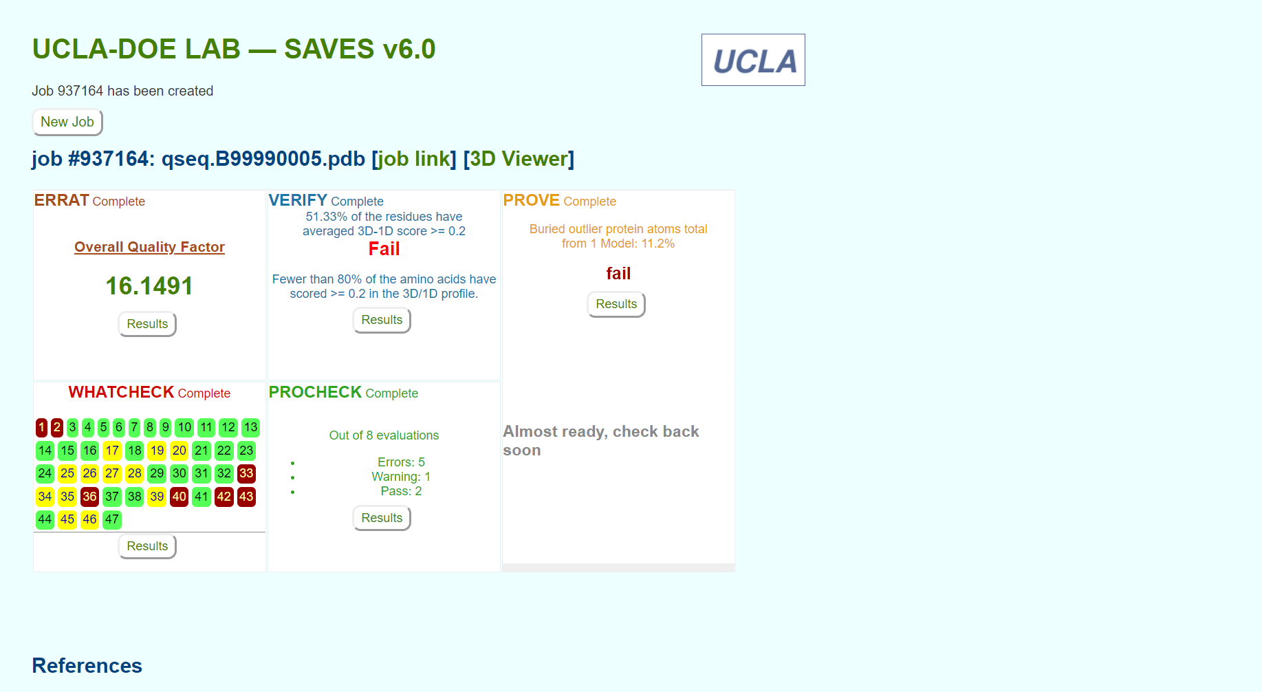**Fig3. Result page for structure validation for various servers**

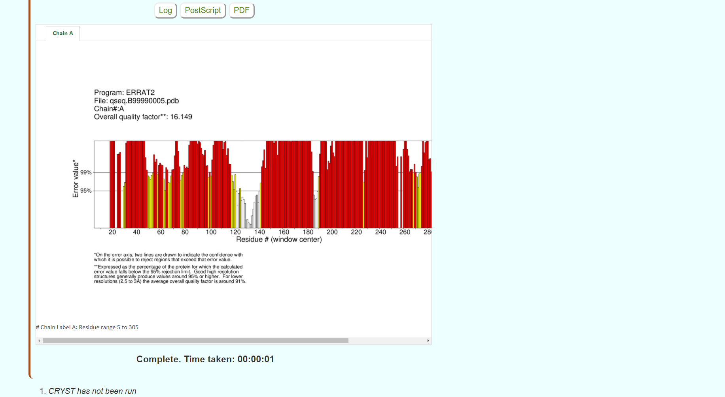**Fig4. Result page for ERRAT**

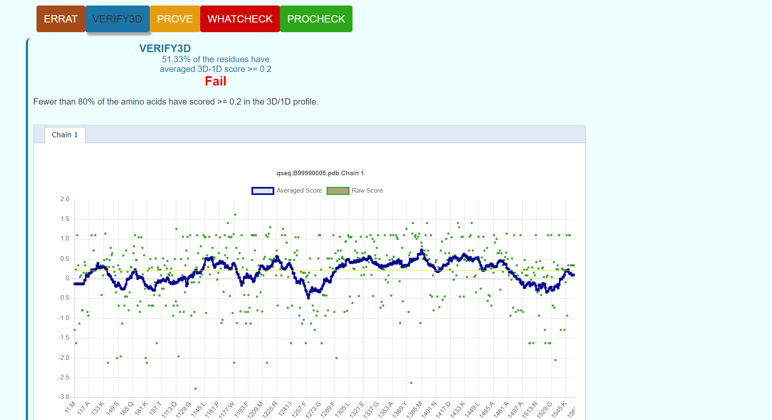**Fig5. Result page for Verify3D**

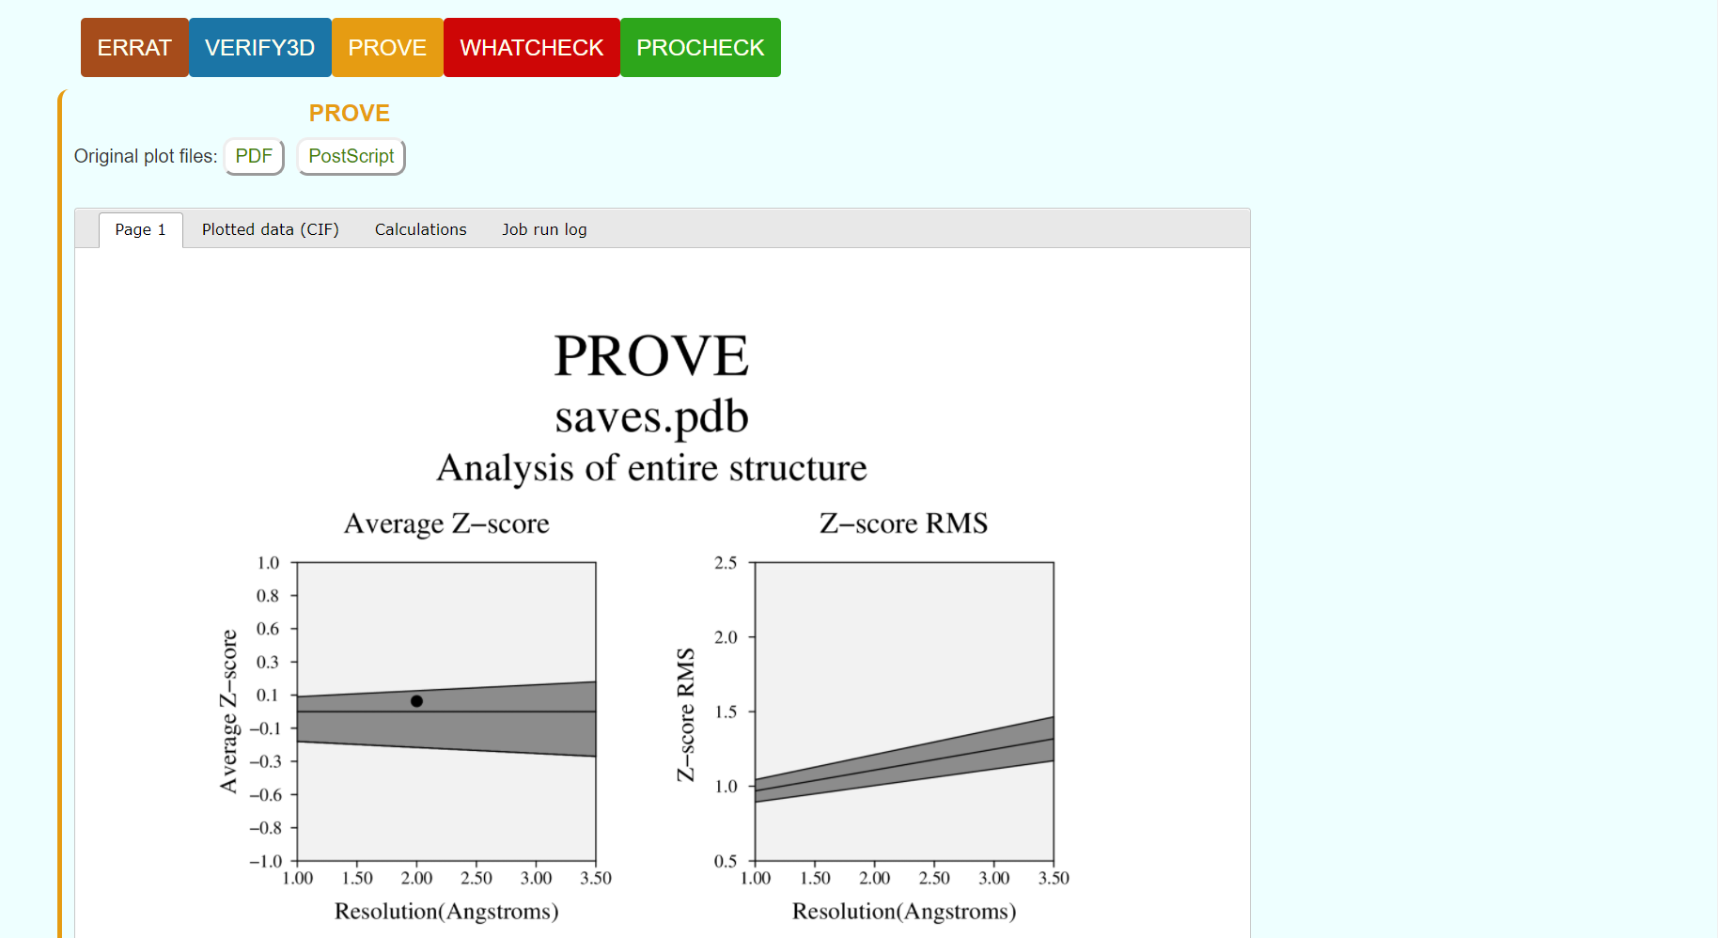**Fig6. Result page for Prove**

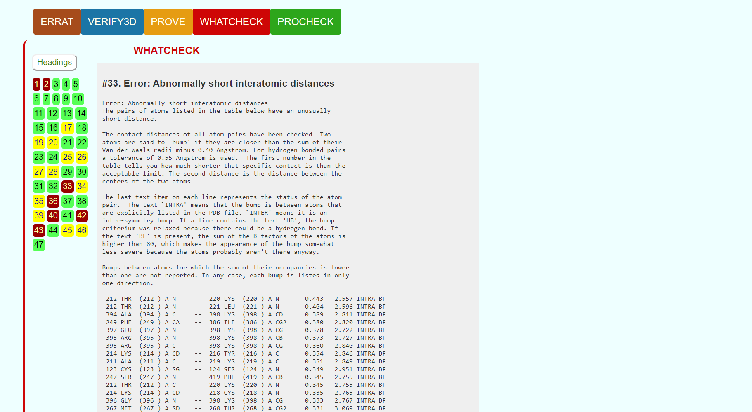**Fig7. Result page for Whatcheck**

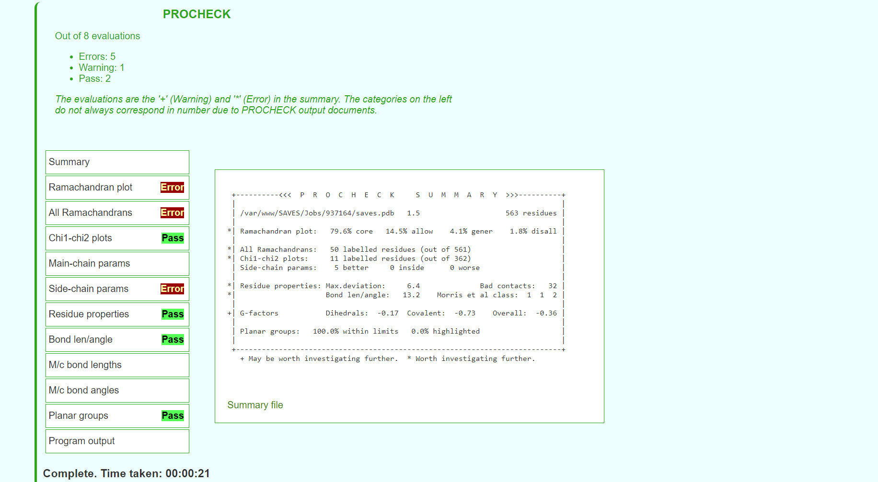**Fig8. Result page for procheck**

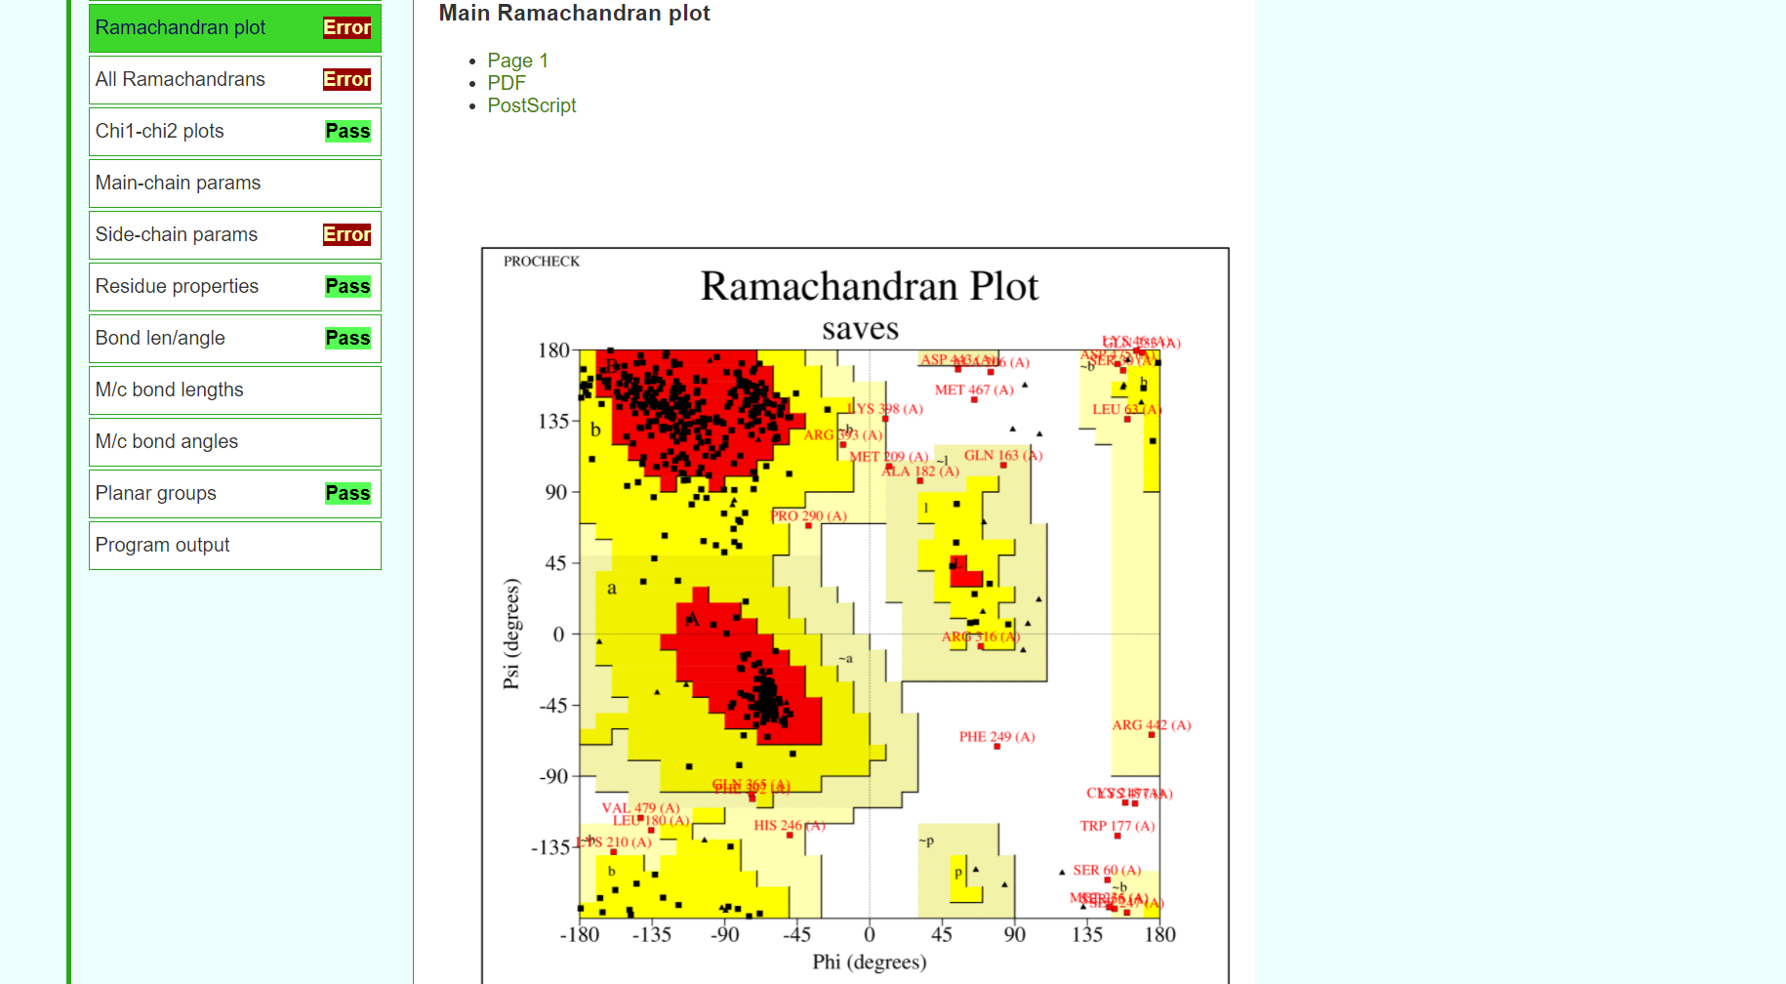**Fig9. Result page for Ramachandran plot**

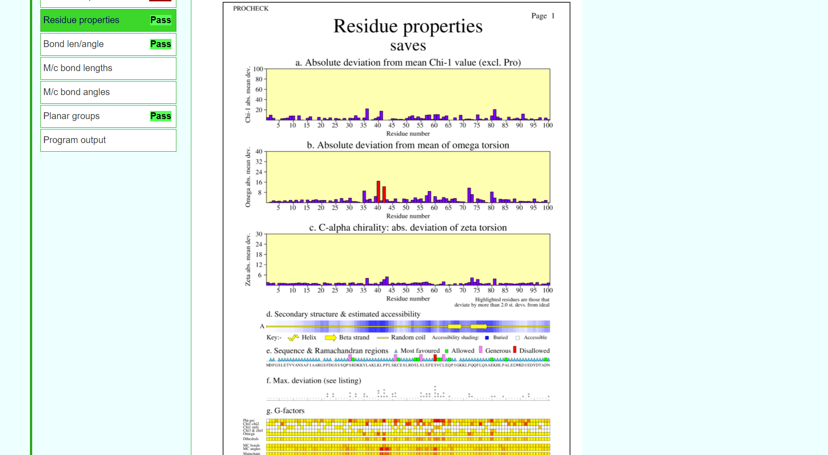**Fig10. Result page for residue properties**

**RESULT:**

The structure predicted for enzyme kinase by homology modelling using modeller was validated using SAVES server.

**CONCLUSION:**

SAVES in an integrated server containing various tools on a single platform that can be used for tertiary structure validation. The predicted structure for rhodopsin by modeller failed the validation thus, I-TASSER based on threading approach will be used to predict a better structure and will be validated again using SAVES server.

**REFERENCES:**

1. Xiong, J. (2008).Tertiary structure prediction. Essential bioinformatics. Cambridge: Cambridge University Press. 220-222.
2. SAVESv6.0 - Structure Validation Server. (n.d.). Saves.mbi.ucla.edu. Retrieved March 8, 2022, from <https://saves.mbi.ucla.edu/>
3. SAVESv6.0 - Structure Validation Server. (n.d.). Saves.mbi.ucla.edu. Retrieved March 8, 2022, from <https://saves.mbi.ucla.edu/?job=924086>

**DATE: 10-03-22**

**WEBLEM 4b**

**SAVES server**

**(**[**URL:https://saves.mbi.ucla.edu/**](URL:https://saves.mbi.ucla.edu/)**)**

**AIM:**

To validate structure model1 generated from I-TASSER server.

**INTRODUCTION:**Model1 is the structure predicted using threading approach using I-TASSER. The structure has to be evaluated to make sure that the structural features of the model are consistent with the physicochemical rules. This can be done using SAVES server.

SAVES is a structure validation server that has various tools like Errat, Verify3D, Prove, Whatcheck, Procheck.and Cryst integrated in one single platform. This involves checking anomalies in φ–ψ angles, bond lengths, close contacts, and so on. Another way of checking the quality of a protein model is to implicitly take these stereochemical properties into account. This is a method that detects errors by compiling statistical profiles of spatial features and interaction energy from experimentally determined structures. By comparing the statistical parameters with the constructed model, the method reveals which regions of a sequence appear to be folded normally and which regions do not. If structural irregularities are found, the region is considered to have errors and has to be further refined.

**METHODOLOGY:**

1. Open homepage for SAVES server. (URL: <https://saves.mbi.ucla.edu/>)
2. Upload structure retrieved from I-TASSER in PDB format.
3. Obtain results for Errat, Verify3D, Prove, Whatcheck and Procheck.
4. Observe and interpret the results.

**OBERSERVATION:**

**Fig1. Homepage for SAVES server**

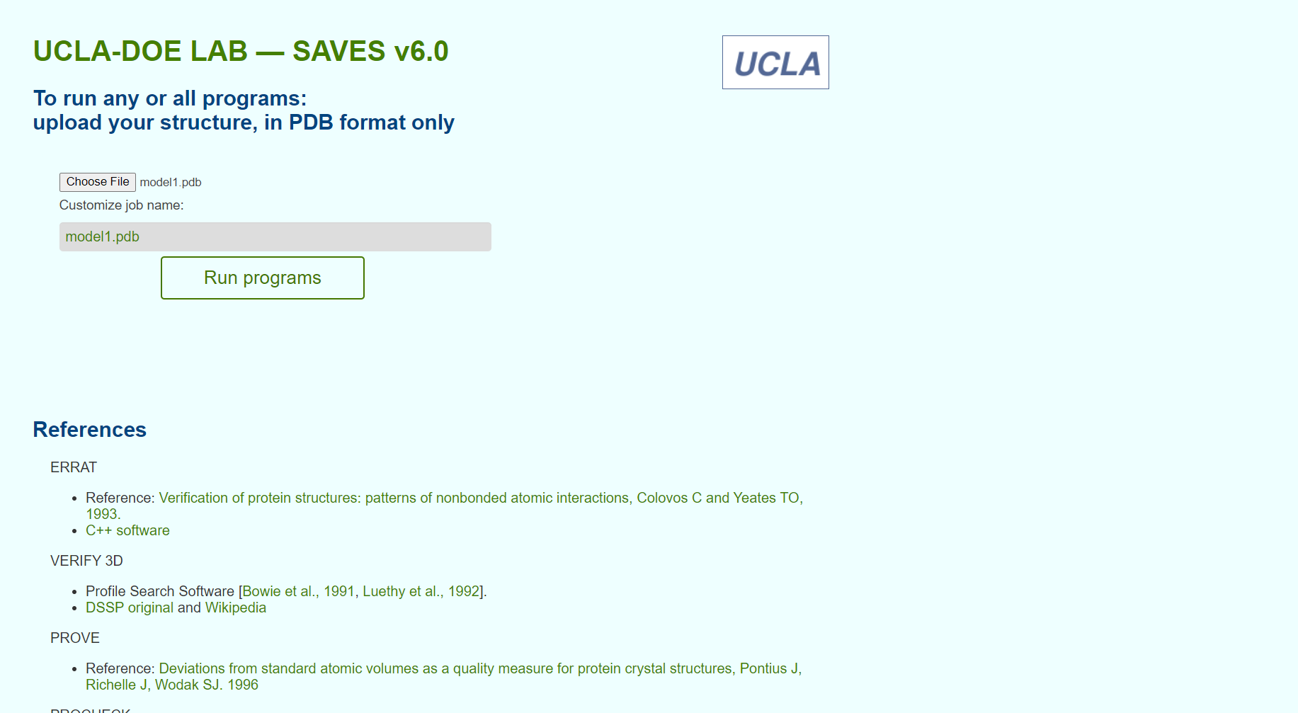**Fig2. Structure from Modeller for validation**

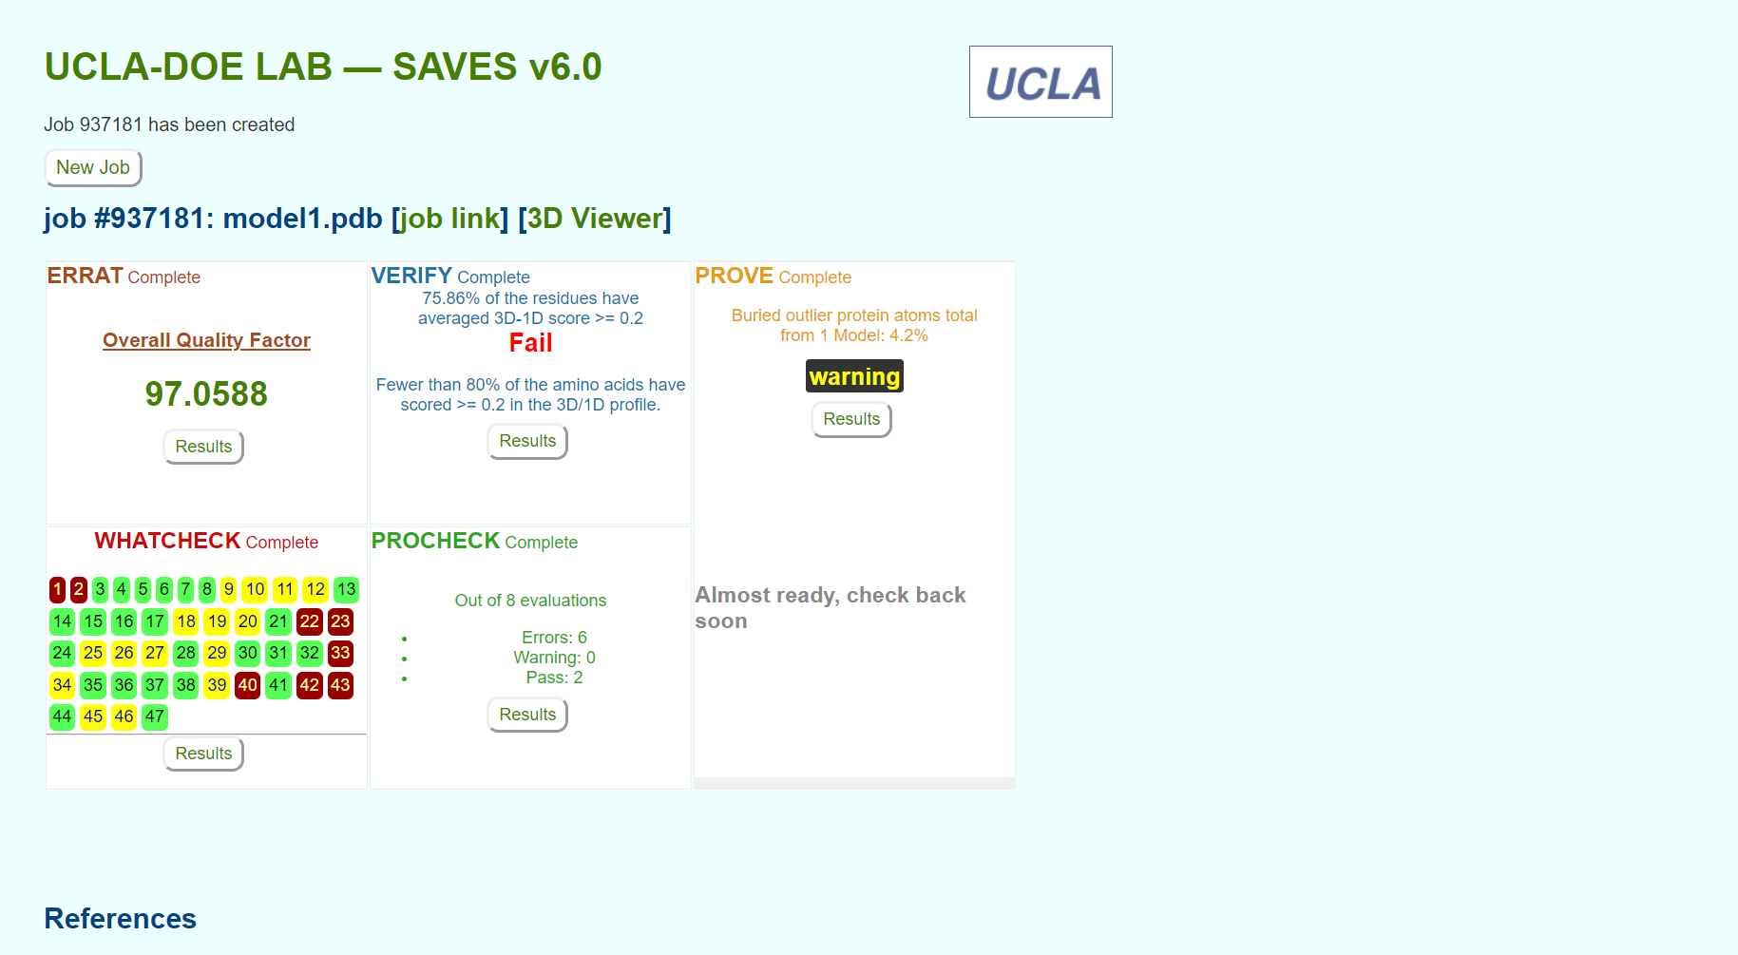**Fig3. Result page for structure validation for various servers**

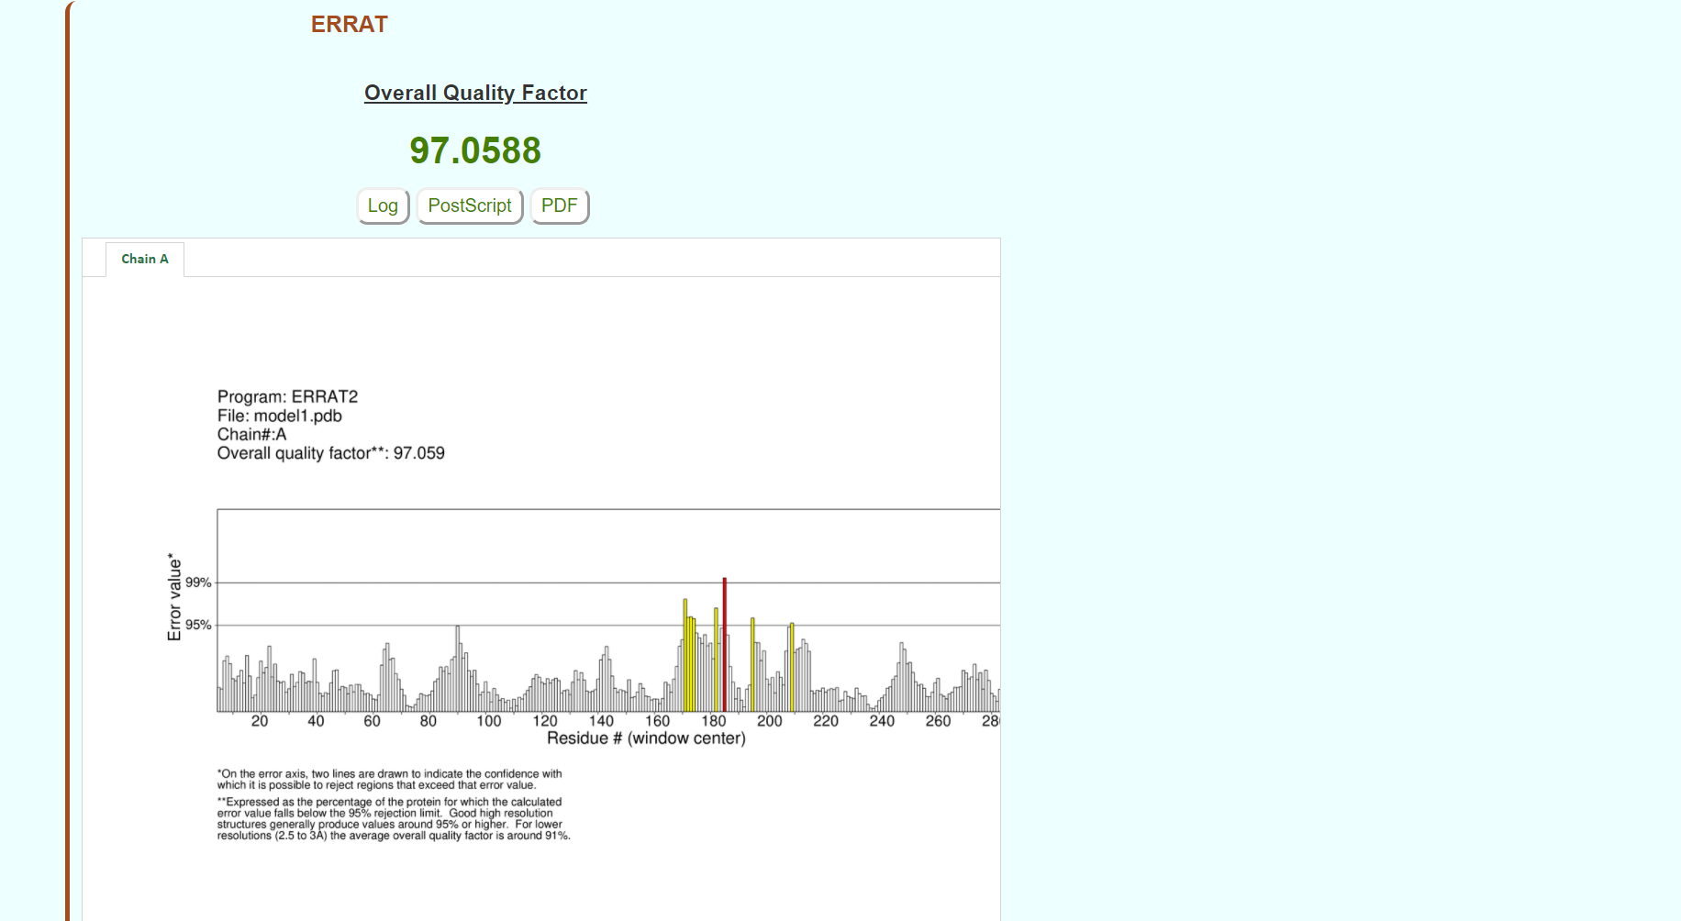**Fig4. Result page for Errat**

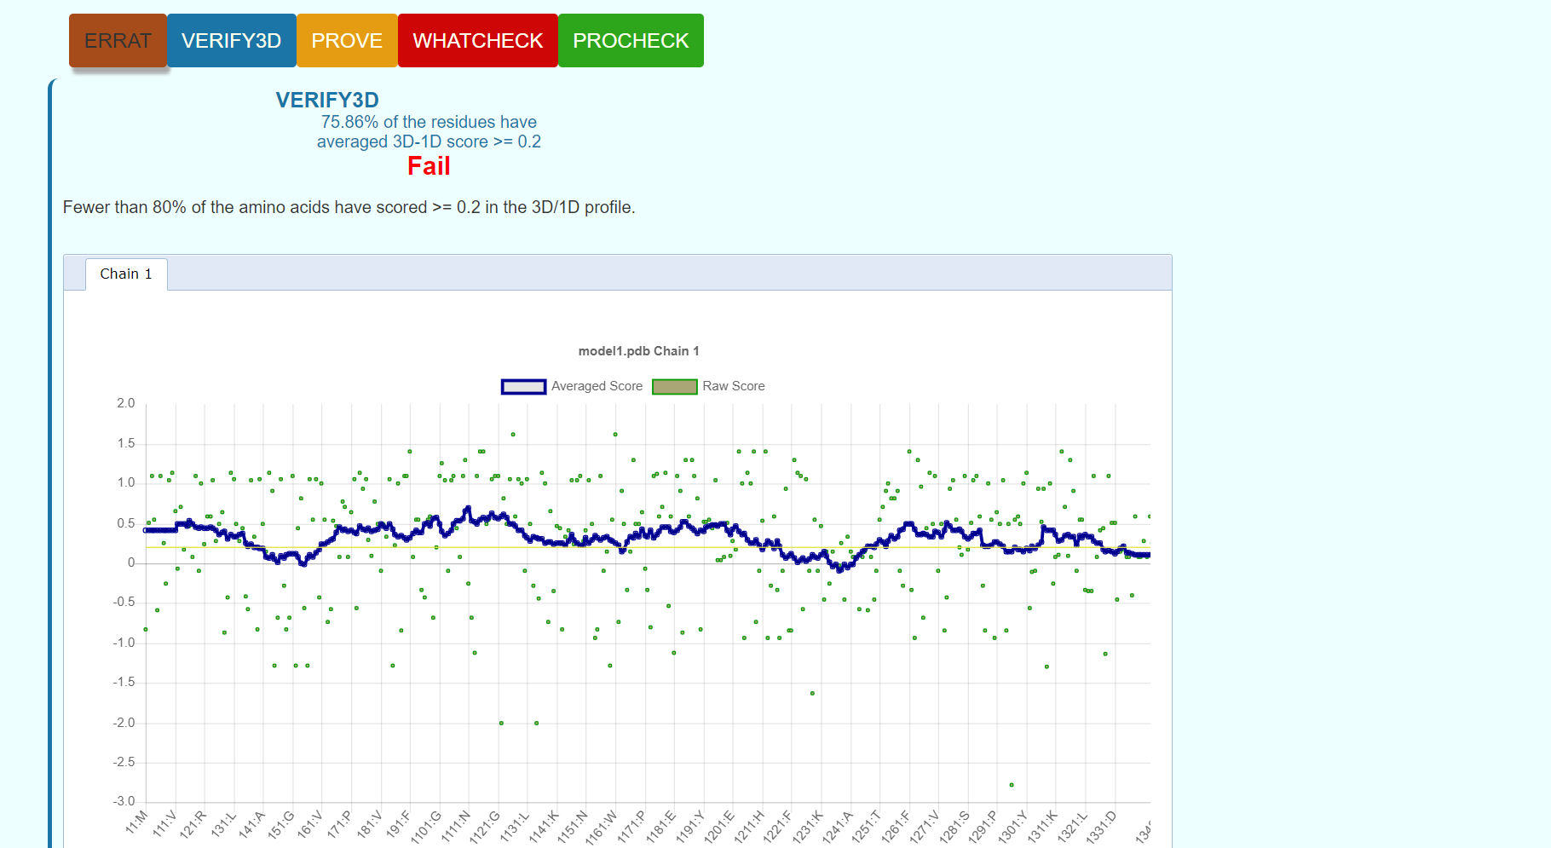**Fig5. Result page for Verify3D**

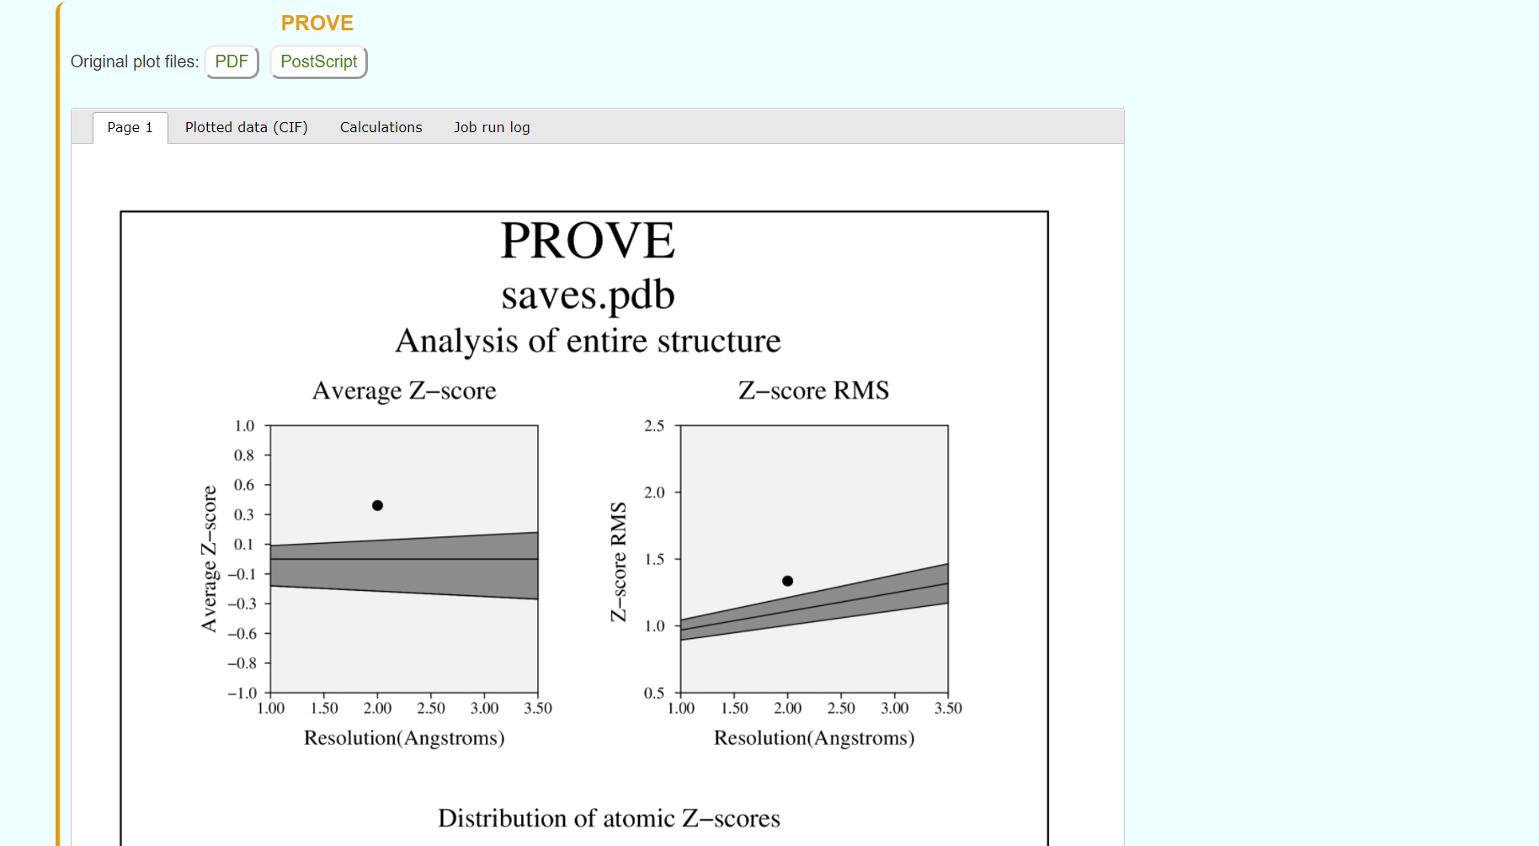**Fig6. Result page for Prove**

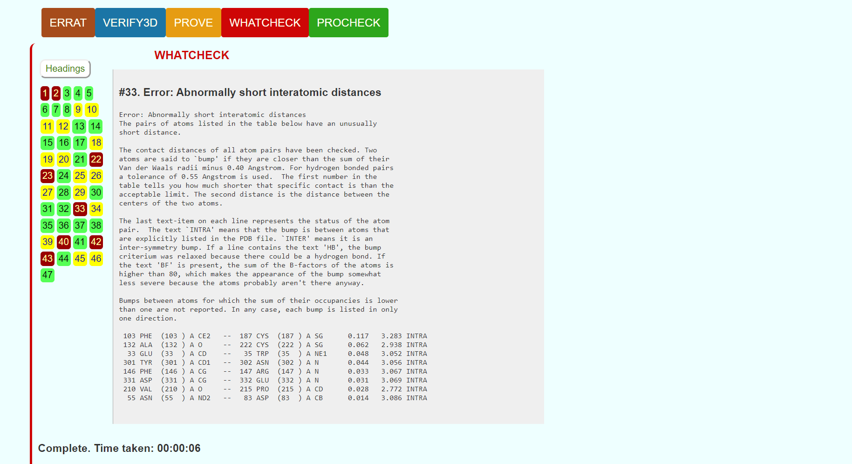**Fig7. Result page for Whatcheck**

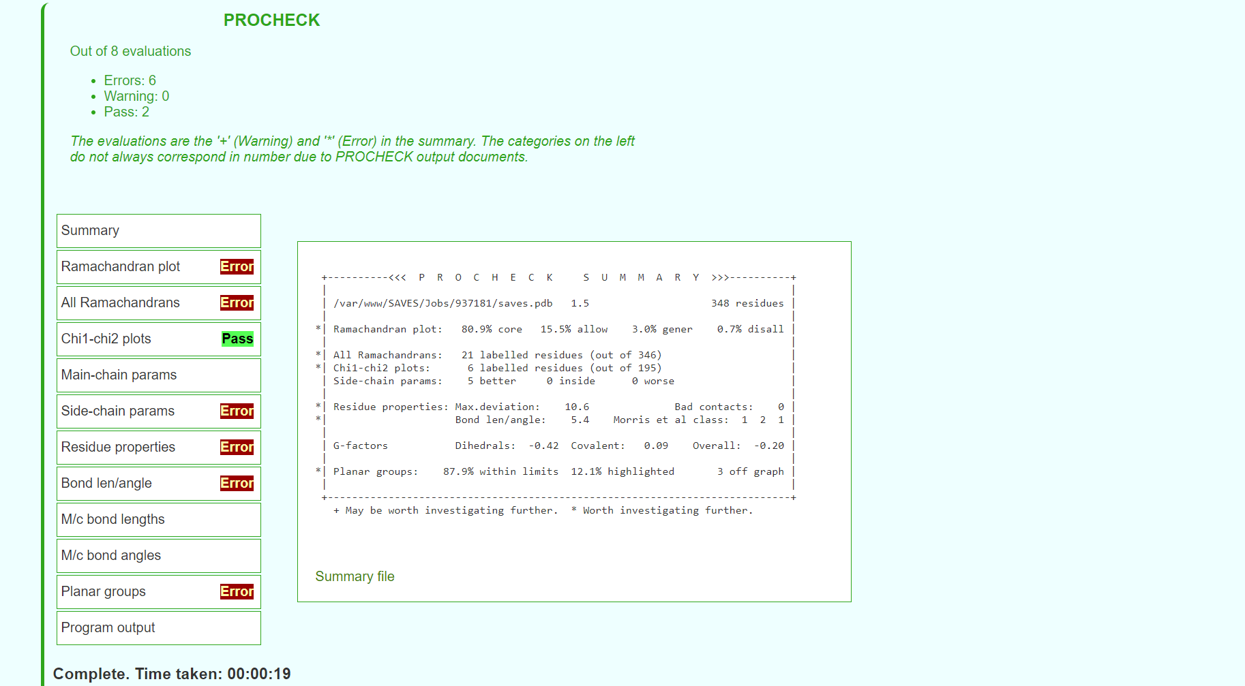**Fig8. Result page for Procheck**

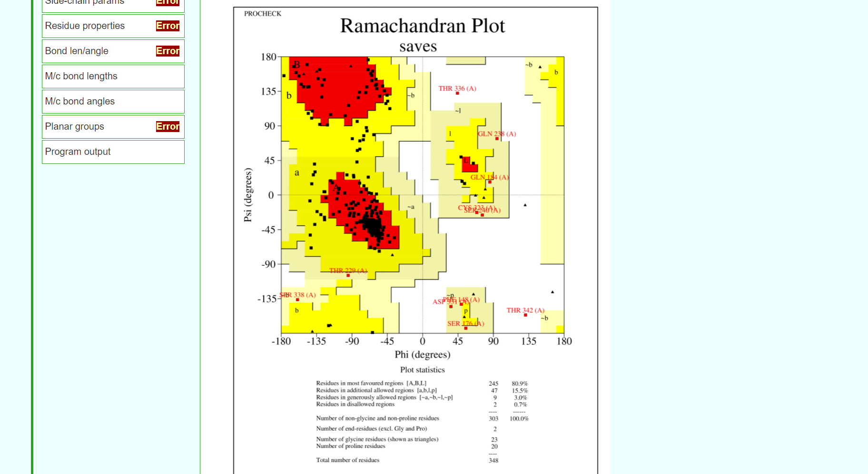**Fig9. Result page for Ramachandran plot**

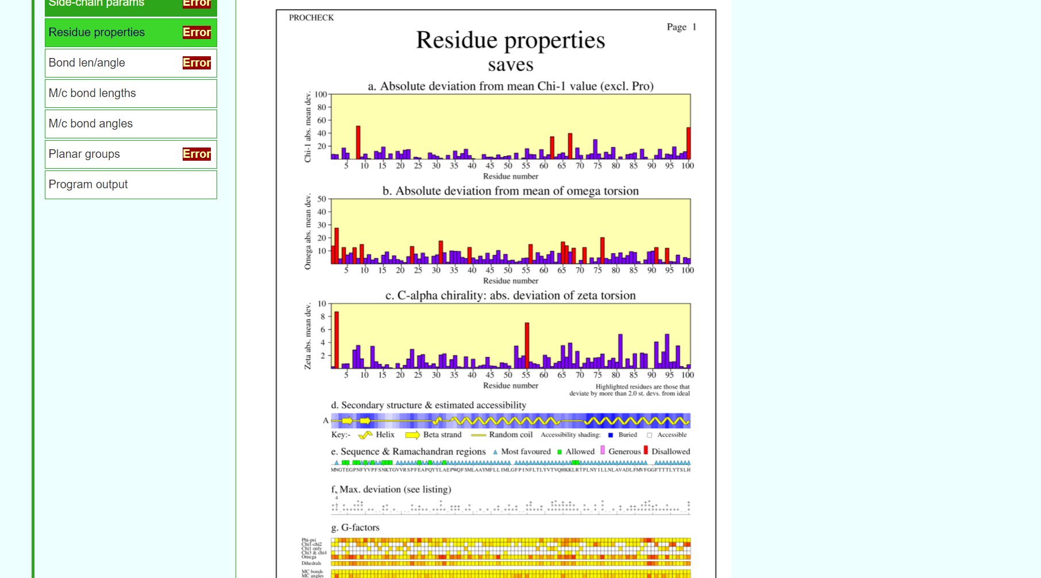**Fig10. Result page for reside properties**

**RESULT:**

The structure predicted for enzyme kinase by threading approach using I-TASSER was validated using SAVES server.

**CONCLUSION:**

SAVES in an integrated server containing various tools on a single platform that can be used for tertiary structure validation. The predicted structure for kinase by I-TASSER passed only for ERRAT and did not give required results for the rest. Even though I-TASSER gave better predicted structure than modeller, Robetta based on ab-initio approach will be used to predict a better structure and will be validated again using SAVES server.

**REFERENCES:**

1. Xiong, J. (2008).Tertiary structure prediction. Essential bioinformatics. Cambridge: Cambridge University Press. 220-222.
2. SAVESv6.0 - Structure Validation Server. (n.d.). Saves.mbi.ucla.edu. Retrieved March 8, 2022, from <https://saves.mbi.ucla.edu/>
3. SAVESv6.0 - Structure Validation Server. (n.d.). Saves.mbi.ucla.edu. Retrieved March 8, 2022, from <https://saves.mbi.ucla.edu/?job=924117>

**DATE: 10-03-22**

**WEBLEM 4c**

**SAVES server**

**(URL:** [**https://saves.mbi.ucla.edu/**](https://saves.mbi.ucla.edu/)**)**

**AIM:**

To validate structure 240040 generated from Robetta server.

**INTRODUCTION:**

240040 is the structure predicted using Ab-initio approach using Robetta. The structure has to be evaluated to make sure that the structural features of the model are consistent with the physicochemical rules. This can be done using SAVES server.

SAVES is a structure validation server that has various tools like Errat, Verify3D, Prove, Whatcheck, Procheck.and Cryst integrated in one single platform. This involves checking anomalies in φ–ψ angles, bond lengths, close contacts, and so on. Another way of checking the quality of a protein model is to implicitly take these stereochemical properties into account. This is a method that detects errors by compiling statistical profiles of spatial features and interaction energy from experimentally determined structures. By comparing the statistical parameters with the constructed model, the method reveals which regions of a sequence appear to be folded normally and which regions do not. If structural irregularities are found, the region is considered to have errors and has to be further refined.

**METHODOLOGY:**

1. Open homepage for SAVES server. (URL: <https://saves.mbi.ucla.edu/>)
2. Upload structure retrieved from Robetta in PDB format.
3. Obtain results for Errat, Verify3D, Prove, Whatcheck and Procheck.
4. Observe and interpret the results.

**OBSERVATION:**

**Fig1. Homepage for SAVES server**

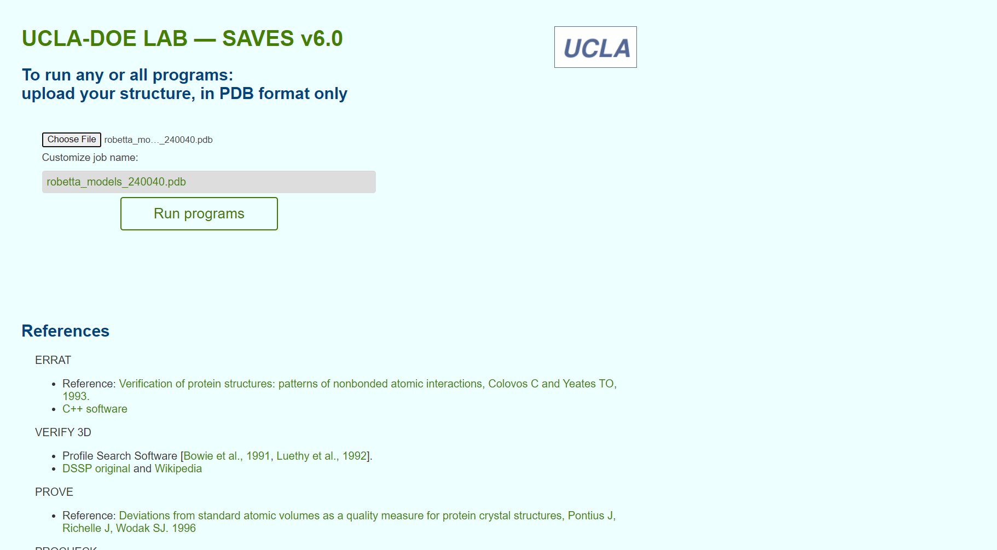**Fig2. Structure from Modeller for validation**

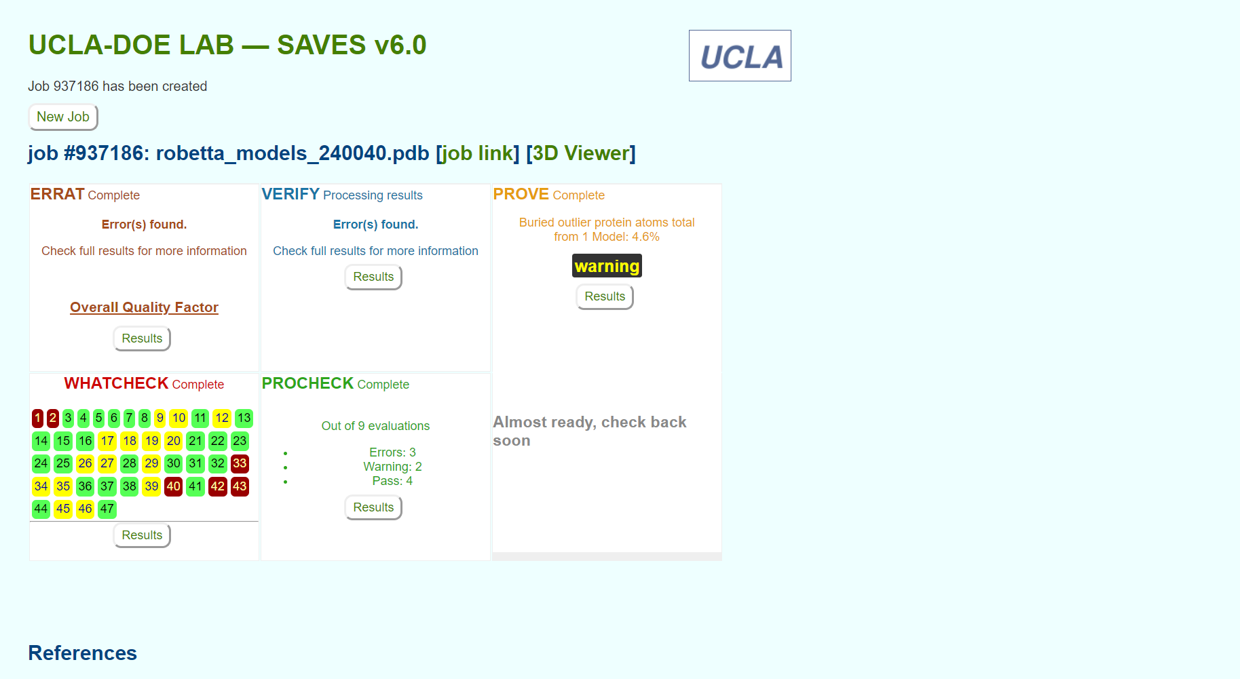**Fig3. Result page for structure validation for various servers**

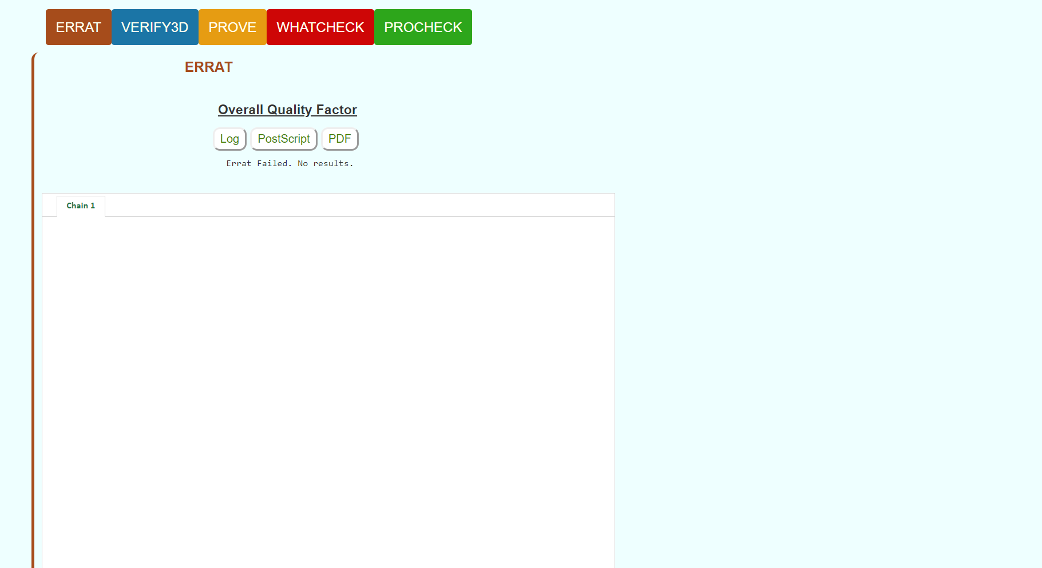**Fig4. Result page for Errat**

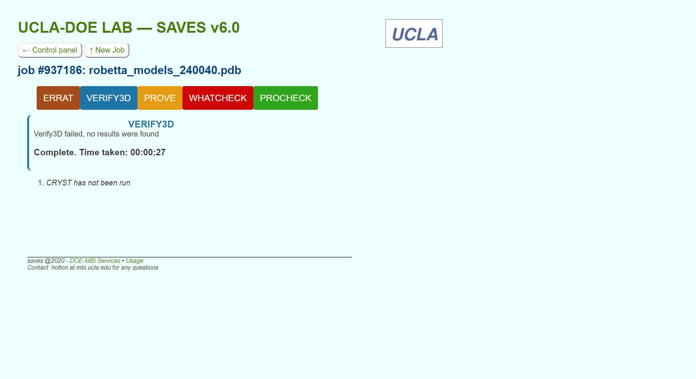**Fig5. Result page for Verify3D**

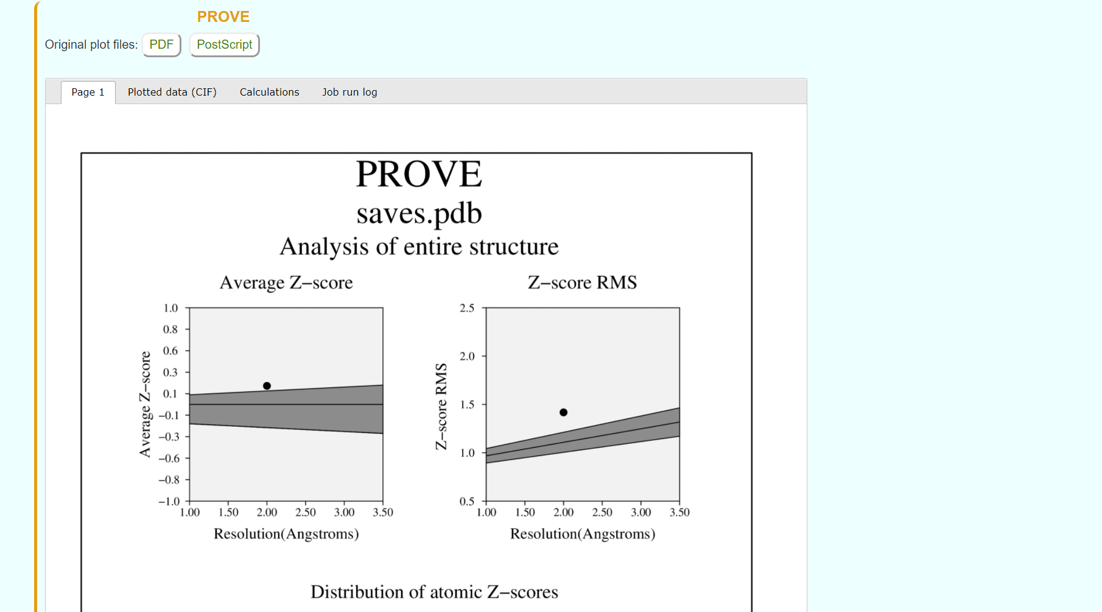**Fig6. Result page for PROVE**

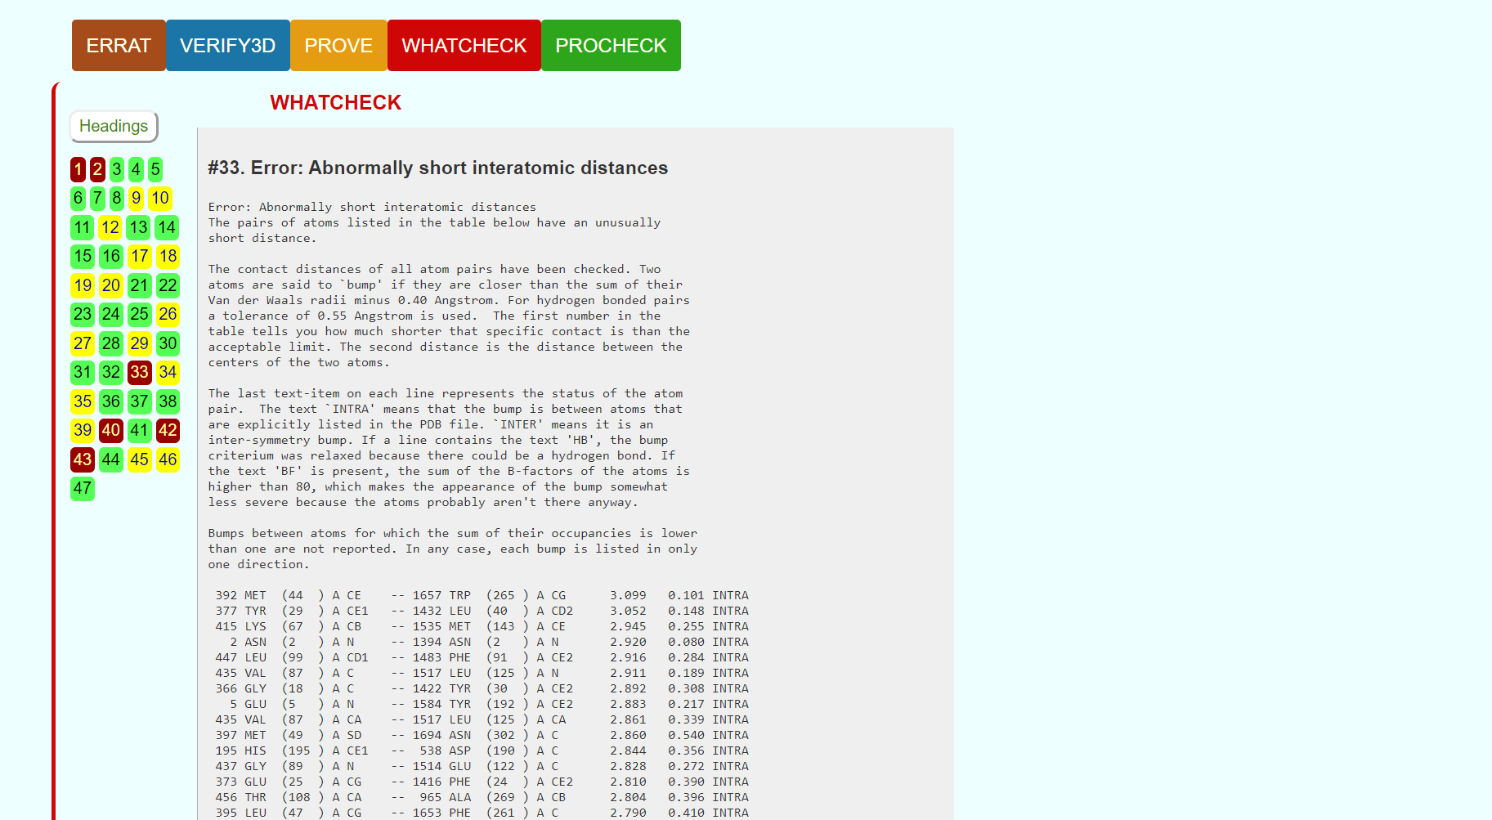**Fig7. Result page for Whatcheck**

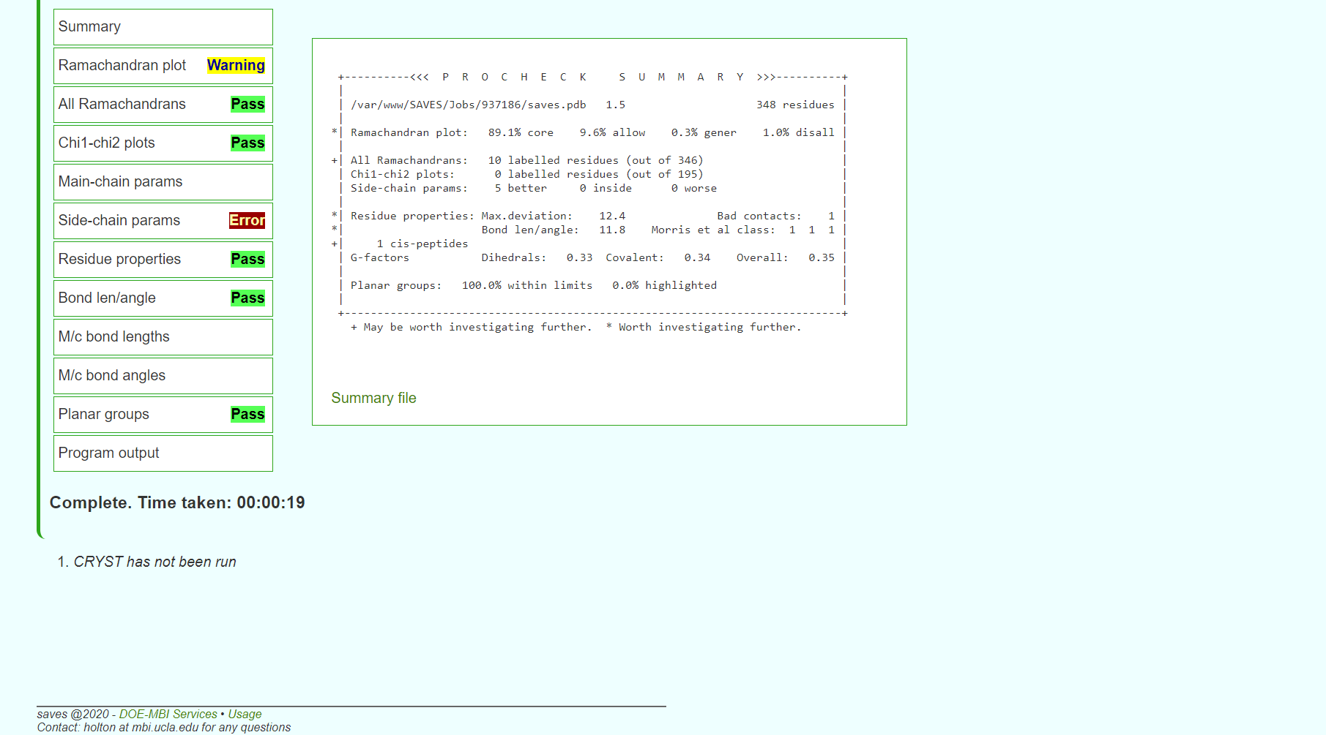**Fig8. Result page for Procheck**

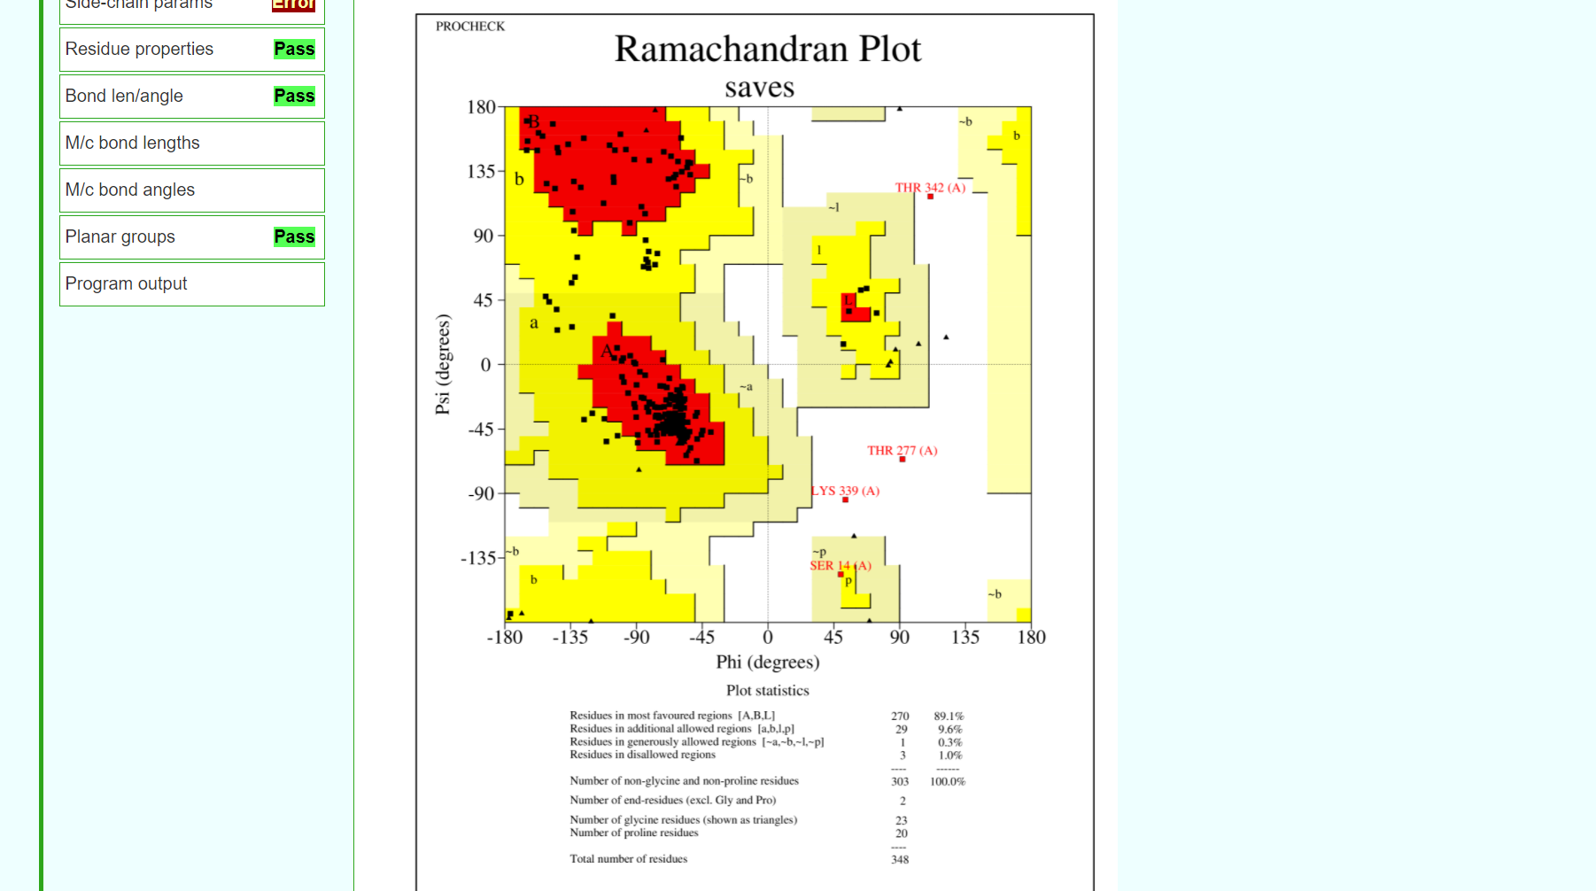**Fig9. Result page for Ramachandran plot**

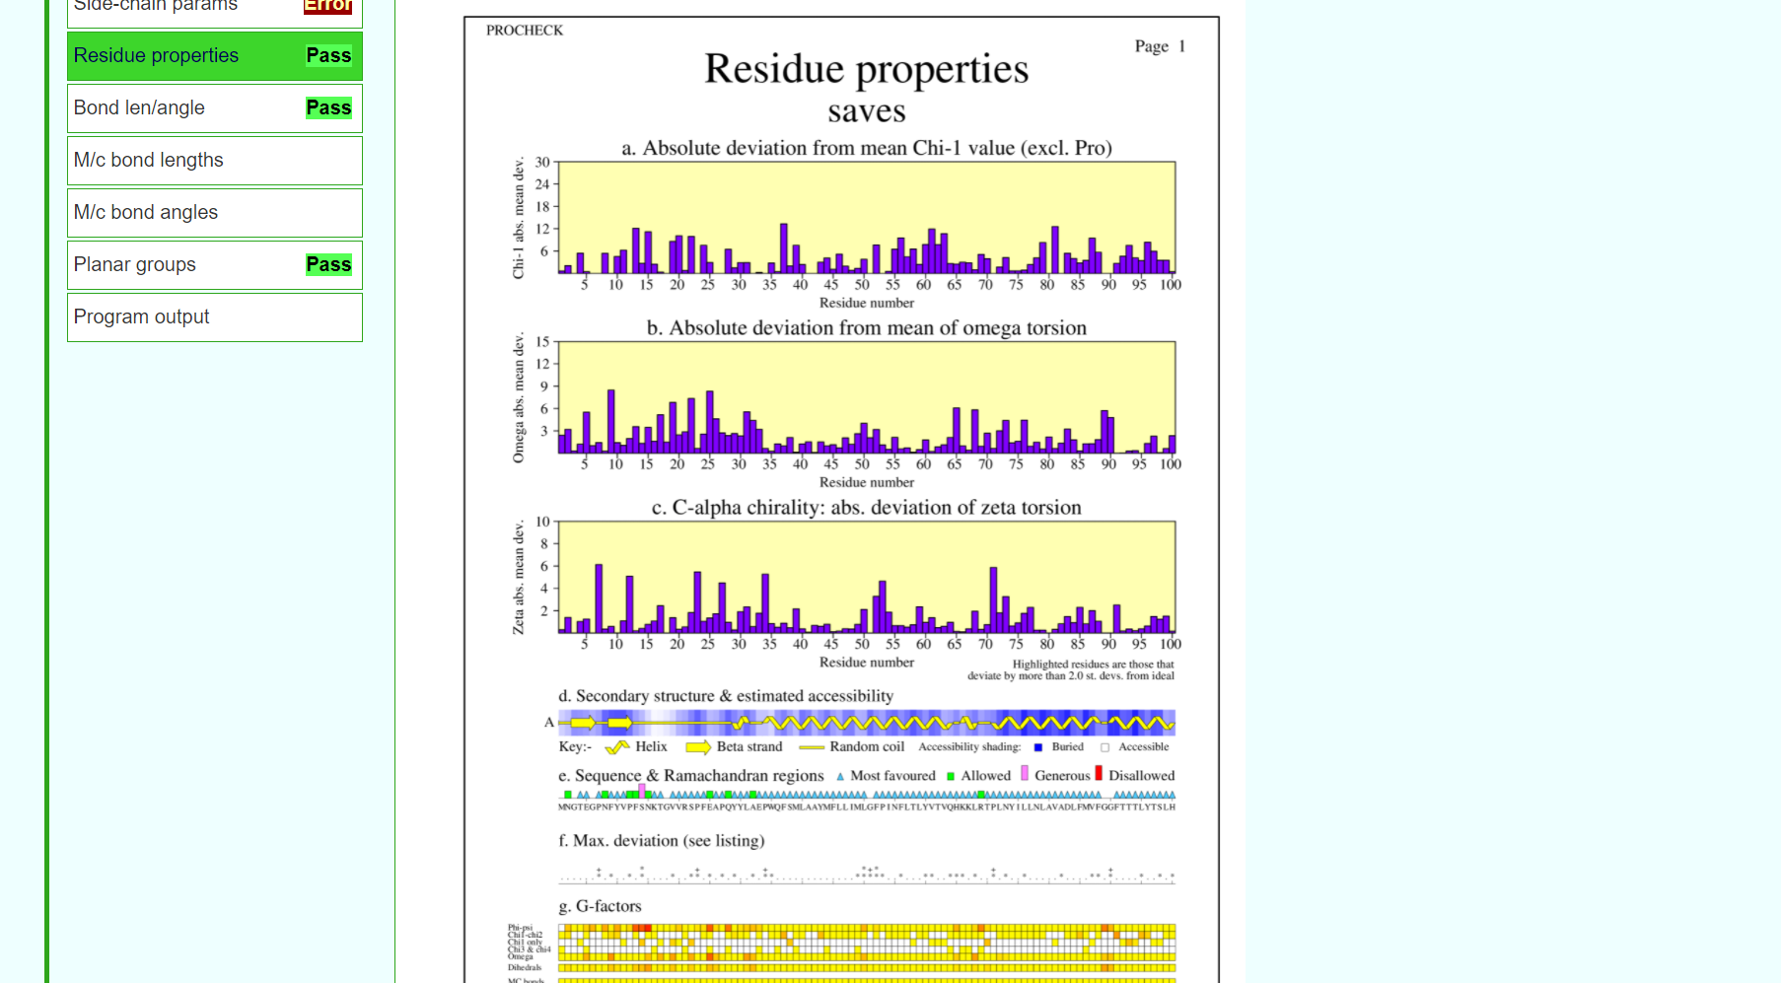**Fig10. Result page for residue properties**

**RESULT:**

The structure predicted for enzyme kinase by abi-initio approach using Robetta was validated using SAVES server.

**CONCLUSION:**

SAVES in an integrated server containing various tools on a single platform that can be used for tertiary structure validation. The predicted structure for Rhodopsin by Robetta passed maximum requirements of validation. Hence, it can be concluded that the structure predicting by Robetta was the most accurate out of all three methods used for prediction.

**REFERENCES:**

1. Xiong, J. (2008).Tertiary structure prediction. Essential bioinformatics. Cambridge: Cambridge University Press. 220-222.
2. SAVESv6.0 - Structure Validation Server. (n.d.). Saves.mbi.ucla.edu. Retrieved March 8, 2022, from <https://saves.mbi.ucla.edu/>
3. SAVESv6.0 - Structure Validation Server. (n.d.). Saves.mbi.ucla.edu. Retrieved March 8, 2022, from <https://saves.mbi.ucla.edu/?job=928054>

**Date: 05-03-22**

**WEBLEM 5**

**Introduction to Visualization of Tertiary structure using RASMOL & PyMOL**

We can obtain all the available information about the 3D structure of this enzyme by browsing through the links or download the PDB file to a local directory in our computer and work with our preferred molecular modelling and visualization package.

**RasMol:**

RasMol is a computer program written for molecular graphics visualization intended and used primarily for the depiction and exploration of biological macromolecule structures, such as those found in the Protein Data Bank. It was originally developed by Roger Sayle in the early 90s. Historically, it was an important tool for molecular biologists since the extremely optimized program allowed the software to run on (then) modestly powerful personal computers. Before RasMol, visualization software ran on graphics workstations that, due to their expense, were less accessible to scholars. RasMol has become an important educational tool as well as continuing to be an important tool for research in structural biology.

**Installation:**

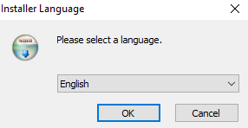

**Select language and proceed**

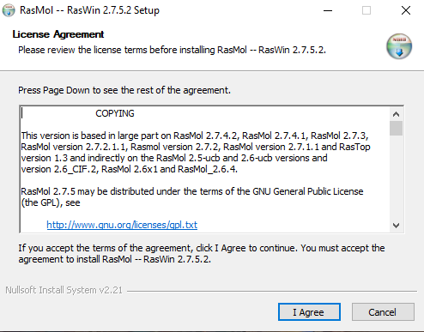

**Read the License Agreement and click “I Agree” to proceed**

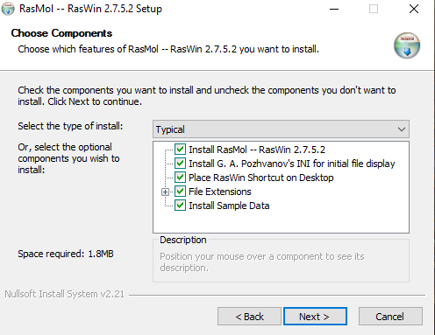

**Select the components of RasMol you want to install and click “Next” to proceed**

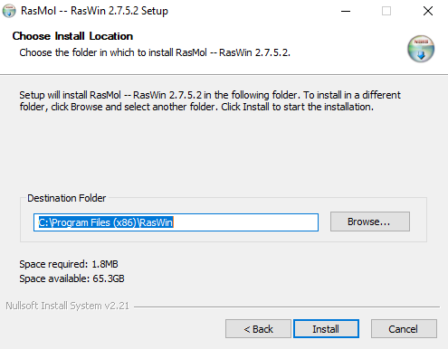

**Select the directory in which you want to install RasMol and click “Install” to proceed**

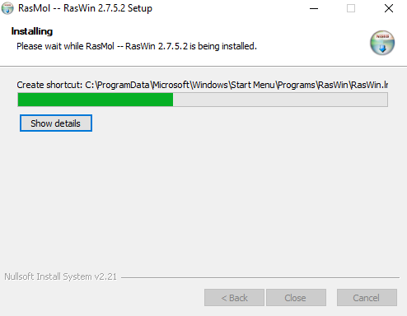

**The software will now install**

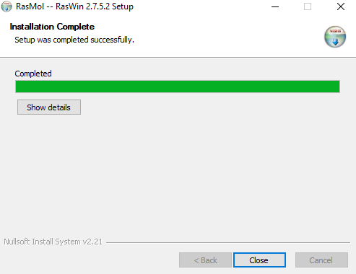

**Close the installer after the install is completed**

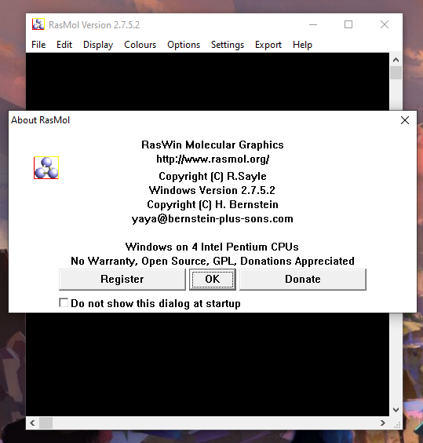

**RasMol is now installed**

**PyMol**

PyMOL, a cross-platform molecular graphics tool, has been widely used for three-dimensional (3D) visualization of proteins, nucleic acids, small molecules, electron densities, surfaces, and trajectories. It is also capable of editing molecules, ray tracing, and making movies. This Python-based software, alongside many Python plugin tools, has been developed to enhance its utilities and facilitate the drug design in PyMOL. To gain an insightful view of useful drug design tools and their functions in PyMOL, we present an extensive discussion on various molecular modeling modules in PyMOL, covering those for visualization and analysis enhancement, protein–ligand modeling, molecular simulations, and drug screening.

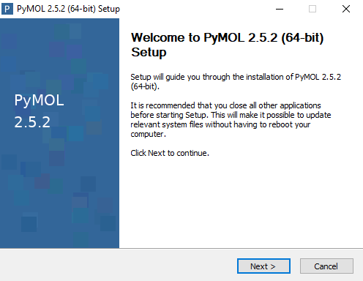

**Download and run the installer. Click next to proceed**

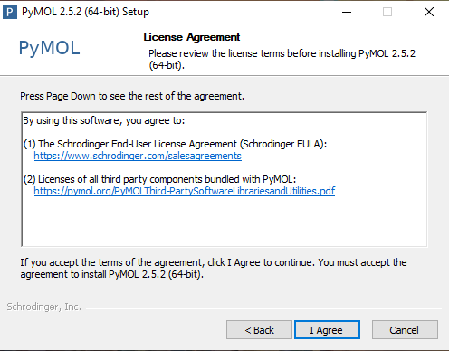

**Read the License Agreement and click “I Agree” to proceed**

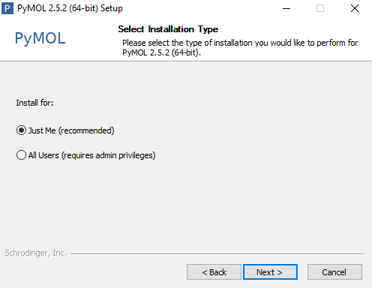

**Select the Installation type and click “Next” to proceed**

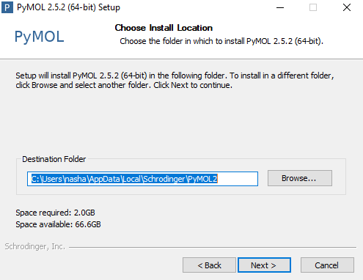

**Select the Directory in which you want to install PyMol**

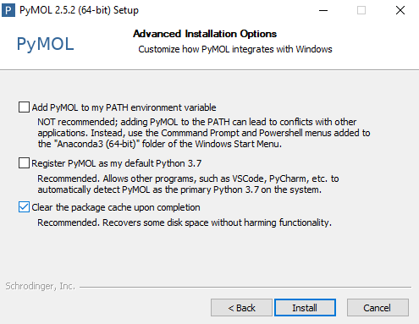

**Select the additional options if you want to and click “Install” to start the installation of PyMol**

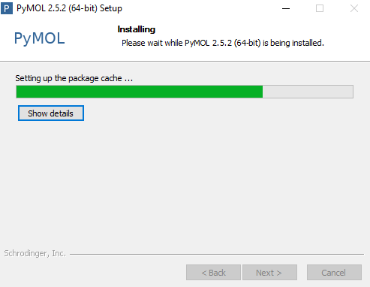

**Let the installer install PyMol**

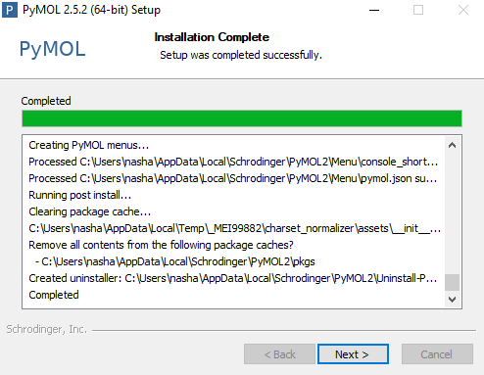

**After completion click on “Next” to finalize installation**

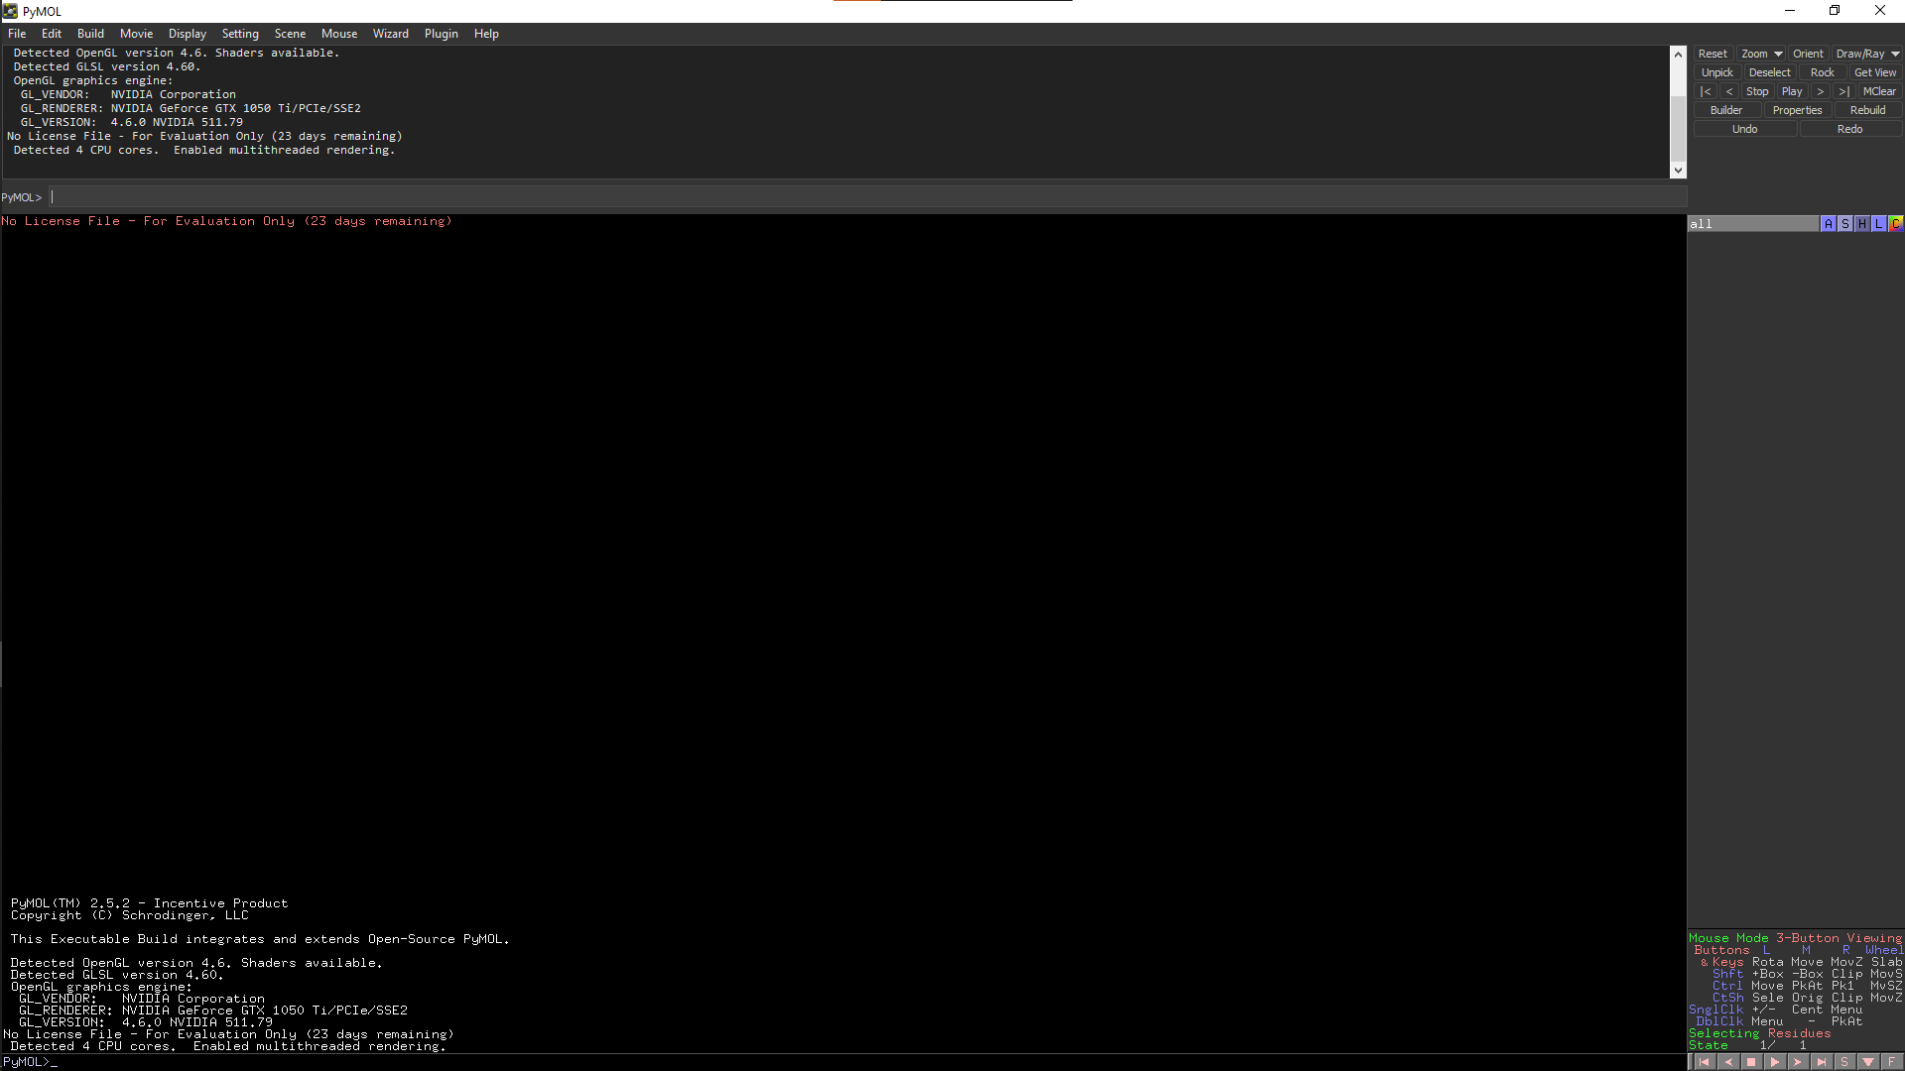

**Pymol is now installed**

Thus, RASMOL and PyMOL tools can be used for protein structure visualisation which is helpful in understanding protein–ligand modeling, molecular simulations, and drug screening. It provides an essential support for presenting results, reasoning on and formulating hypotheses related to molecular structure. It also helps to analyze and compare protein structures to gain insight to functions of the proteins.

**REFERENCES:**

1. Xiong, J. (2008). Protein Structure Visualization, Comparison, and Classification. Essential bioinformatics. Cambridge: Cambridge University Press. 187-188.
2. Yuan, S., Chan, H. C. S., & Hu, Z. (2017). Using PyMOL as a platform for computational drug design. WIREs Computational Molecular Science, 7(2). <https://doi.org/10.1002/wcms.1298>
3. RasMol and OpenRasMol. (n.d.). Www.openrasmol.org. Retrieved March 4, 2022, from <http://www.openrasmol.org/>
4. PyMOL | pymol.org. (2019). Pymol.org. Retrieved March 4, 2022, from <https://pymol.org/2/>

**Date: 05-03-22**

**WEBLEM 6A**

**To visualize 3D structure of Hemoglobin (1SI4) using RASMOL & PyMOL tool**

**RASMOL:**

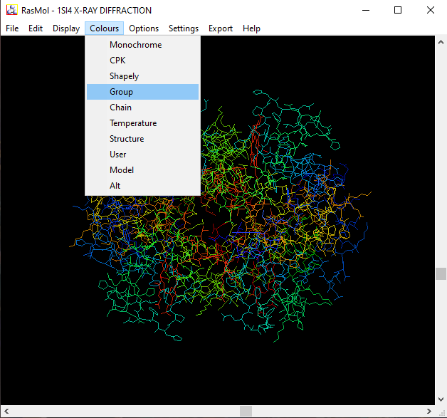

**Fig1. PDB Structure of Hemoglobin (1SI4) loaded in RasMol to show it in 3D space with the colour scheme set to Groups**

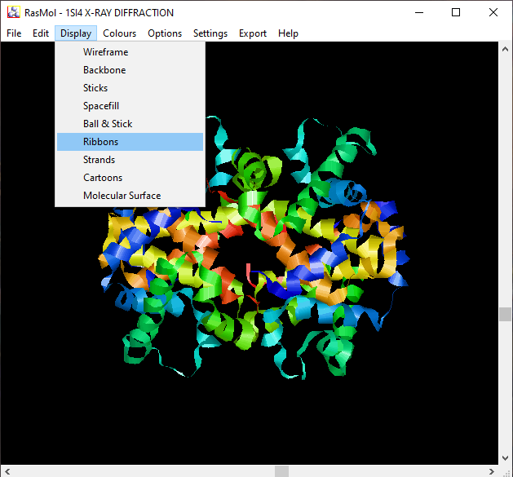

**Fig2. PDB structure of Hemoglobin (1SI4) Shown with the display mode set to ribbons**

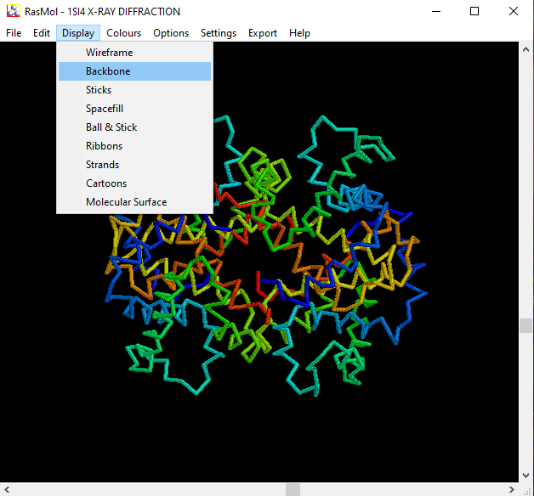

**Fig3. PDB structure of Hemoglobin (1SI4) shown with display type set to Backbone**

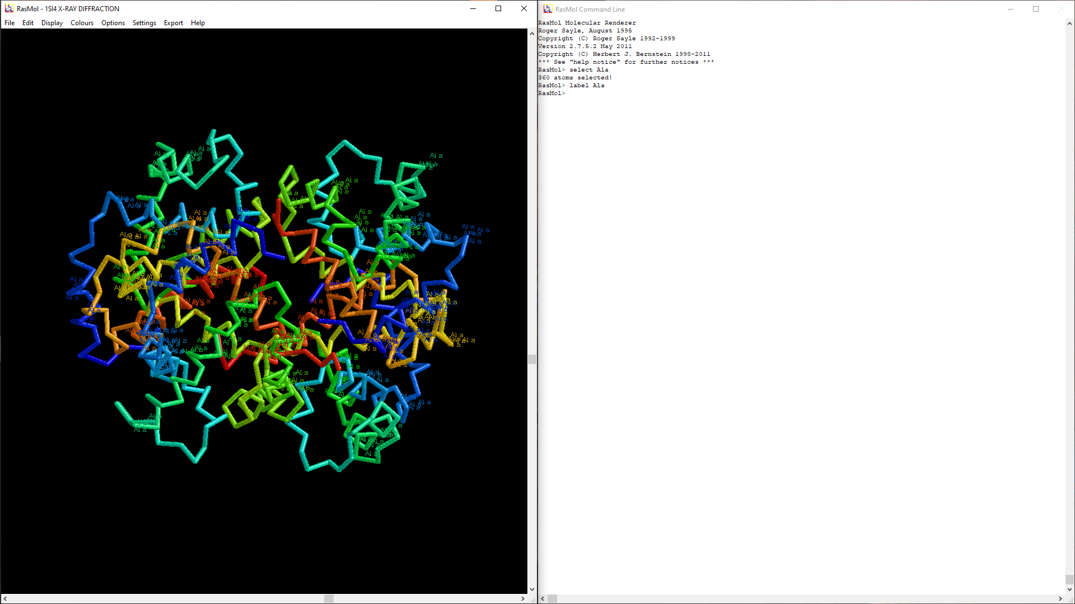**Fig.4 PDB Structure of Hemoglobin (1SI4) visualizing Alanine in the structure.**

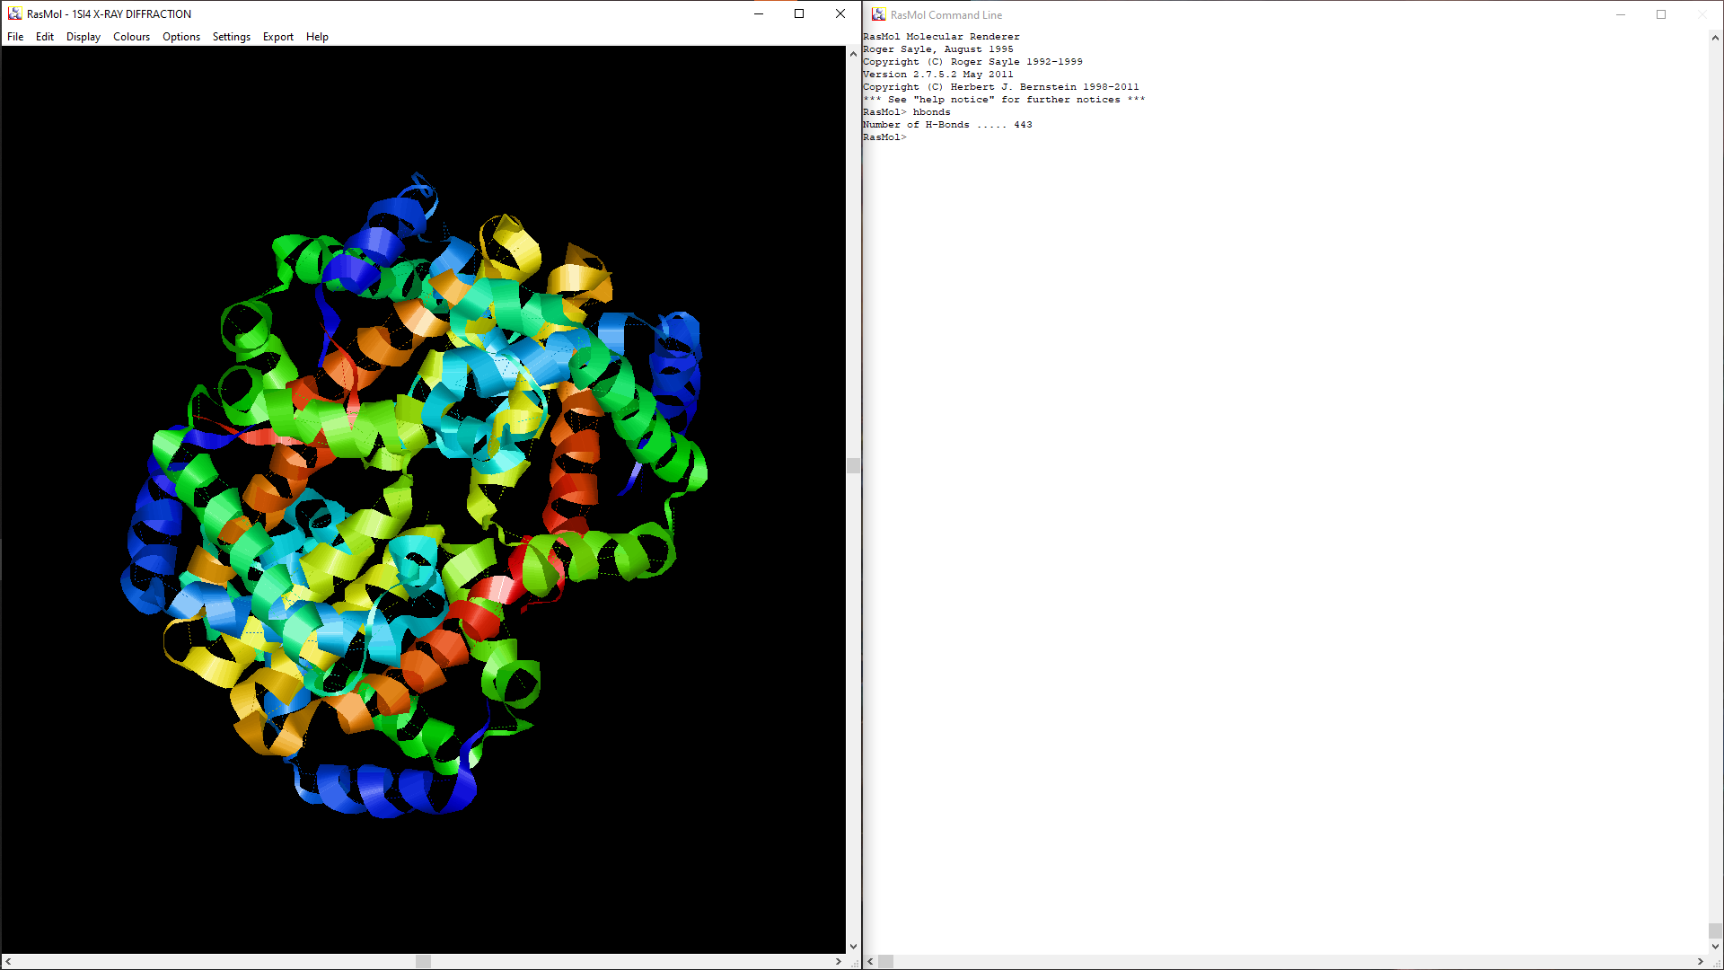**Fig5. PDB structure of Hemoglobin (1SI4) with Hydrogen Bonds visualized**

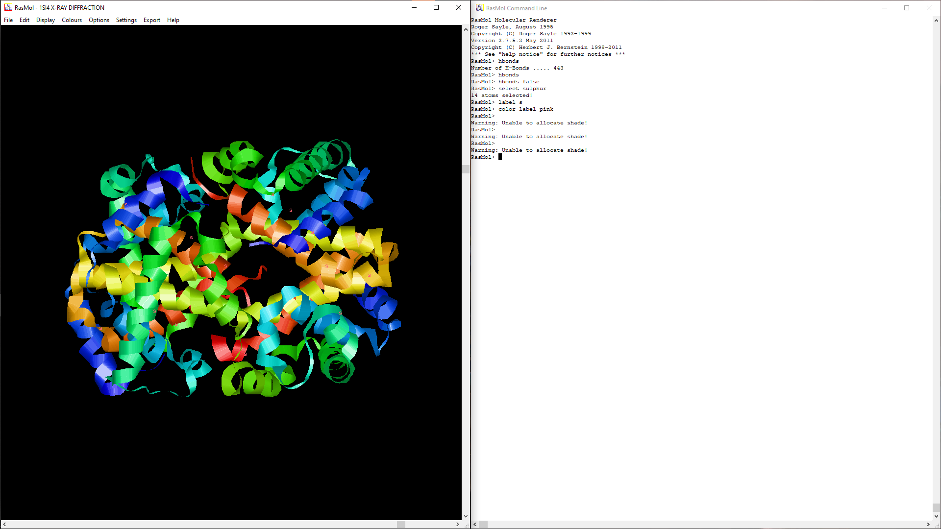**Fig6. PDB structure of Hemoglobin (1SI4) with sulphur atoms visualized with label “s”**

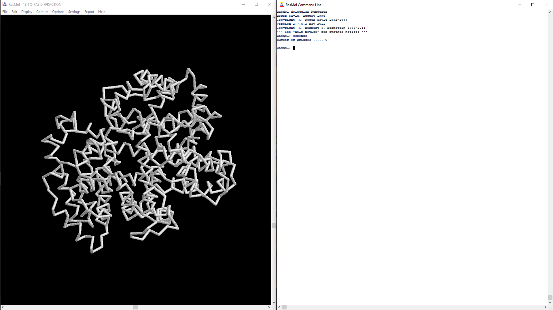**Fig7. PDB structure of Hemoglobin (1SI4) visualizing sulphuer-sulphur bonds (0 in this case)**

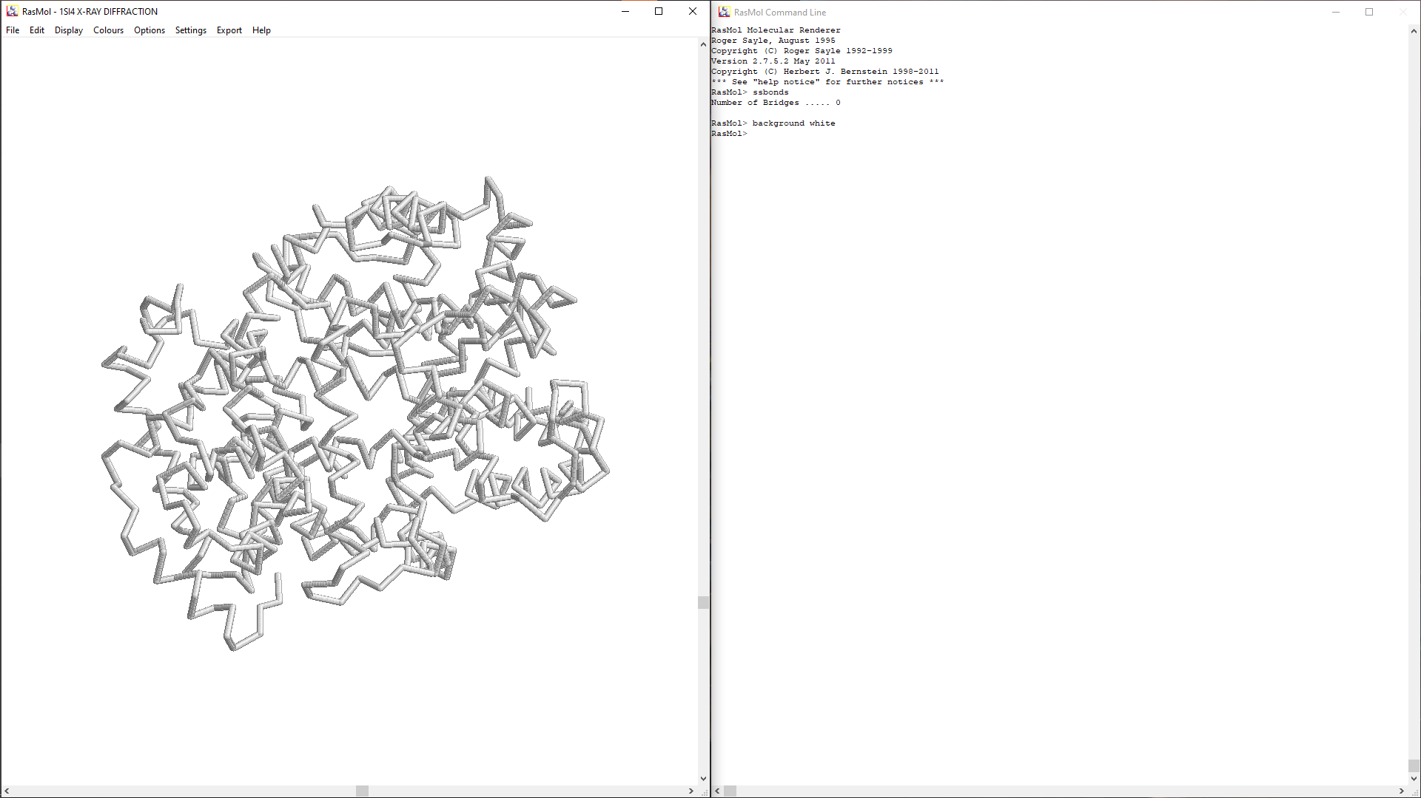**Fig8. PDB structure of Hemoglobin (1SI4) with the background color set to white to clearly see the sulphur-sulphur bonds (0 in this case)**

**PYMOL:**

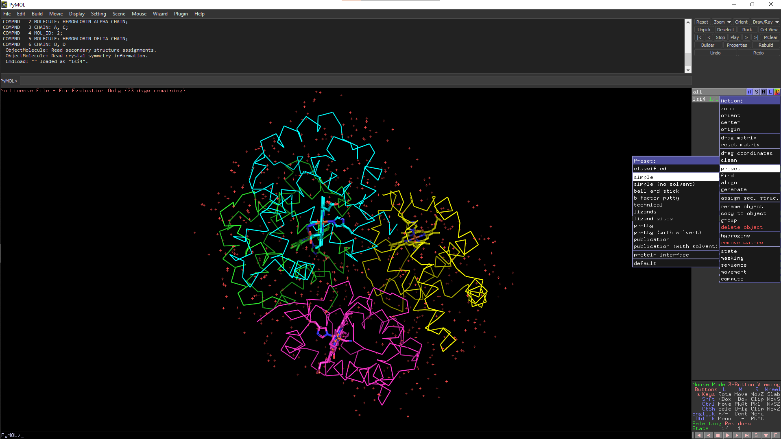

**Fig9. PDB structure Hemoglobin (1SI4) loaded in PyMol and set to simple view preset**

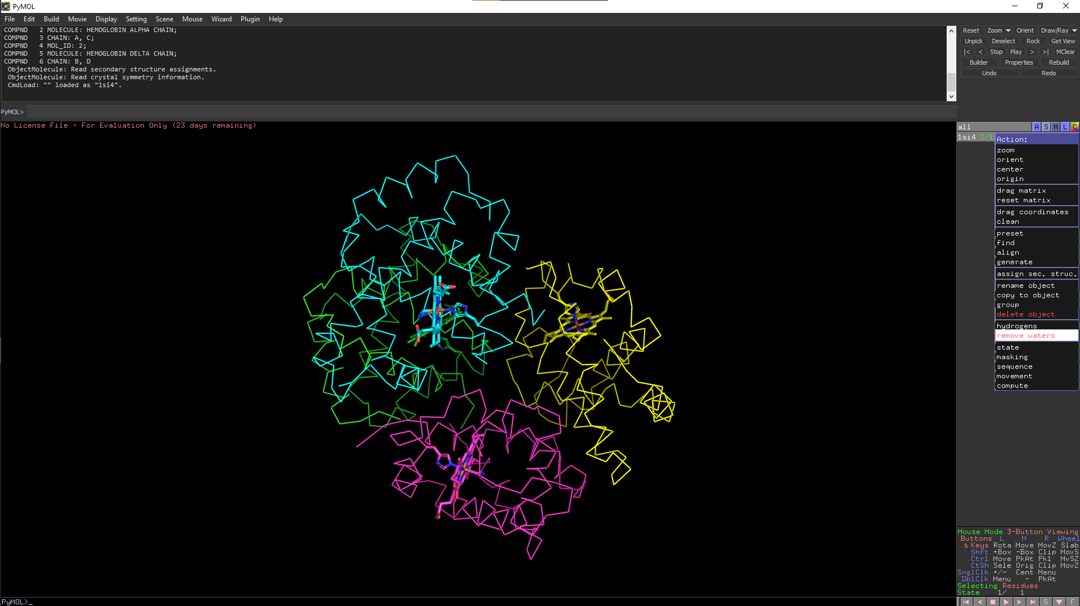**Fig10. PDB structure of Hemoglobin (1SI4) with waters removed**

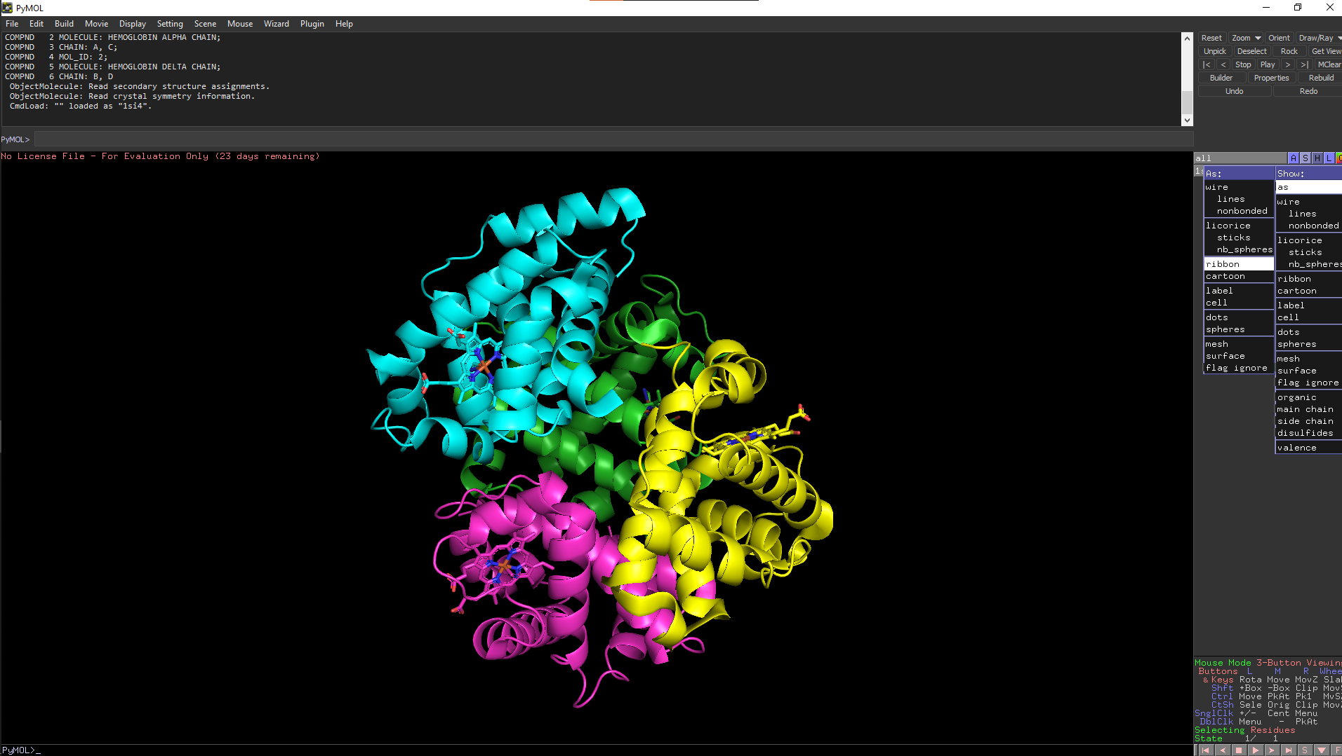**Fig11. PDB structure of Hemoglobin (1SI4) with visual style set to ribbon**

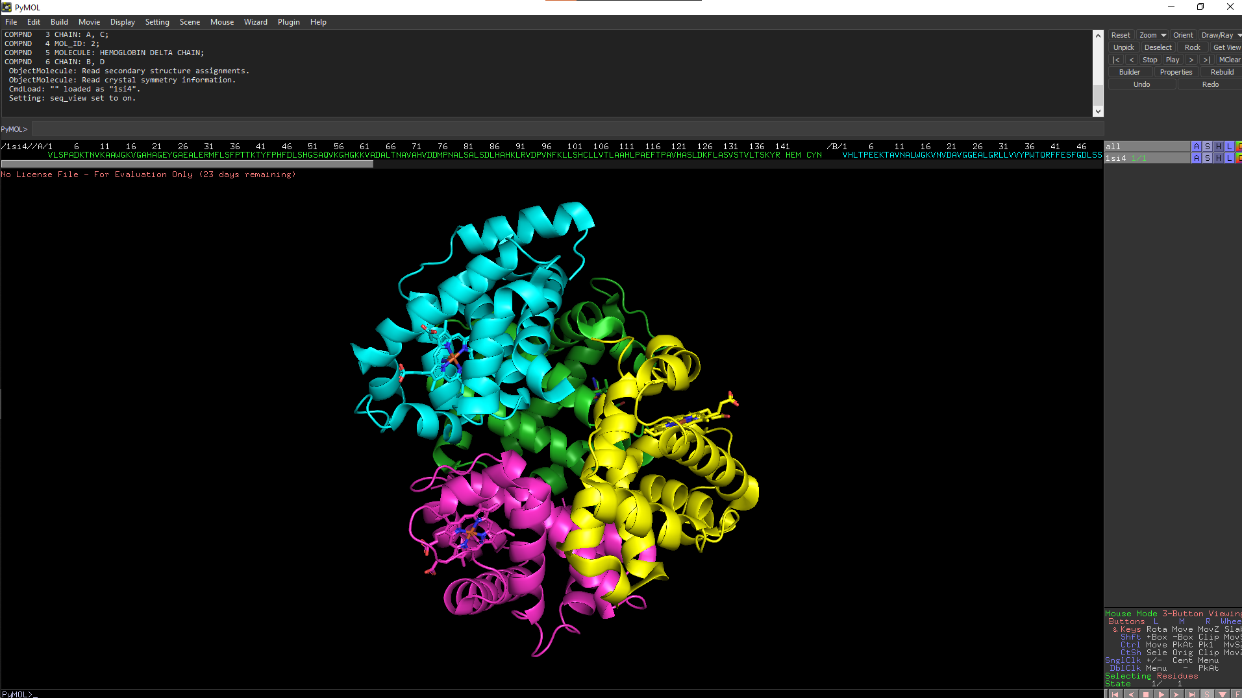**Fig12. PDB structure of Hemoglobin (1SI4) with the sequence displayed**

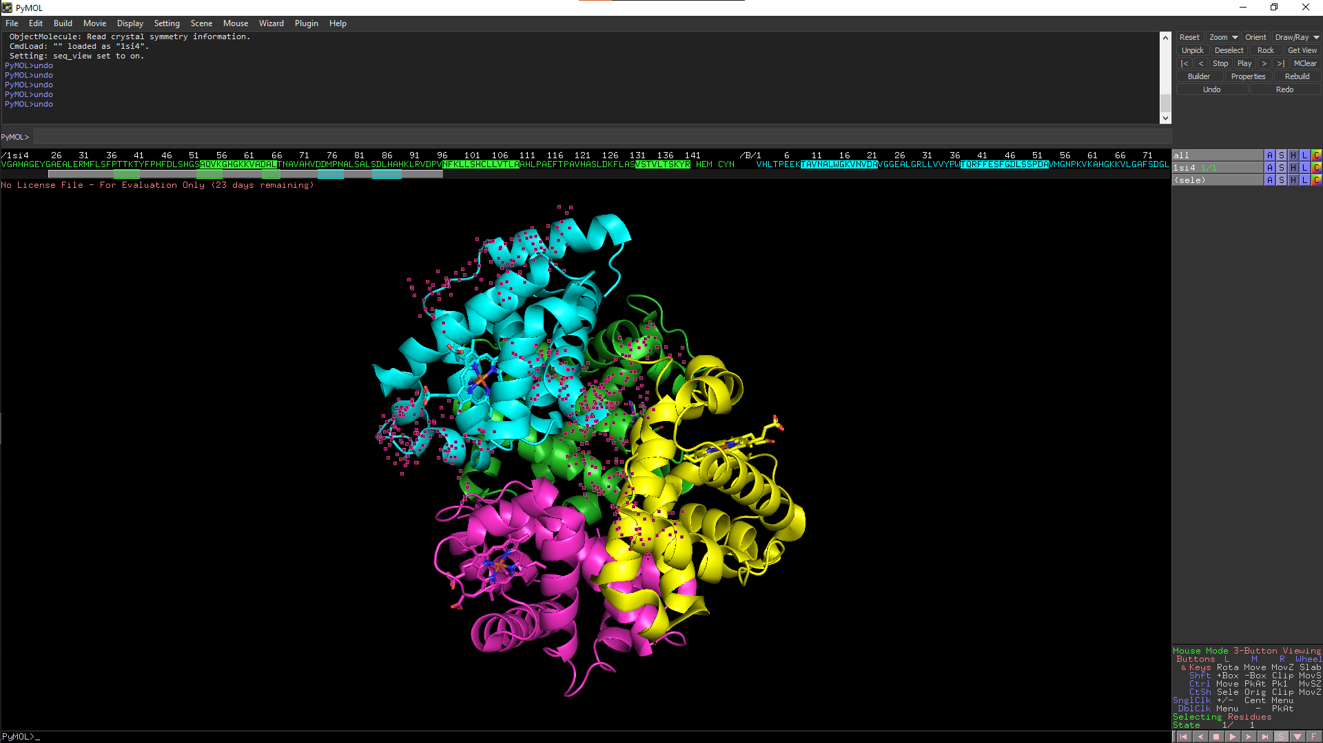**Fig13. PDB structure of Hemoglobin (1SI4) with random segments from sequence selected and visualized**

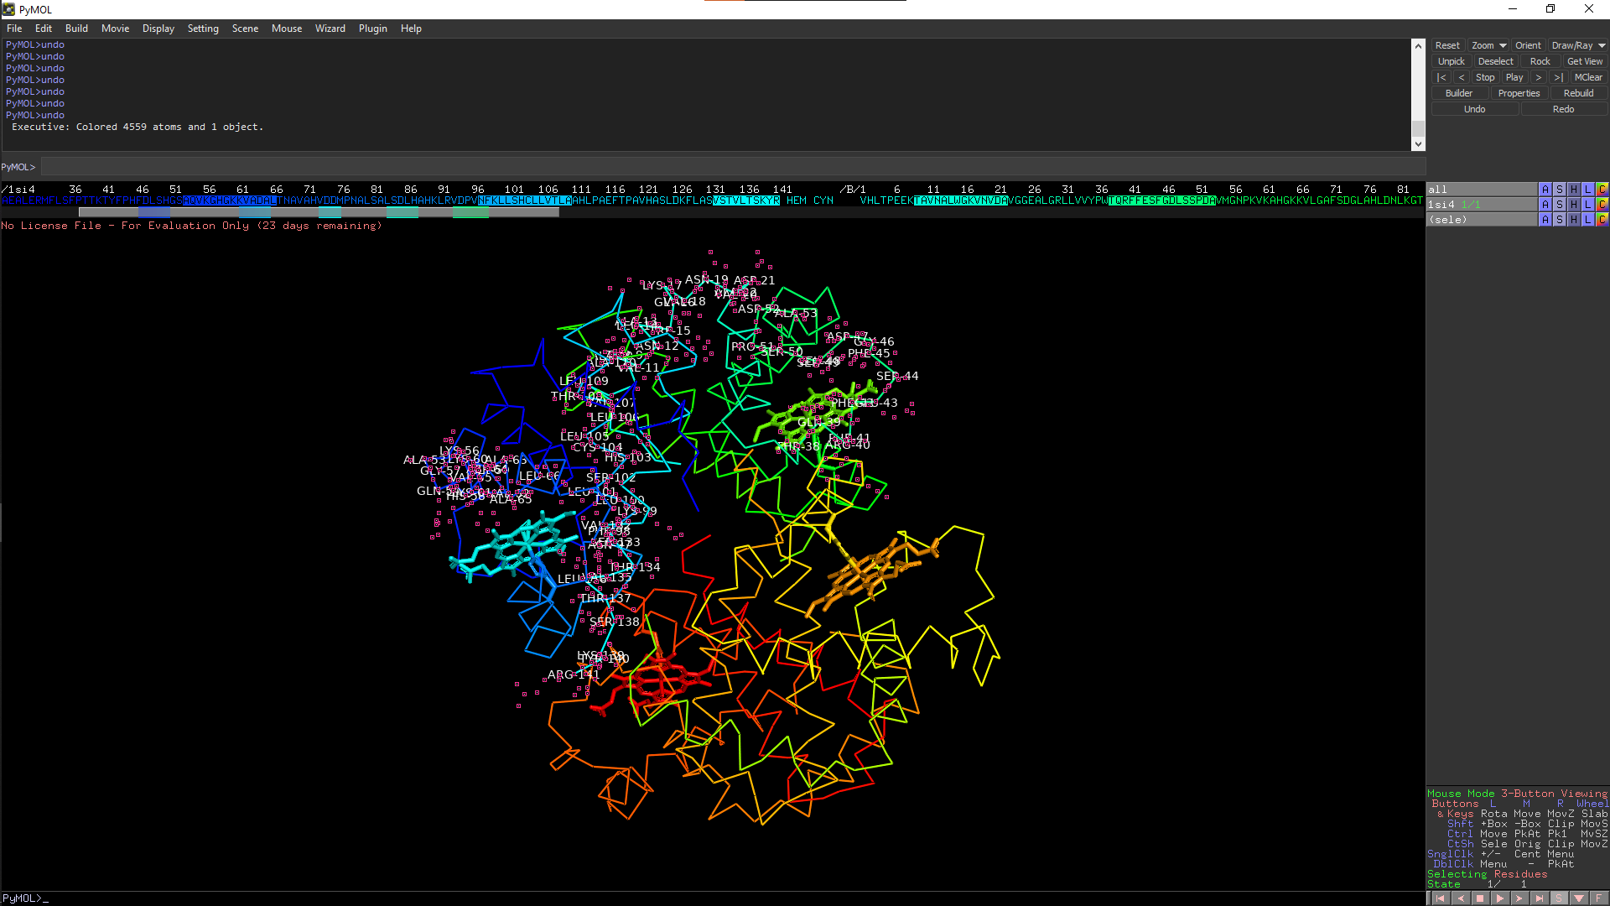**Fig14. PDB structure of Hemoglobin (1SI4) with the residues of the randomly selected segments from sequence visualized**

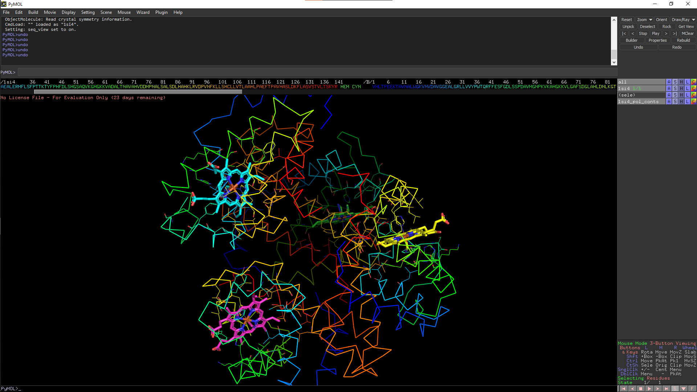**Fig15. PDB structure of Hemoglobin (1SI4) with it set to preset ligand view**

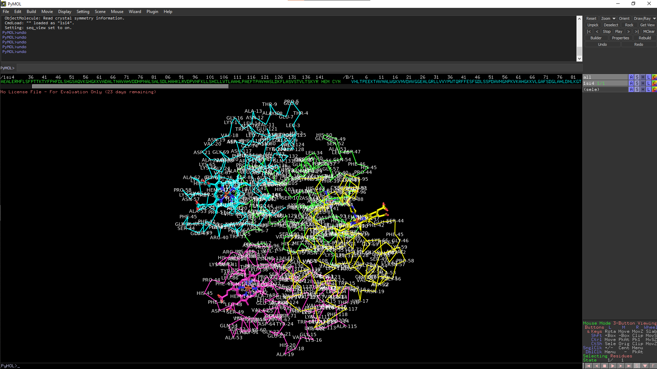**Fig16. PDB structure of Hemoglobin (1SI4) with all its residues labelled**

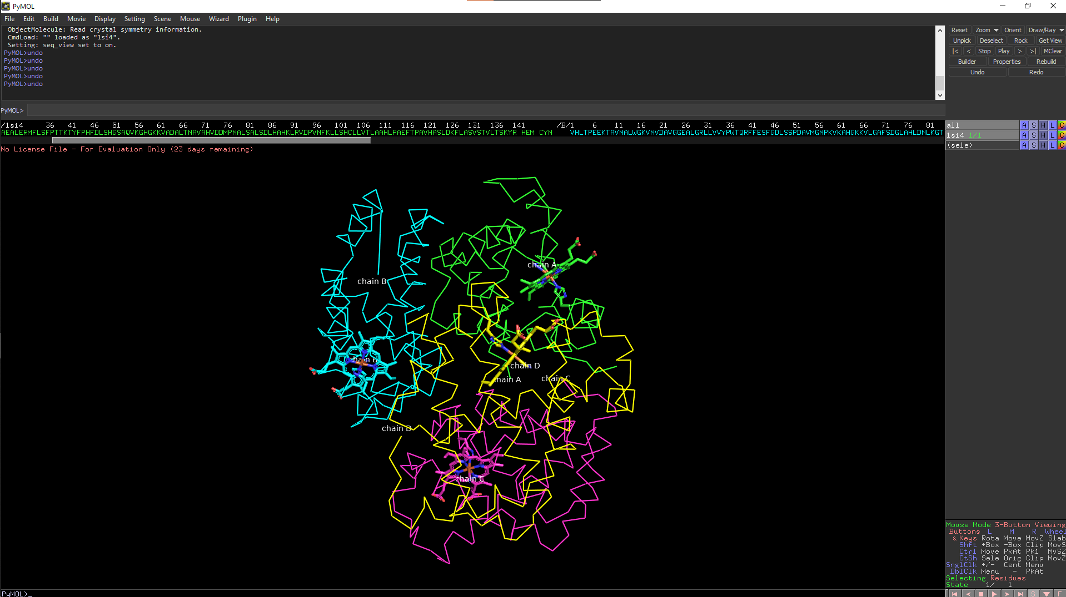**Fig17. PDB structure of Hemoglobin (1SI4) with all its chains labelled**

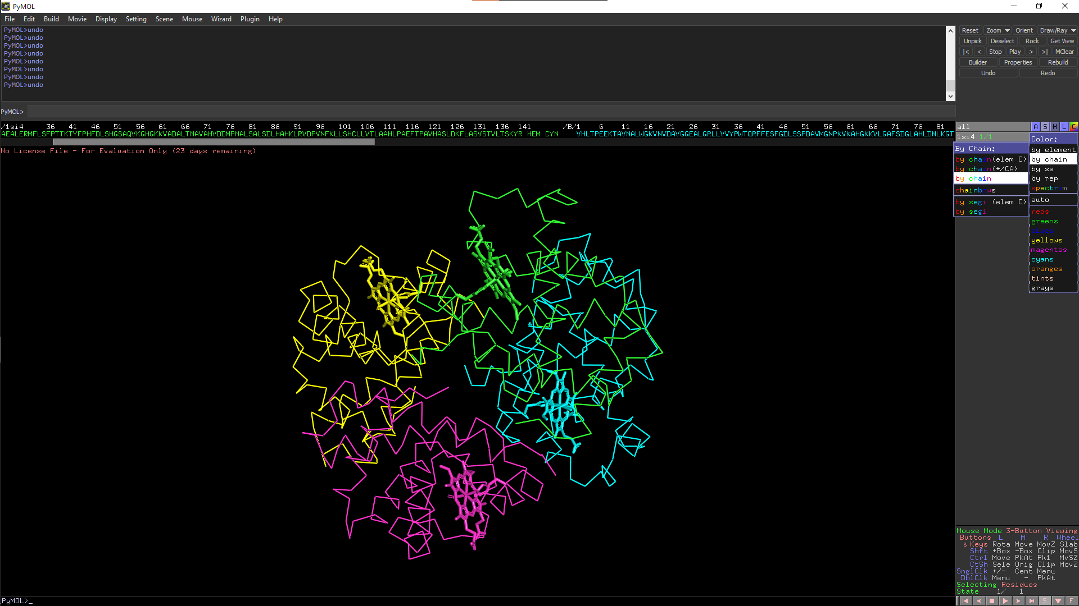**Fig18. PDB structure of Hemoglobin (1SI4) visualized with the chain color scheme set to rainbow**

**RESULT:**

Hemoglobin structure was visualised with various formats along with its residues, bonds and chains using RASMOL and PyMOL tools.

**CONCLUSION:**

RASMOL and PyMOL tools can be used for protein structure visualisation which is helpful in understanding protein–ligand modeling, molecular simulations, and drug screening. It provides an essential support for presenting results, reasoning on and formulating hypotheses related to molecular structure. It also helps to analyze and compare protein structures to gain insight to functions of the proteins.

**REFERENCES:**

1. The Editors of Encyclopedia Britannica. (2018). Fibrin | biochemistry. In Encyclopædia Britannica. Retrieved March 4, 2022, from <https://www.britannica.com/science/fibrin>
2. Yuan, S., Chan, H. C. S., & Hu, Z. (2017). Using PyMOL as a platform for computational drug design. WIREs Computational Molecular Science, 7(2). <https://doi.org/10.1002/wcms.1298>
3. RasMol and OpenRasMol. (n.d.). Www.openrasmol.org. Retrieved March 4, 2022, from <http://www.openrasmol.org/>
4. PyMOL | pymol.org. (2019). Pymol.org. Retrieved March 4, 2022, from <https://pymol.org/2/>

**Date: 04-03-22**

**WEBLEM 6**

**Introduction to binding pocket prediction of protein w.r.t to PTM studies**

Protein structures are complex and are sculpted with numerous surface pockets, internal cavities and cross channels. These topographic features provide structural basis and micro-environments for proteins to carry out their functions such as ligand binding, DNA interaction and enzymatic activity. Identification and quantification of these topographic features of proteins are therefore of fundamental importance for understanding the structure–function relationship of proteins, in engineering proteins for desired properties and in developing therapeutics against protein targets.

**CASTp:**

* The CASTp server aims to provide comprehensive and detailed quantitative characterization of topographic features of proteins. Since its release 15 years ago, the CASTp server has ∼45,000 visits and fulfills ∼33,000 calculation requests annually. It has been proven to be a useful tool for a wide range of studies, including investigations of signaling receptors, discoveries of cancer therapeutics, understanding of mechanism of drug actions, studies of immune disorder diseases, analysis of protein–nanoparticle interactions, inference of protein functions and development of high-throughput computational tools.
* The CASTp server takes protein structures in the PDB format and a probe radius as input for topographic computation. Through the intuitive interface, users can either search for pre-computed results using a four-letter PDB ID, or submit their own protein structures to request customized computation. For pre-computed results, a default probe radius of 1.4 Å is used, which is the standard value for computing solvent accessible surface area. For customized computation request, users can specify any probe radius desired.
* The CASTp server identifies all surface pockets, interior cavities and cross channels in a protein structure and provides detailed delineation of all atoms participating in their formation. It also measures their exact volumes and areas, as well as sizes of the mouth openings if exist. These metrics are calculated analytically, using both the solvent accessible surface model (Richards’ surface)and the molecular surface model (Connolly’s surface). In addition, the CASTp server also provides imprints of topographic features. These results can be directly downloaded from CASTp server, which can be visualized using either the UCSF Chimera or our PyMOL plugin, CASTpyMOL.

**NetOGlyc – 4.0**

* Glycosylation is the most abundant and diverse posttranslational modification of proteins. While several types of glycosylation can be predicted by the protein sequence context, and substantial knowledge of these glycoproteomes is available, our knowledge of the GalNAc-type O-glycosylation is highly limited. This type of glycosylation is unique in being regulated by 20 polypeptide GalNAc-transferases attaching the initiating GalNAc monosaccharides to Ser and Thr (and likely some Tyr) residues.
* The finding of unique subsets of O-glycoproteins in each cell line provides evidence that the O-glycoproteome is differentially regulated and dynamic. The greatly expanded view of the O-glycoproteome should facilitate the exploration of how site-specific O-glycosylation regulates protein function.
* The output conforms to the GFF version 2 format. For each input sequence the server prints a list of potential glycosylation sites, showing their positions in the sequence and the prediction confidence scores. Only the sites with scores higher than 0.5 are predicted as glycosylated and marked with the string "#POSITIVE" in the comment field.

**NetPhos - 3.1**

* Protein phosphorylation at serine, threonine or tyrosine residues affects a multitude of cellular signaling processes. How is specificity in substrate recognition and phosphorylation by protein kinases achieved?
* In addition, serine and threonine residues in p300/CBP that can be modified by O-linked glycosylation with N-acetylglucosamine are identified. Glycosylation may prevent phosphorylation at these sites, a mechanism named yin-yang regulation.
* The results can be interpreted as:
  + **Sequence** - the sequence name;
  + # - the position of the residue in the sequence;
  + **x** - the residue in one-letter code;
  + **Context** - the sequence context of the residue, shown as a 9-residue subsequence centered on the residue;
  + **Score** - the prediction score (a value in the range [0.000-1.000]; the scores above **0.500** indicate positive predictions);
  + **Kinase** - the active kinase or the string "unsp" for non-specific prediction (as in NetPhos 2.0);
  + **Answer** - the string "**YES**" for positive predictions, else a dot.

**References:**

* Tian, W., Chen, C., Lei, X., Zhao, J., &amp; Liang, J. (2018). CASTp 3.0: Computed atlas of surface topography of proteins. Nucleic Acids Research, 46(W1). https://doi.org/10.1093/nar/gky473 Precision mapping of the human O-GalNAc glycoproteome through SimpleCell technology.
* Steentoft C, Vakhrushev SY, Joshi HJ, Kong Y, Vester-Christensen MB, Schjoldager KT, Lavrsen K, Dabelsteen S, Pedersen NB, Marcos-Silva L, Gupta R, Bennett EP, Mandel U, Brunak S, Wandall HH, Levery SB, Clausen H. EMBO J, 32(10):1478-88, May 15, 2013. (doi: 10.1038/emboj.2013.79. Epub 2013 Apr 12)
* Sequence- and structure-based prediction of eukaryotic protein phosphorylation sites. Blom, N., Gammeltoft, S., and Brunak, S. Journal of Molecular Biology: 294(5): 1351-1362, 1999.

**Date: 04-03-22**

**WEBLEM 6A**

**To predict binding pocket of protein Glutamine using Castp server.**

**Introduction:**

* The CASTp server aims to provide comprehensive and detailed quantitative characterization of topographic features of proteins. Since its release 15 years ago, the CASTp server has ∼45,000 visits and fulfills ∼33,000 calculation requests annually. It has been proven to be a useful tool for a wide range of studies.
* **Glutamine**
  + Glutamine is the most abundant and versatile amino acid in the body. In health and disease, the rate of glutamine consumption by immune cells is similar or greater than glucose. For instance, in vitro and in vivo studies have determined that glutamine is an essential nutrient for lymphocyte proliferation and cytokine production, macrophage phagocytic plus secretory activities, and neutrophil bacterial killing. Glutamine release to the circulation and availability is mainly controlled by key metabolic organs, such as the gut, liver, and skeletal muscles.

**Methodology:**

* Take a PDB id from a protein structure of Glutamine
* Enter the PDB id on the webpage of CASTp
* Interpret the results

**Observation:**

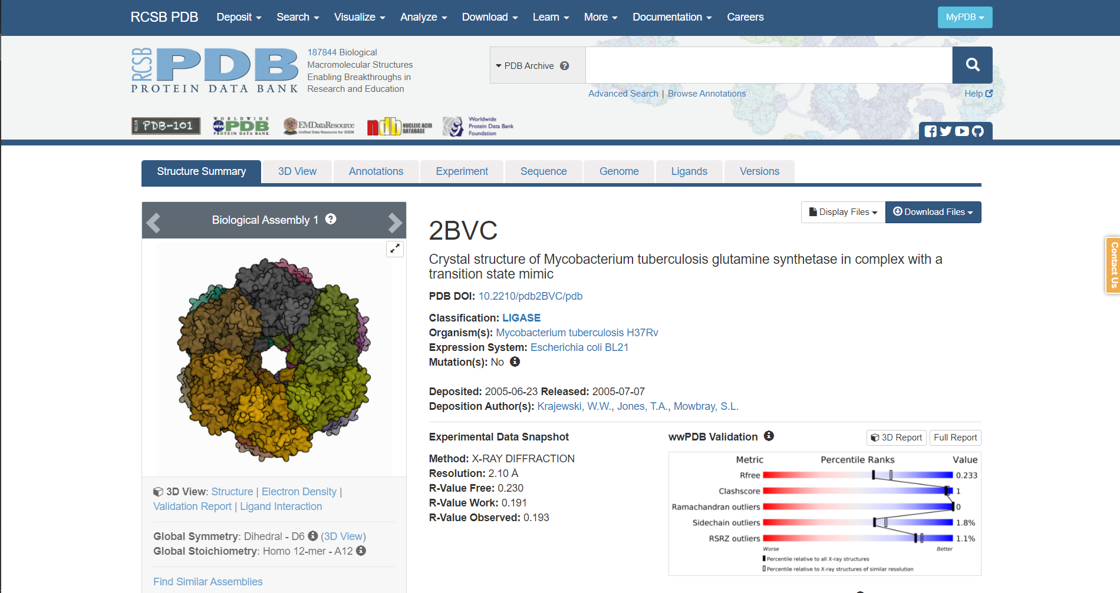**Fig1. PDB page for query Glutamine**

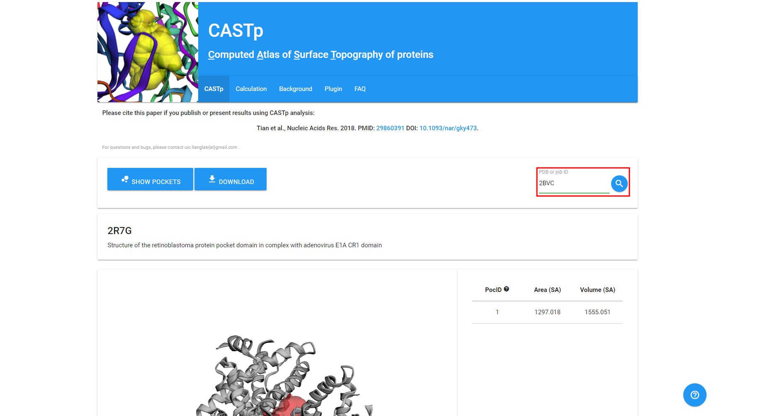**Fig2. CASTp page with the PDB id of my query entered**

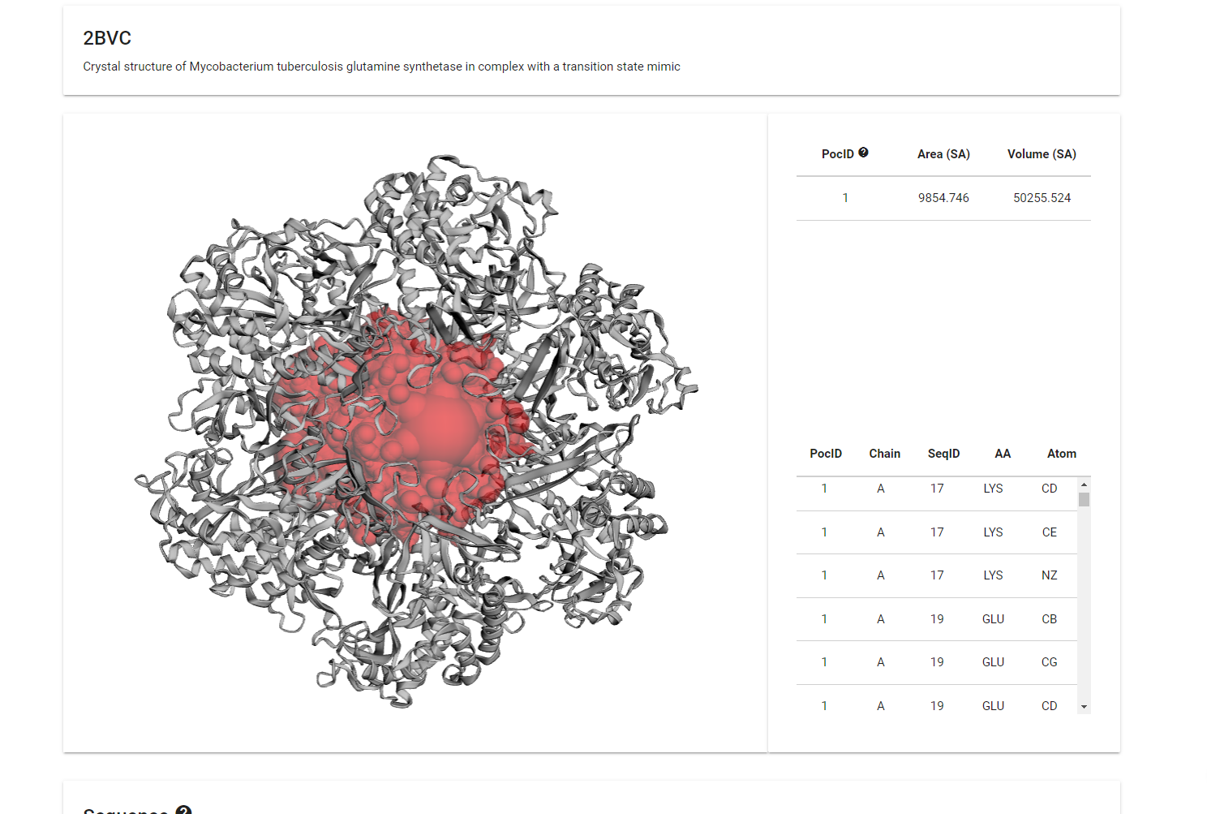**Fig3. Result of my query on CASTp**

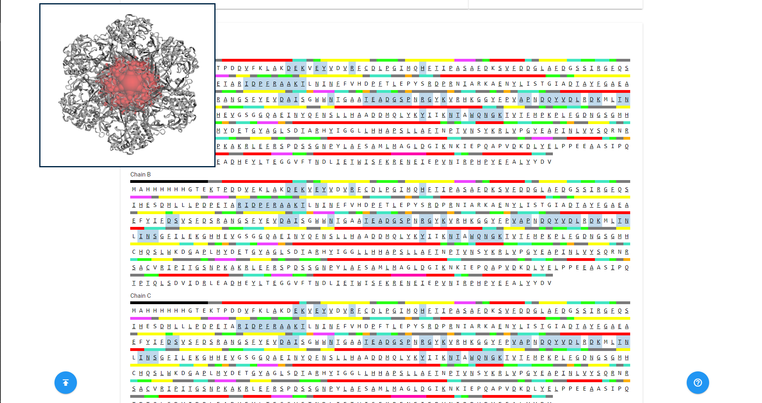**Fig4. Sequence data of the query on CASTp**

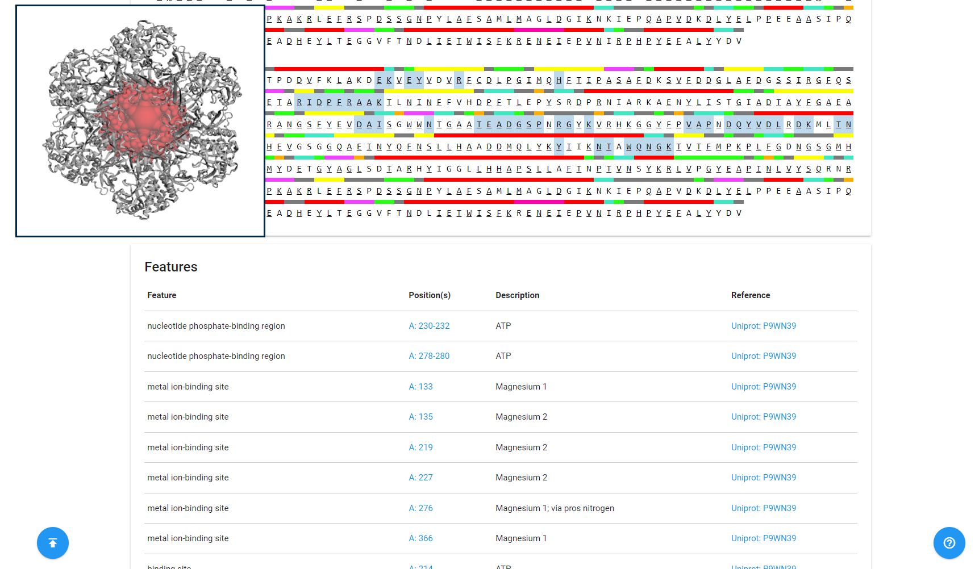**Fig5. Features data of my query on CASTp**

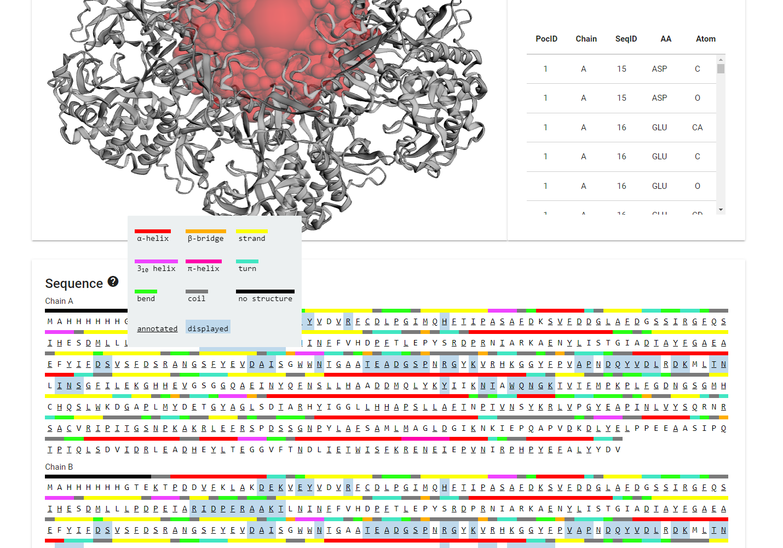**Fig6. Legend to refer to interpret data**

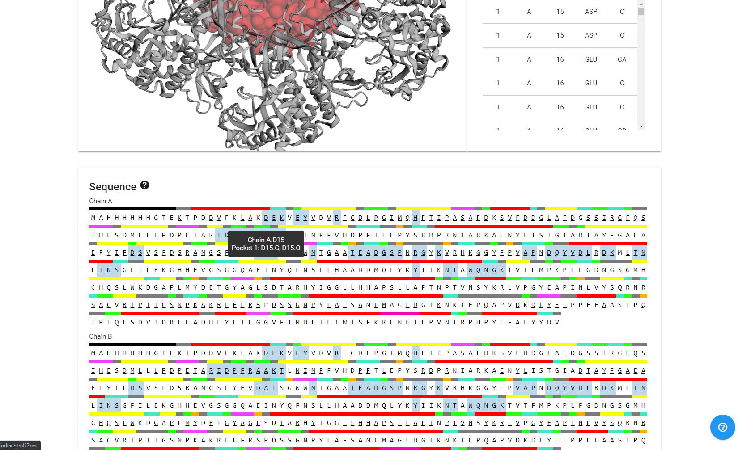

**Fig7. Pocket info for Chain A.D15, Pocket 1: D15.C, D15.O**

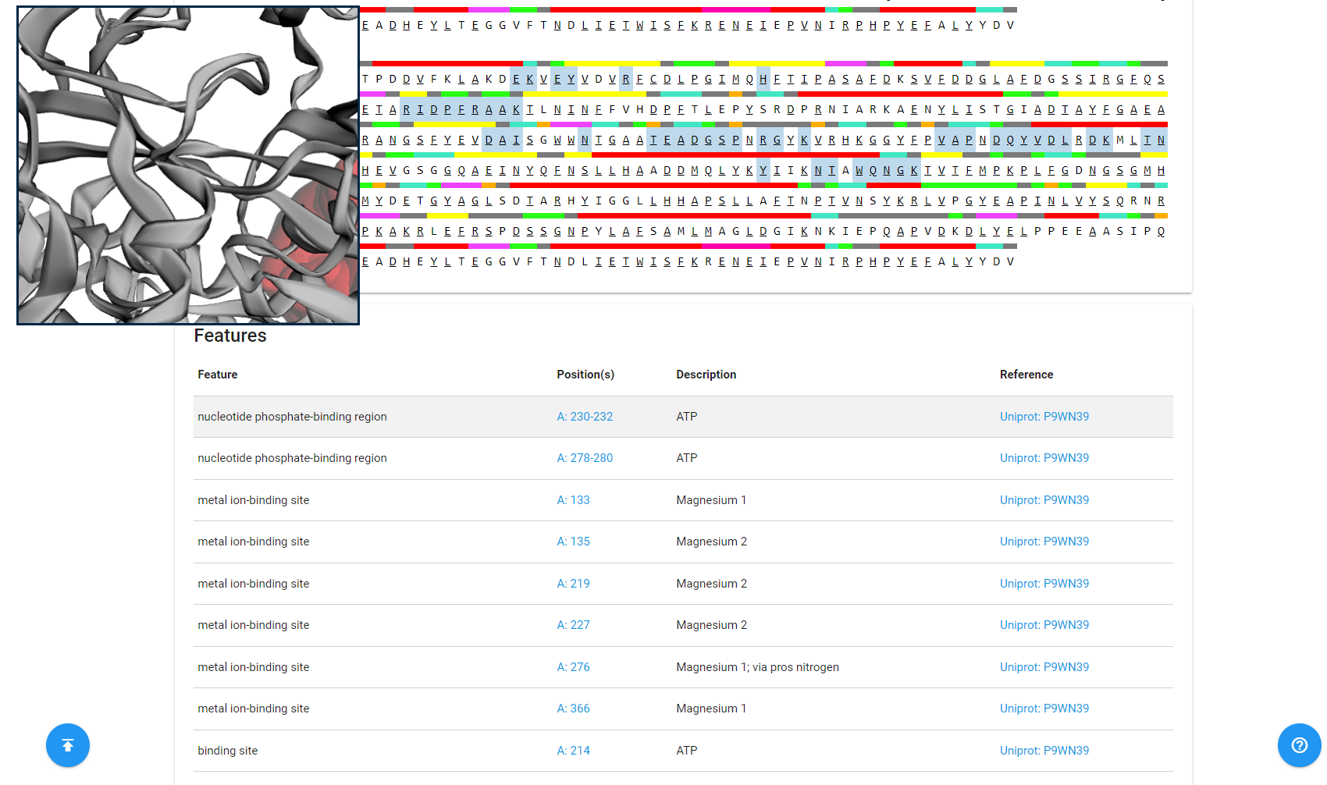**Fig8. Position in 3D space of nucleotide phosphate binding region A:230-232**

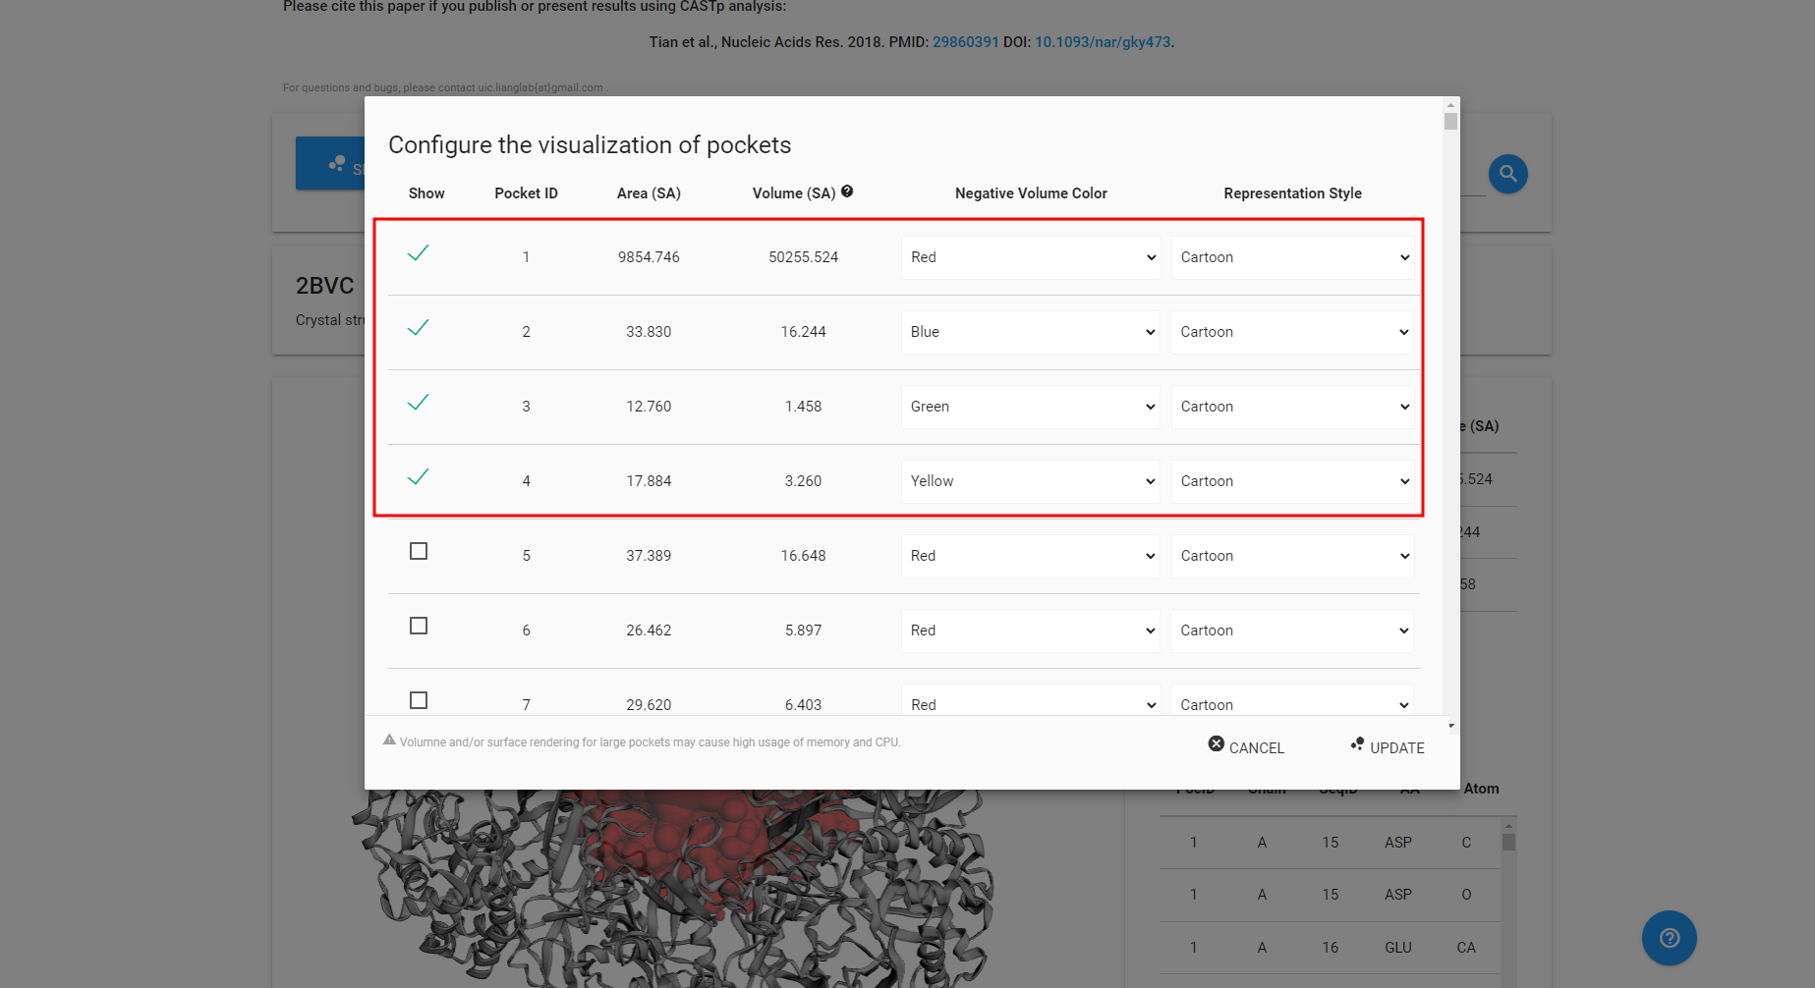**Fig9. Customizing the visualization of pocket in CASTp**

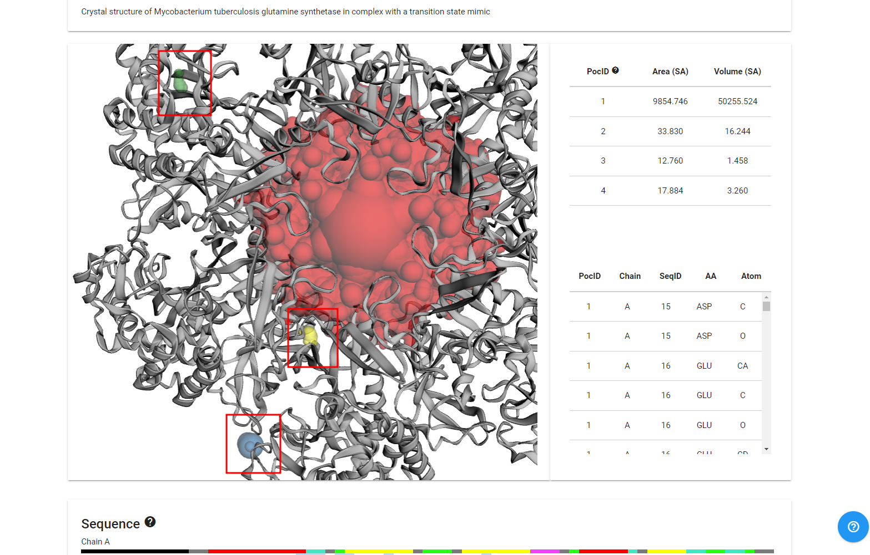**Fig10. Customized view of pockets for query in CASTp**

**Result:**

1. The Results are categorically divided:
   1. **Structure:** Here we can customize the visualization of the protein structure.
   2. **Sequence:** Here we can see the amino acid sequences of the given protein structure.
   3. **Features:** Here we see the features of the provided protein structure
2. In the given structure the Area is 9854.746 SA and the volume is 50255.524 SA

**Observation:**

* Castp is a great tool to find out the specific sites on the protein in 3D space.
* The colors of the site can be changed according to us and be seen clearly and boldly.

**References:**

* Bank, R. C. S. B. P. D. (n.d.). *2BVC: Crystal structure of mycobacterium tuberculosis glutamine synthetase in complex with a transition state mimic*. RCSB PDB. Retrieved March 3, 2022, from https://www.rcsb.org/structure/2BVC
* CASTp 3.0: Computed atlas of surface topography of proteins. (n.d.). Retrieved March 3, 2022, from <http://sts.bioe.uic.edu/castp/index.html?2bvc>
* Cruzat, V., Macedo Rogero, M., Noel Keane, K., Curi, R., & Newsholme, P. (2018). Glutamine: Metabolism and immune function, supplementation and clinical translation. *Nutrients*, *10*(11), 1564. https://doi.org/10.3390/nu10111564

**Date: 04-03-22**

**WEBLEM 6B**

**To predict binding pocket for Glycosylation sites in (query name) using NetOGlyc 4.0 Server**

**Introduction:**

* Glycosylation is the most abundant and diverse posttranslational modification of proteins.
* The output conforms to the GFF version 2 format. For each input sequence the server prints a list of potential glycosylation sites, showing their positions in the sequence and the prediction confidence scores. Only the sites with scores higher than 0.5 are predicted as glycosylated and marked with the string "#POSITIVE" in the comment field.
* **Glutamine**
  + Glutamine is the most abundant and versatile amino acid in the body. In health and disease, the rate of glutamine consumption by immune cells is similar or greater than glucose. For instance, in vitro and in vivo studies have determined that glutamine is an essential nutrient for lymphocyte proliferation and cytokine production, macrophage phagocytic plus secretory activities, and neutrophil bacterial killing. Glutamine release to the circulation and availability is mainly controlled by key metabolic organs, such as the gut, liver, and skeletal muscles.

**Methodology:**

* Take a FASTA sequence from uniport
* Enter the sequence into the submission box
* Interpret the result according to the output tab

**Observation:**

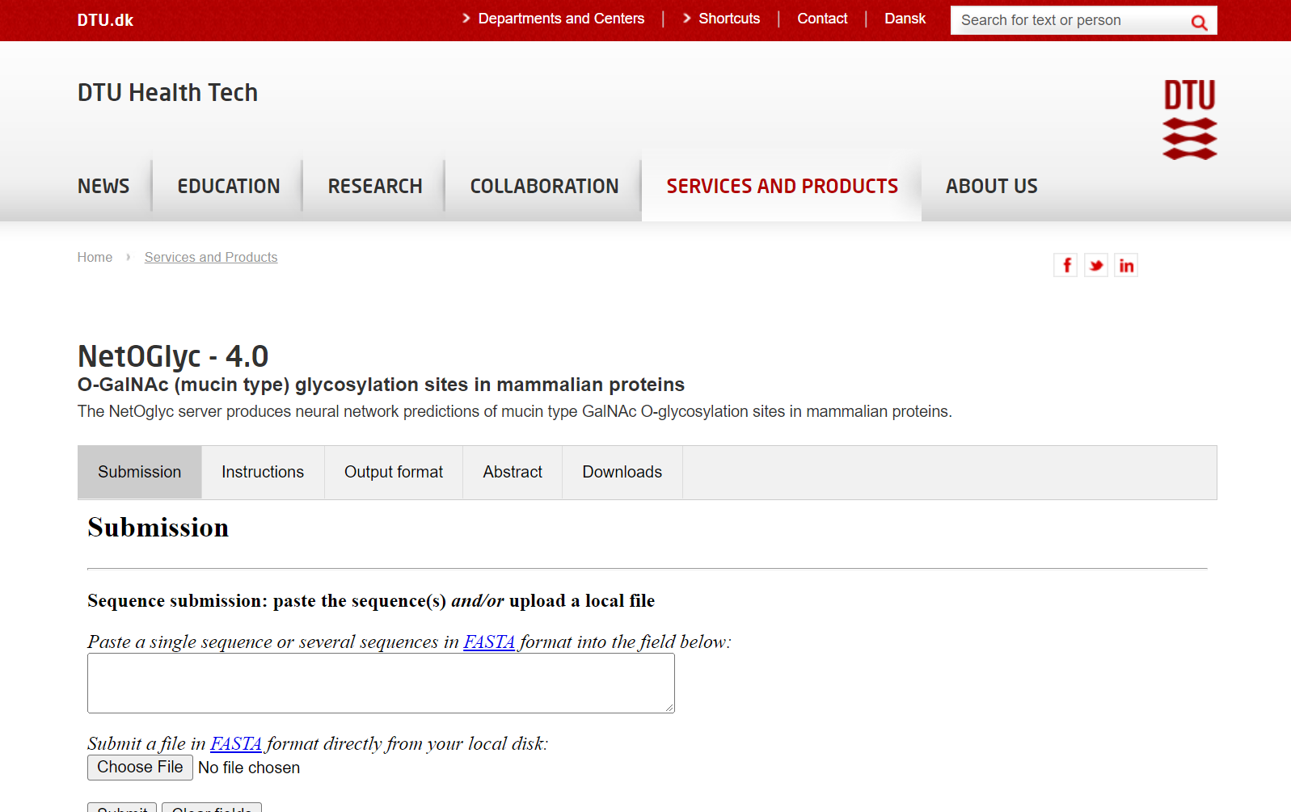**Fig1. Homepage of NetOGlyc – 1.0**

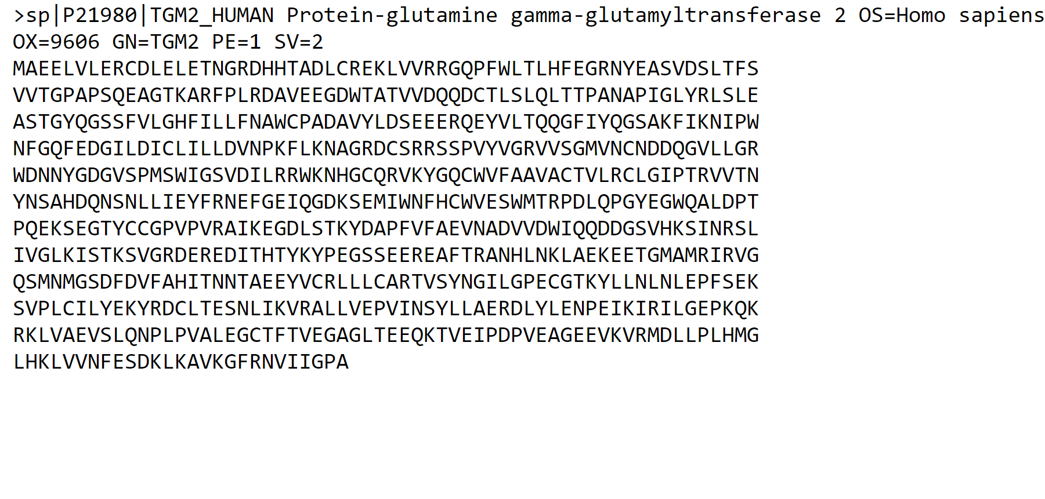**Fig2. FASTA Sequence for query Glutamine**

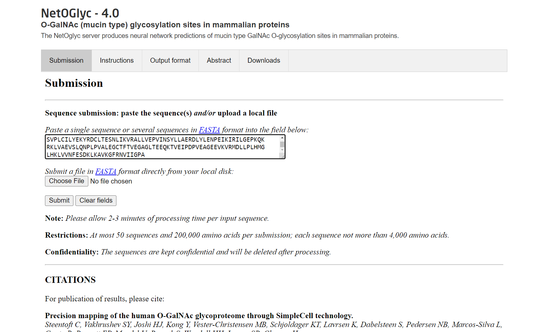**Fig3. Homepage of NetOGlyc with the FASTA sequence of query pasted in the search box**

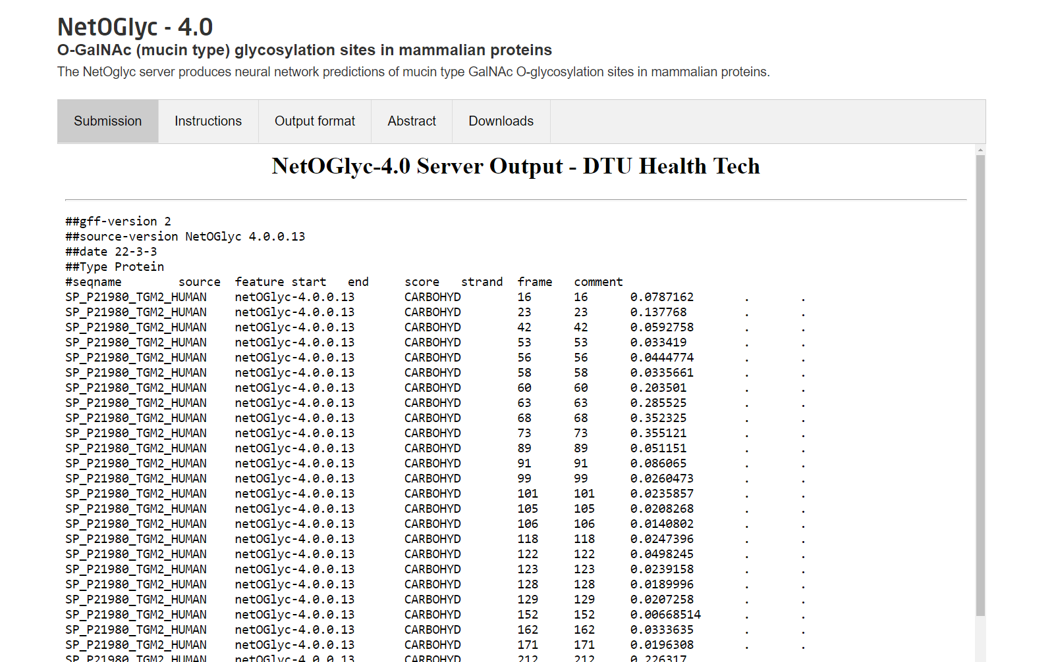**Fig4. Result page of NetNGlyc showing the submission data for query**

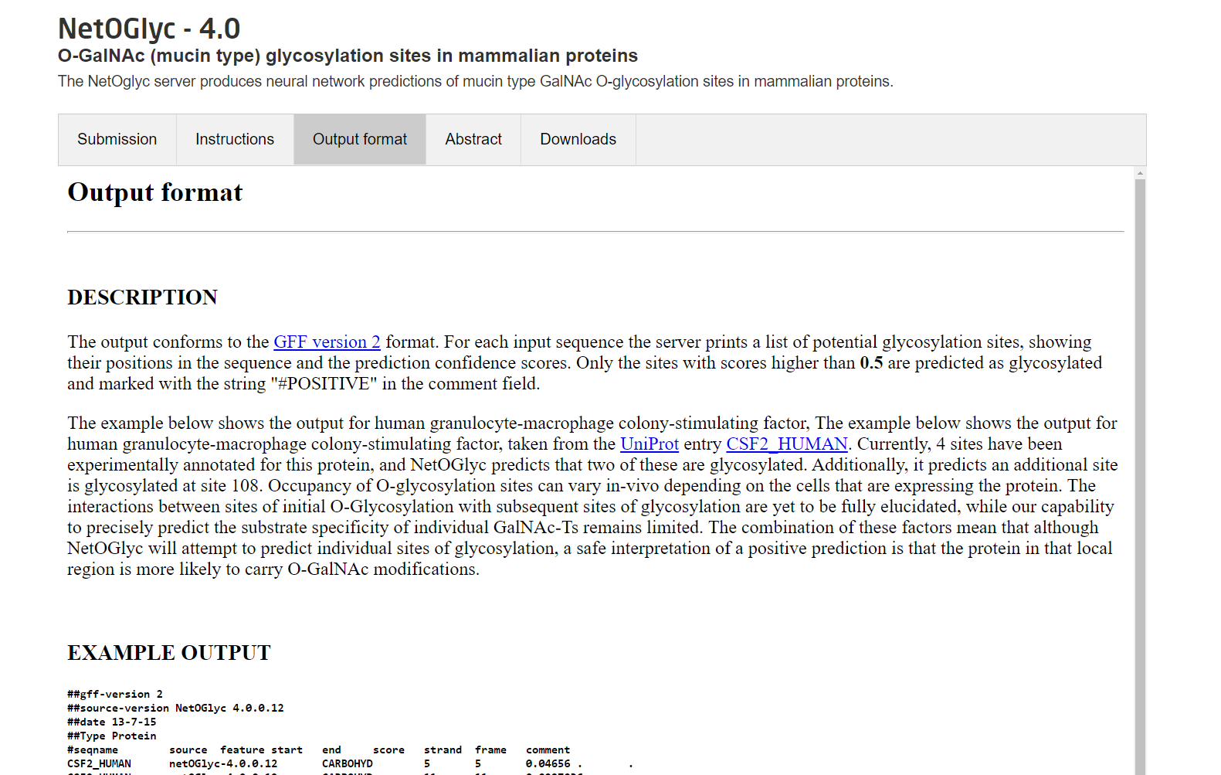**Fig5. Output format for NetOGlyc used to refer to interpret the results of our query**

**Result:**

* After submitting the FASTA sequence for query Glutamine it gives 3 potential glycolysis sites.
* This interpretation can be made by looking at the scores higher than 0.5 and a comment that has #POSITIVE

**Conclusion:**

* To conclude NetOGlyc is a great source to gather data about the potential Glycolysis sites quickly and accurately
* We can submit one or multiple sequences upto 50 sequences and 200,000 amino acids at once which makes the processing of sequences more efficient

**References:**

* Precision mapping of the human O-GalNAc glycoproteome through SimpleCell technology. Steentoft C, Vakhrushev SY, Joshi HJ, Kong Y, Vester-Christensen MB, Schjoldager KT, Lavrsen K, Dabelsteen S, Pedersen NB, Marcos-Silva L, Gupta R, Bennett EP, Mandel U, Brunak S, Wandall HH, Levery SB, Clausen H. EMBO J, 32(10):1478-88, May 15, 2013. (doi: 10.1038/emboj.2013.79. Epub 2013 Apr 12)
* Uniprot. (n.d.). Retrieved March 3, 2022, from https://www.uniprot.org/uniprot/P21980.fasta
* Cruzat, V., Macedo Rogero, M., Noel Keane, K., Curi, R., & Newsholme, P. (2018). Glutamine: Metabolism and immune function, supplementation and clinical translation. *Nutrients*, *10*(11), 1564. https://doi.org/10.3390/nu10111564

**Date: 04-03-22**

**WEBLEM 6B**

**To predict binding pocket for Phosphorylation site in (query name) using NetPhos 3.1 server**

**Introduction:**

* Protein phosphorylation at serine, threonine or tyrosine residues affects a multitude of cellular signaling processes. How is specificity in substrate recognition and phosphorylation by protein kinases achieved? In addition, serine and threonine residues in p300/CBP that can be modified by O-linked glycosylation with N-acetylglucosamine are identified. Glycosylation may prevent phosphorylation at these sites, a mechanism named yin-yang regulation.
* **Glutamine**
  + Glutamine is the most abundant and versatile amino acid in the body. In health and disease, the rate of glutamine consumption by immune cells is similar or greater than glucose. For instance, in vitro and in vivo studies have determined that glutamine is an essential nutrient for lymphocyte proliferation and cytokine production, macrophage phagocytic plus secretory activities, and neutrophil bacterial killing. Glutamine release to the circulation and availability is mainly controlled by key metabolic organs, such as the gut, liver, and skeletal muscles.

**Methodology:**

* Take FASTA sequence from uniprot
* Enter it in the submission box for NetPhos
* Interpret the result according to the output page of NetPhos

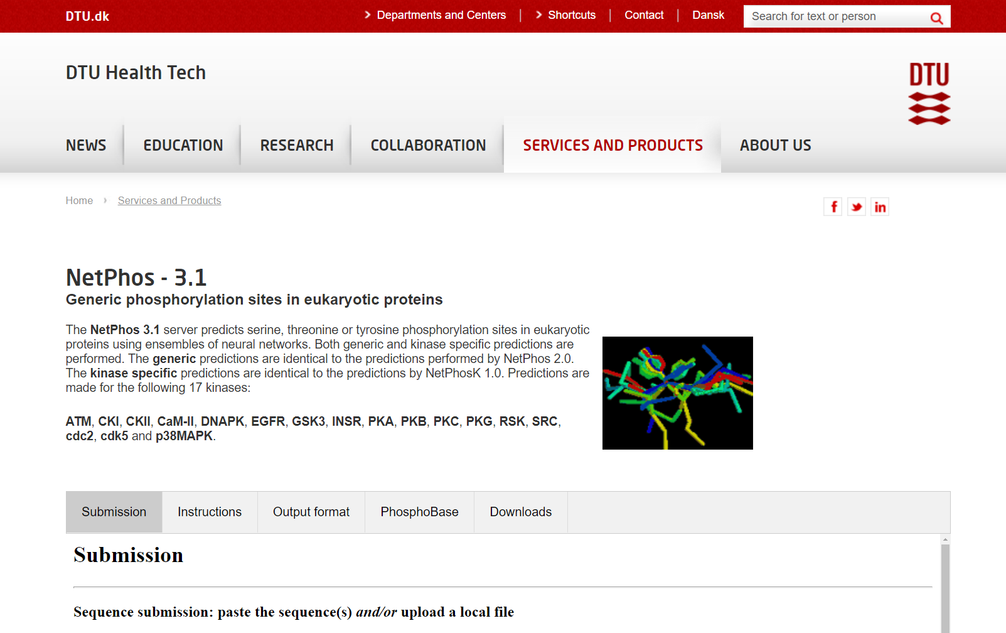**Fig1. Homepage of NetPhos 3.1**

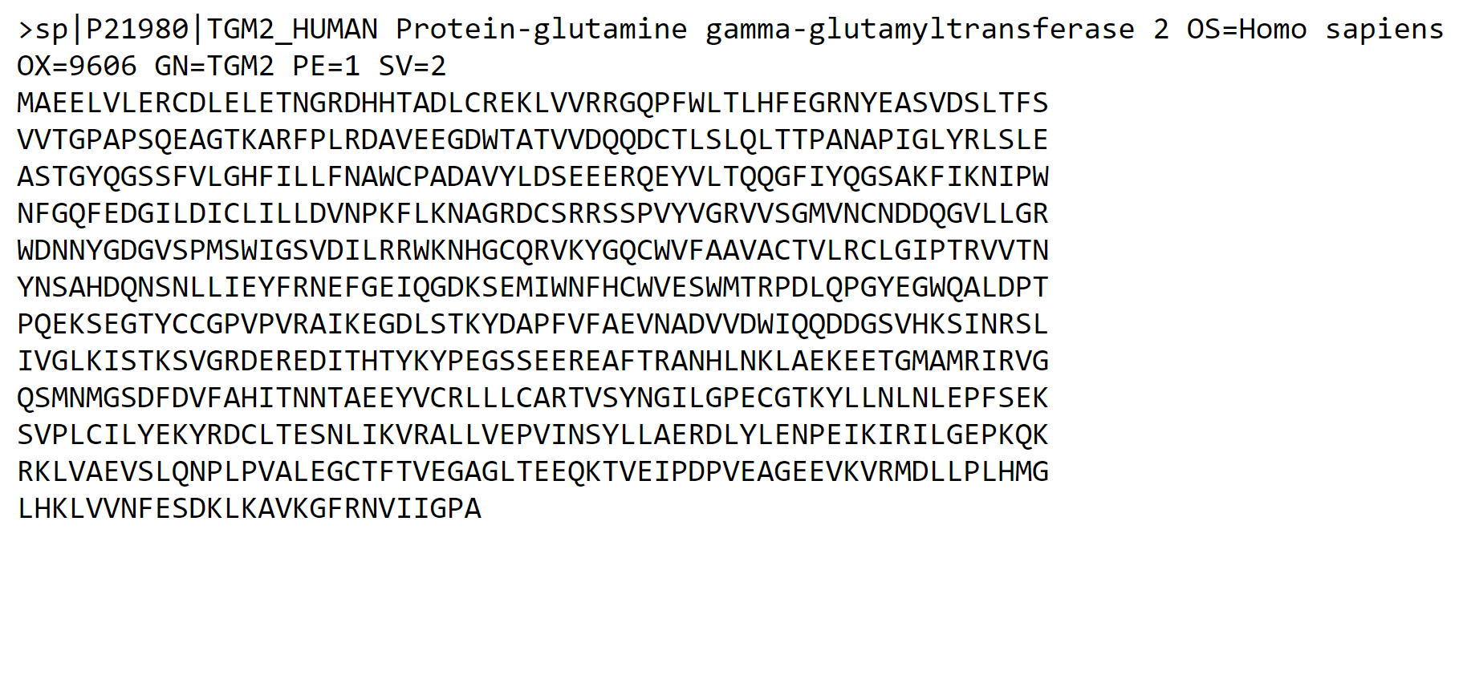**Fig2. FASTA Sequence for Query Glutamine**

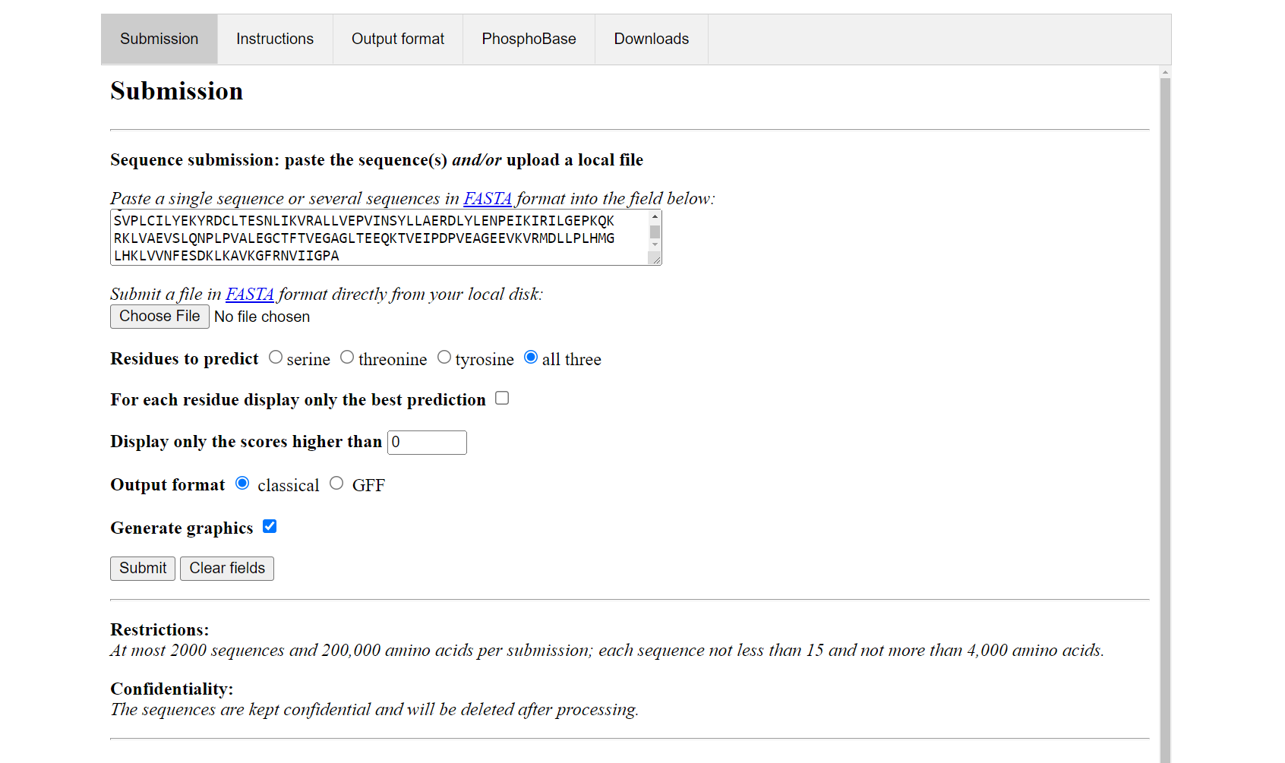**Fig3. FASTA sequence pasted in the submission box on NetPhos 3.1**

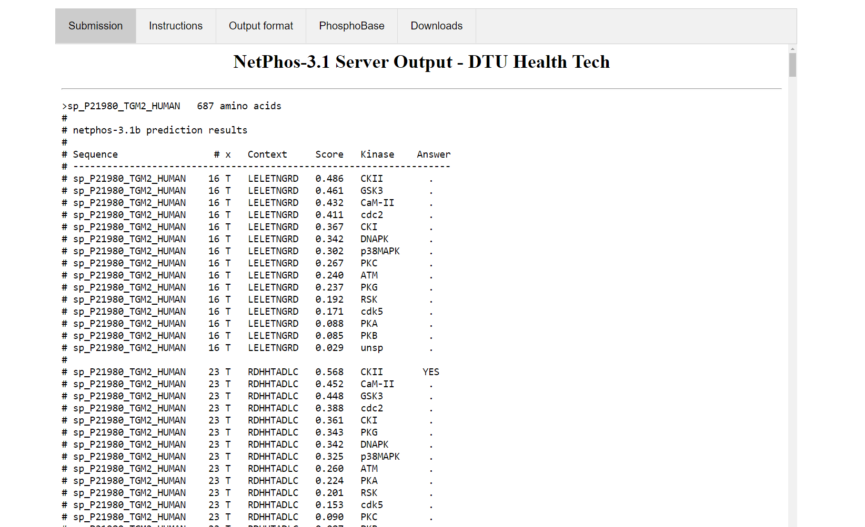**Fig4. Server output for the FASTA sequence showing amino acid prediction results**

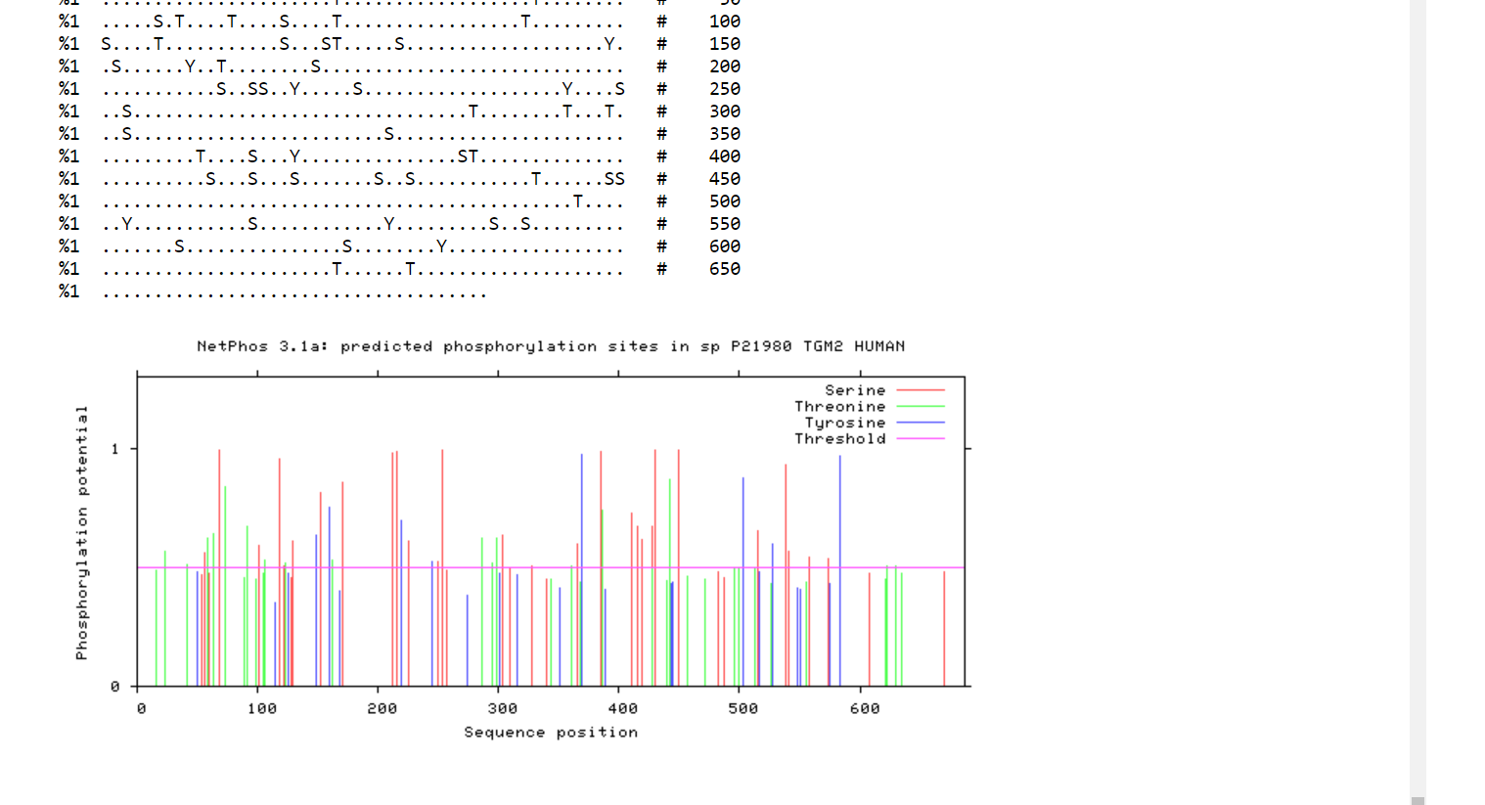**Fig5. Predicted phosphorylation sites in the sequence according to NetPhos 3.1**

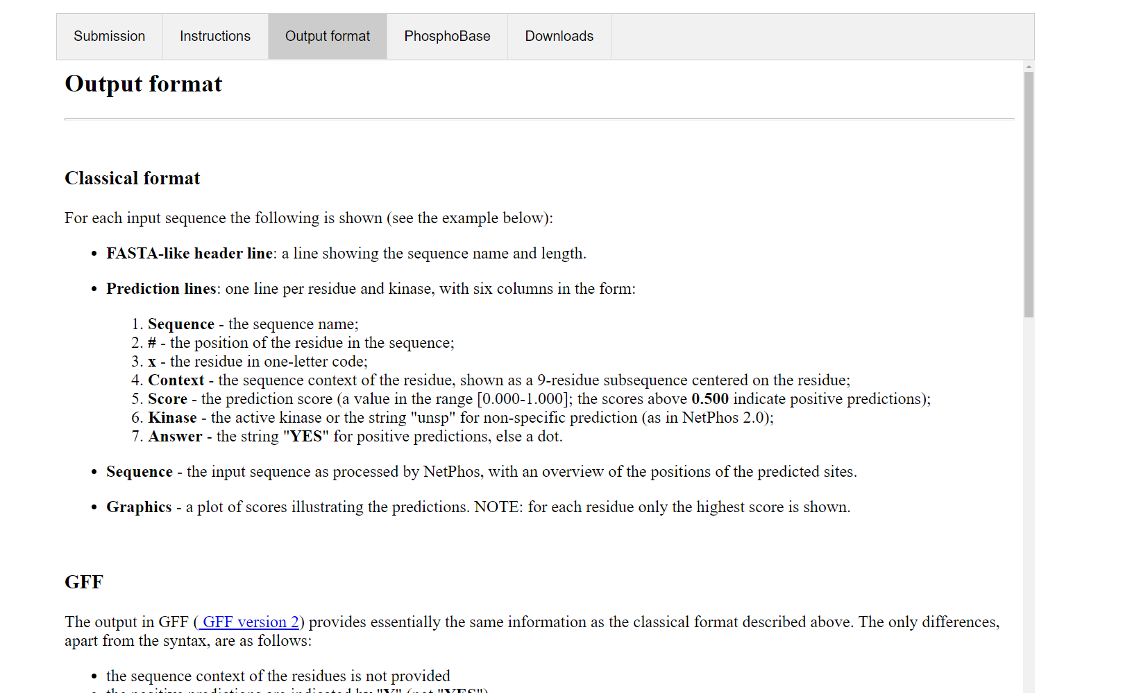**Fig6. Output format of NetPhos 3.1 used to interpret results for query accordingly**

**Result:**

* After submitting the result we can determine that there are 56 potential phosphorylation sites in the given protein sequence
* This interpretation was made on the basis that 56 results have a score about 0.5 and answer is YES
* The active kinase is also given and for non-specific prediction it is “**unsp**”

**Observation:**

* NetPhos is a great tool to find the phosphorylation sites of a given protein sequence.
* Multiple sequences can be submitted at once and the results can be interpreted in bulk making it easier to interpret.

**References:**

* Uniprot. (n.d.). Retrieved March 3, 2022, from <https://www.uniprot.org/uniprot/P21980.fasta>
* Sequence- and structure-based prediction of eukaryotic protein phosphorylation sites. Blom, N., Gammeltoft, S., and Brunak, S. Journal of Molecular Biology: 294(5): 1351-1362, 1999.
* Cruzat, V., Macedo Rogero, M., Noel Keane, K., Curi, R., & Newsholme, P. (2018). Glutamine: Metabolism and immune function, supplementation and clinical translation. *Nutrients*, *10*(11), 1564. https://doi.org/10.3390/nu10111564